Home Wind Turbine Weather Monitoring System

Innovative Mini-Windmill, Duke Energy Sponsored Project
Senior Design I + Senior Design II
Spring 2018

Group Number: 2

Group Members | Major
Zachary Bischoff | Computer Engineering
Devin Goldstein | Computer Engineering
Benneth Rejuso | Electrical Engineering
Logan Wharton | Electrical Engineering

Table of Contents
1 Executive Summary 1
2 Project Description 2
2.1 Project Motivation 2
2.2 Objectives 3
2.3 Goals 4
3 Research 4
3.1 Wind turbine Key Components 4
3.2 Energy Study in Low PV Areas 6
3.3 Pre-existing Small Wind turbine design 9
3.3.1 Xzeres Skystream 3.7 10
3.3.2 Xzeres Air X 11
3.3.3 AeroVironment Architectural Wind 12
3.3.4 Xzeres Whisper 442SR 13
3.3.5 Bargey Excel 14
3.3.6 Design Comparison 15
3.4 Battery Technology 18
3.4.1 Lead Acid Batteries 19
3.4.2 Lithium-ion Batteries 19
3.4.3 Nickel Batteries 20
3.4.4 Deep Cycle vs. Shallow Cycle 20
3.4.5 Battery Choice 22
3.5 Sensors 25
3.5.1 Wind Speed Sensor 25
3.5.2 Wind Direction Sensor 27
3.5.3 Rain Sensor 29
3.5.4 Noise Sensor 30
3.5.5 Temperature sensor 31
3.5.6 Energy Sensor 34
3.5.7 Charge Controller Data 35
3.5.8 LCD Display 36
3.5.9 Sensor Summary 37
3.5.10 Sensor Changes in Senior Design II 37
3.6 Microcontrollers 38
3.6.1 MSP430 38
3.6.2 MSP432 41
3.6.3 Kinetis K66 42
3.6.4 PIC Series 43
3.6.5 Raspberry Pi 44
3.6.6 A10-OLinuXino-LIME 45
4 Design Constraints 46
4.1 Economic Constraints 46
4.2 Time Constraints 46
4.3 Environmental Constraints 47
4.4 Social Constraints 47
4.5 Political Constraints 47
4.6 Health and Safety Constraints 47
4.7 Manufacturability and Sustainability Constraints 48
5 Hardware Design and Details 48
5.1 Hardware Design Overview 48
5.2 Wind Turbine Selection and Design 49
5.2.1 Wind Turbine 1 50
5.2.2 Wind Turbine 2 51
5.2.3 Wind Turbine 3 52
5.2.4 Wind turbine comparison and selection 53
5.2.5 Senior design ll Changes 55
5.3 Gearbox 55
5.3.1 Senior Design ll changes 57
5.4 Generator 57
5.5 Wind Direction Control System 59
5.6 Charge Controller 61
5.7 Wind Turbine Tower 62
5.7.1 Wind Tower Research 62
5.7.2 Wind Tower Design 62
5.7.3 Wind Turbine Tower Final Design 64
5.8 Resistors 65
5.8.1 Resistor Calculation 66
5.8.2 Resistor Selection 66
5.8.3 Main Circuit with Resistors Values 67
5.8.4 Senior Design II Changes 67
5.9 Sensor Technology 68
5.9.1 Wind Speed Sensor 68
5.9.2 Power/Energy Sensor 69
5.9.3 Temperature Sensor 70
5.9.4 Wind Direction Sensor 71
5.10 Microcontrollers 71
5.10.1 Microcontroller Pricing 71
5.10.2 Microcontroller Processors and Clock Speeds 72
5.10.3 Microcontroller Memory 72
5.10.4 Microcontroller Networking 73
5.10.5 Microcontroller Operating Systems 73
5.10.6 Microcontroller Graphics Processors 74
5.10.7 Microcontroller Hardware Schematics 75
5.10.8 Microcontroller GPIO 75
5.10.9 Microcontroller Final Result 76
5.10.10 Microcontroller Changes in Senior Design II 77
5.11 Display 78
5.11.1 Display Changes in Senior Design II 80
5.12 Printed Circuit Board (PCB) 80
5.12.1 Senior Design II PCB Implementations and Changes 82
5.13 Electrical Load List 85
6 Software Design and Details 86
6.1 Software Design Overview 86
6.2 Class Structure 87
6.2.1 Main class: 87
6.2.2 Energy Sensor Class: 88
6.2.3 Wind Speed Class: 88
6.2.4 Wind Direction Class: 89
6.2.5 Temperature sensor Class: 90
6.2.6 Display Creation Class: 91
6.2.7 Energy Data Class: 91
6.2.8 Temperature Data Class: 92
6.2.9 Web Server class: 93
6.2.10 Display Driver class: 94
6.2.11 Wind Data Class 95
6.3 GUI Design 96
6.3.1 Main Page Sketch 96
6.3.2 Detail Sketch 97
6.4 Software Design Changes in Senior Design II 98
6.4.1 Class Structure changes 98
6.4.2 GUI changes 99
7 Engineering Codes and Standards 100
7.1 Wind turbine Codes and Standards 100
7.1.1 IEC 60050-415 Ed. 1.0 b:1999 101
7.1.2 ISO 12494:2017 101
7.1.3 ANSI/AGMA/AWEA 6006-A03 (R2016) 101
7.1.4 IEC 60076-16 Ed. 1.0 b:2011 102
7.1.5 ISO 12925-1:2018 102
7.1.6 AS 4959-2010 102
7.1.7 BS EN 50308:2004 102
7.1.8 BS EN 12843:2004 103
7.1.9 IEC 61400-1 Ed. 3.0 b:2005 103
7.1.10 IEC 61400-2 Ed. 3.0 b:2013 103
7.1.11 IEC 61400-3 Ed. 1.0 b:2009 104
7.1.12 IEC 61400-4 Ed. 1.0 en:2012 104
7.1.13 IEC 61400-11 Ed. 3.0 en:2012 104
7.1.14 IEC 61400-12-1 Ed. 2.0 b:2017 104
7.1.15 EC 61400-13 Ed. 1.0 b:2015 105
7.1.16 IEC/TS 61400-14 Ed. 1.0 en:2005 105
7.1.17 IEC 61400-21 Ed. 2.0 b:2008 105
7.1.18 IEC 61400-22 Ed. 1.0 b:2010 106
7.1.19 IEC 61400-23 Ed. 1.0 en:2014 106
7.1.20 IEC 61400-24 Ed. 1.0 en:2010 106
7.1.21 IEC 61400-25-1 Ed. 2.0 b:2017 106
7.1.22 IEC 61400-25-2 Ed. 2.0 b:2015 107
7.1.23 IEC 61400-25-3 Ed. 2.0 b:2015 107
7.1.24 IEC 61400-25-4 Ed. 2.0 b:2016 107
7.1.25 IEC 61400-25-5 Ed. 2.0 en:2017 108
7.2 Codes and Standards Design Impact 108
7.2.1 IEC 600050-415 Ed. 1.0 b:1999 108
7.2.2 ISO 12494:2017 108
7.2.3 ANSI/AGMA/AWEA 6006-A03 (R2016) 108
7.2.4 IEC 60076-16 Ed. 1.0 b:2011 109
7.2.5 ISO 12925-1:2018 109
7.2.6 AS 4959-2010 109
7.2.7 BS EN 50308:2004 109
7.2.8 BS EN 12843:2004 109
7.2.9 IEC 61400-1 Ed. 3.0 b:2005 109
7.2.10 IEC 61400-2 Ed. 3.0 b:2013 109
7.2.11 IEC 61400-3 Ed. 1.0 b:2009 110
7.2.12 IEC 61400-4 Ed. 1.0 en:2012 110
7.2.13 IEC 61400-11 Ed. 3.0 en:2012 110
7.2.14 IEC 61400-12-1 Ed. 2.0 b:2017 110
7.2.15 IEC 61400-13 Ed. 1.0 b:2015 110
7.2.16 IEC/TS 61400-14 Ed. 1.0 en:2005 110
7.2.17 IEC 61400-21 Ed. 2.0 b:2008 110
7.2.18 IEC 61400-22 Ed. 1.0 b:2010 110
7.2.19 IEC 61400-23 Ed. 1.0 en:2014 111
7.2.20 IEC 61400-24 Ed. 1.0 en:2010 111
7.2.21 IEC 61400-25-1 Ed. 2.0 b:2017 111
7.2.22 IEC 61400-25-2 Ed. 2.0 b:2015 111
7.2.23 IEC 61400-25-3 Ed. 2.0 b:2015 111
7.2.24 IEC 61400-25-4 Ed. 2.0 b:2016 111
7.2.25 IEC 61400-25-4 Ed. 2.0 b:2016 111
8 Block Diagrams 111
8.1 Hardware 111
8.2 Software 112
9 Project Prototype Construction and Coding 112
9.1 Parts Acquisition and BOM 113
9.2 PCB Vendor and Assembly 113
9.3 Final Coding Plan 113
9.3.1 Changes in Senior Design II 116
10 Project Prototype Testing 119
10.1 Hardware Test Environment 119
10.1.1 Circuitry Operation 119
10.2 Software Test Environment 120
10.2.1 Software Test Environment Changes in Senior Design II 120
11 Standard Operations 120
12 Budget 121
12.1 Cost Table 122
12.2 House of Quality 123
13 Milestone Schedule 125
13.1 Senior Design I - Spring 2018 125
13.2 Senior Design II - Summer 2018 126
14 Bibliography i
15 Copyright Permissions iii

Executive Summary
Renewable energy has become a major concern over the last few decades. There have been advancements within the wind, solar, hydro, and other forms of renewable energy during this time. Wind energy harnesses the power of wind to turn a turbine that will generate electrical energy from the conversion of mechanical energy to electrical energy. As motors and turbines have become more efficient, more energy can be harnessed from wind while not polluting the environment such as other forms of energy like coal and oil. Although solar energy implementation is on the rise, we believe that wind turbines can also be implemented in a way such that they can also be an appealing form of renewable energy, especially in areas with low photovoltaic access. As of now, wind turbines are considered an eyesore because they are enormous and take up a lot of space. Due to their large spatial needs, this renewable energy source is placed a way away from the cities that need them. With this, we wondered if there was a way to integrate these turbines closer to home. Thus, it was discovered that mini-wind turbines exist for this purpose.

For this project, we plan to implement a vertical mini-wind turbine in the sense that it will be placed on taller buildings. Having the turbines up high will increase the possibility of collecting energy from the wind. This turbine will be placed on a platform that will also contain an energy storage system. Attached to the turbine will be various sensors that will send data about wind speed, wind direction, temperature, and energy production to a microcontroller. Along with the microcontroller, a Wi-Fi module will be accessible on a printed circuit board that we will design and assemble. Through the Wi-Fi module, the collected data will be sent to a web application that will display all this information.

While designing this project, many constraints will need to be taken into consideration. Economically, it would be ideal to find the cheapest parts needed to put this all together. Of course, reality doesn’t always provide the best parts for a low price. Environmentally, this turbine should be should be not be visually polluting. Many have the opinion that wind turbines are not visually pleasing because they are too large. This mini-wind turbine will be much smaller than traditional wind turbines, but it will still be noticeable on top of structures. Because of this, the system should be visually pleasing, and should also try to take up as little space as possible. Time is will also be a big factor in this project, because it will dictate how achievable any goals will be. In regard, to health and safety, this product should be able to operate without any malfunctions. Lead acid batteries will be used in the design, so they will need to be stored and connected properly to reduce any electrical dangers from happening.

Along with constraints, there are a handful of codes and standards that apply to wind turbines. Some talk about the way a wind turbine should be built and even how they should be protected from lightning strikes. Electronically, there are some standards for how a printed circuit board should be designed. These PCB standards cover specifications on dimensions, tolerances, materials, traces, annular rings, and many more. Knowing what these codes and standards are will help to ensure that the design will be constructed in a safe and productive way.

Project Description
Our project has gone through many design phases throughout our brainstorming process. Initially we were going to go with a hovering/flying Wind Turbine that was anchored with cables and used helium balloons to get airborne. Overtime, that idea slowly changed into a home friendly wind turbine that could be used in place of solar in areas that have limited sunlight most of the year. That is our main motivation for our project which is described in more detail below. There are certain objectives that we as a team want to achieve as well as project goals we want to adhere to during development.

Project Motivation
The demand for power is becoming a major concern in not only the United States but to the world. With the increasing demand for power in the world there is an increasing need to pursue as much power generation solutions as possible to meet this demand. Although, there are several energy solutions that rely on past, mundane energy technologies, like coal and fossil fuels, these energy sources pose another imminent threat to the world in the form of greenhouse emissions that are having a growing effect on global warming. With all the factors in mind it is clean energy sources such as solar and wind that offer the best option to solve energy problems.

In terms of growth in the industry, both solar and wind are viable options, but it is wind energy that will be the focus of our project. Our motivation is due in part to two reasons. The first reason is the industries’ perceived inclination towards the implementation solar technology versus wind technology. A big cause for this trend is the spatial advantage that solar energy possesses over wind energy. Solar panels require significantly less space to operate than the current wind turbines and their massive rotating blades and large towers. Additionally, solar energy is much more viable in residential areas because the wind speed and wind abundance in those areas is not consistent enough to compete with the available solar light, which is why the industries lean more towards solar in smaller applications as stated in the first reason. The second reason is that currently most wind turbines are either built onshore far removed from cities and other population centers or offshore on floating platforms over huge bodies of water. Even though onshore and offshore wind turbines farms produce more power than solar farms of comparable size on average, this however is not the case when both power sources are scaled down. The drawbacks of having to locate a wind turbine to a scare area with sufficient enough wind speed and abundance to attain the same power output as a solar panel is impractical on all but the largest scales. It would be much more convenient to place solar panels on a building roof than to deal with all the perceived cons of wind generation as the industry’s trend would suggest.

There is however a growing concept to wind turbines that could be designed to compensate for this perceived weakness. As opposed to the ever-growing trend of wind towers getting taller and taller and rotating blades getting longer and longer for the new generation wind turbines, our group is instead proposing the further development of small wind turbines for use on top of buildings. Small wind turbines have existed for generations, but their popularity is growing due their spatial advantage over their larger counterparts. Another reason for small wind turbine growth is there power generation advantage over solar energy in areas with low solar penetration and areas devoid of consistent solar light for long periods of time. Colder climates where daytime is significantly shorter and solar penetration is extremely lower than the average would warrant the implementation of small wind turbines over solar panels. Also, larger wind towers might be applicable in these colder areas as well, but our focus is on small wind turbines because small wind turbines would still be able to produce energy in these areas too and would still be spatially convenient enough to be mounted atop of residential houses as opposed to larger towers. One of our goals is to produce supplemental power on a small scale and to show that small wind turbines are a source of clean energy, spatially convenient, and the power source that's best for low sunlight areas.

Objectives
There are already existing designs for small wind turbines but none of these pre-existing ideas are contemplating the scale or advantages of our design proposal. Our design would consist of a mini wind turbine mounted on a special platform and placed on top high buildings in metropolitan areas. This platform would farther elevate the mini wind turbine on top of the already tall building, further increasing the amount of wind energy produced. Of Course, our mini wind turbine is not meant to match the power output of onshore and offshore wind turbines but rather to overcome the spatial disadvantage of the two former designs while also producing viable power output. There will be one vertical wind turbine on top of the special platform. While designs for smaller windmill turbines do exist, the problem with them is the amount of space required for them to operate. Our design overcomes this by reducing the size of the turbine to allow for its placement on top of commercial buildings and potentially even homes. One of the main things that will allow us to achieve this is by using a vertical turbine in pairs of two. This is space efficient because they would be attached to one base. We will have sensors that detect high wind speed based on a threshold. These sensors would activate (tentatively) motors that will lock the turbine blades from turning to prevent damage to the turbine.

The base will tentatively be about 4 to 5ft high with a width of tentatively 3 to 4 feet. The platform that the turbines will be on will be tentatively 8-10 feet. The turbines will store their energy in a battery located in the base. The microcontroller controlling the motors will reside on the platform and will tentatively be powered by a battery located on the platform. The most essential part of our design is scalability. Since the footprint of the design is small, multiple bases can be placed within a small area which overall increases the amount of energy produced.

Goals
From a design perspective, there is certain criteria that we feel our project must adhere to. We feel that the following list is a good comprehensive list of goals for our project. There are testable and quantifiable. Most of these goals came about while coming up with a motivation for our project. Any design decision that we make, we will first ask if it meets all of these or at least 80% of these goals.

- System meets codes and standards
- System is power efficient
- System is reliable
- System is affordable
- System is safe
- System generates electrical energy from wind energy
- System maintains stability
- System will protect itself from heavy winds by stopping blades
- System will protect itself from heavy winds by retracting self to base
- System will provide or store energy
- System will be as compact as possible

Research
Once we had our project preliminary design solidified, the next step was the research all the components our design will implement. None of us knew how a wind turbine worked, let alone how sensor and sensor data was transmitted to a device of some kind. Below is our major finding from our research and a brief explanation of how it relates to our project and how we might implement it into our design.

Wind turbine Key Components
This section of the document will give some background into the main components of a wind turbine. This section is important because not everyone is familiar with all the components wind turbine is. We want to clarify exactly which components will be researching, analyzing, comparing, and purchasing.

Starting with a turbine, the main function of a turbine is to convert a source of energy in one form to a source of energy in the form of mechanical energy. The starting energy sources can vary but in terms of a wind turbine the starting energy source is wind. The energy from the wind passing by the rotor blades of wind turbine causes rotation of those same rotor blades. The rotor blades are interconnected to a shaft which rotates as well. The shaft rotation would be classified as mechanical energy. There are further energy transfers in from the shaft to the gearbox but there is no energy conversion to another from since this is still mechanical right through up until generator. So, the process of the turbine of converting wind energy to mechanical energy is practically complete. After the mechanical energy is generated and goes through the gearbox, the next step is the generator process. Again we will cover basis by explaining the function of a generator. A generator is like a turbine in fact that in converts energy in one from to energy in another form, the difference being that a generator converts mechanical energy to electrical energy. This is done by the rotational mechanical energy from gearbox rotating a permanent magnet or current carrying wire within the generator structure. It was important to go over the main process of turbine because our design will incorporate this main process in the analysis and research aspect of this document. For example, we will look at the wind turbine first, than the gearbox, and after the generator.

The figure on the next page will display the process I just explained. The major components of the wind turbine can be seen. This picture provides us an internal view into of the wind turbine and allows us to see the orientation of the major components and their respective sizes and locations.

We learned from this figure that the wind turbine is the whole shell of the system not just the rotating component of the machine that coverts wind energy to rotational mechanical energy, meaning that the generator and gearbox comes provided with the wind turbine. We do not yet know if this the normal case or if this only applies to certain wind turbines. Will clear this up in the research section of this document.

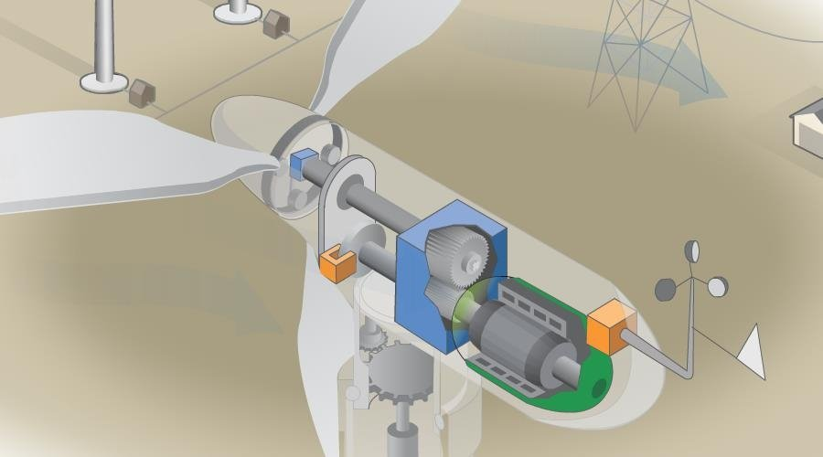
Figure 3.3.1.1
The Generator can be seen at the very back of the wind turbine enclosure as well as the gear box. The mechanical energy from the gears is used to rotate the generator and produce electricity.

Energy Study in Low PV Areas
Part of our goals is to justify the placement of our small wind turbine in low photovoltaic regions. This justification will be addressed in this section of the document.

In far northern cities or cities located above 42 degrees parallel, such as Barrow, USA and Torshavn, Faroe Islands, the amount of average sunlight during the winter season is little to none. This phenomenon is due to the earth’s tilt about its axis which places northern cities at acute angle from the oncoming sunlight generated by the sun. The far northern cities like the mentioned previously are exposed to far less sunlight on average than other cities of world during the winter seasons. The average sunlight year-round for the cities of Barrow and Faroe Islands are shown in following graphs.

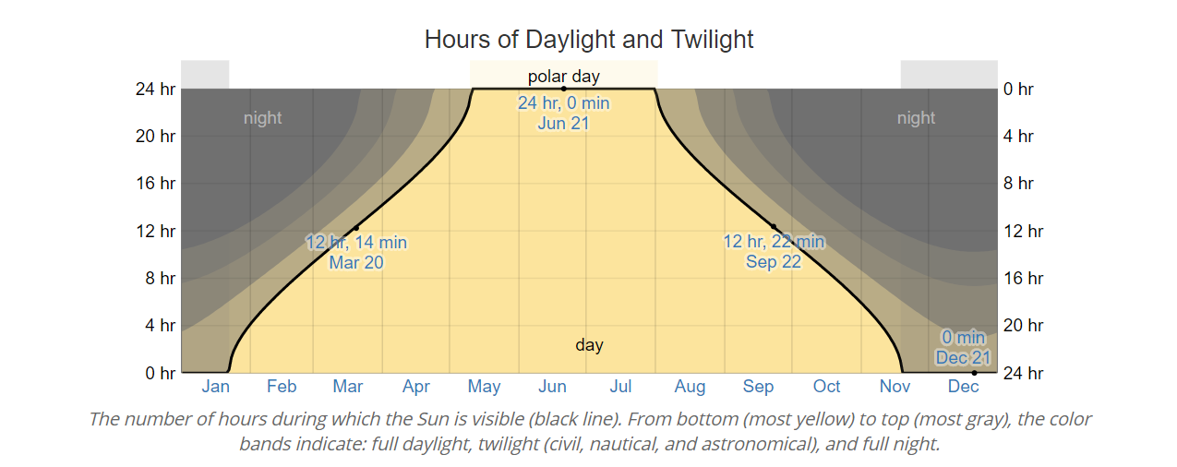
Figure 3.3.1.1
An Hours of Daylight and Twilight graph of Barlow, USA. On the Y-axis is the number of hours. On the X-axis is the 12 months of the year. The yellow shading is representative of daylight. The light gray shading is representative of twilight. The dark gray shading is representative of night time. Polar day is representative of 24 hrs. Of daylight or no night time.

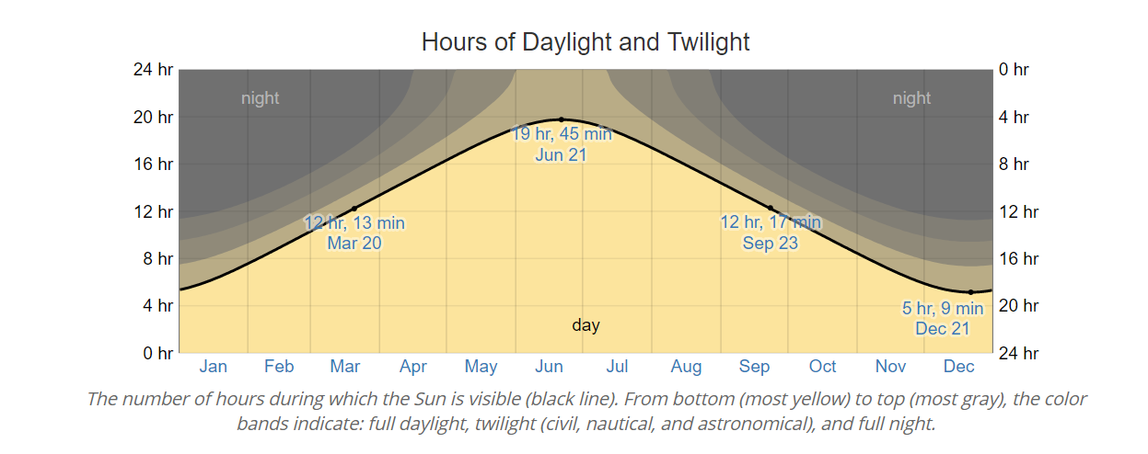
Figure 3.3.1.2
An Hours of Daylight and Twilight graph of Torshavn, Faroe Islands. On the Y-axis is the number of hours. On the X-axis is the 12 months of the year. The yellow shading is representative of daylight. The light gray shading is representative of twilight. The dark gray shading is representative of night time.

As the above graphs display, during the winter seasons there are only a few hours of sunlight, and in the special case of Barlow, there are days without any sunlight at all. With this data in mind, solar panels would not be the optimal power alternative in these places during the winter time periods. However, not only is wind speed and abundance strong year-round in these types of areas but also wind speed tends to increase during the winter seasons. The following graphs are the average wind speed year-round for Barlow, USA and Torshavn, Faroe Islands.
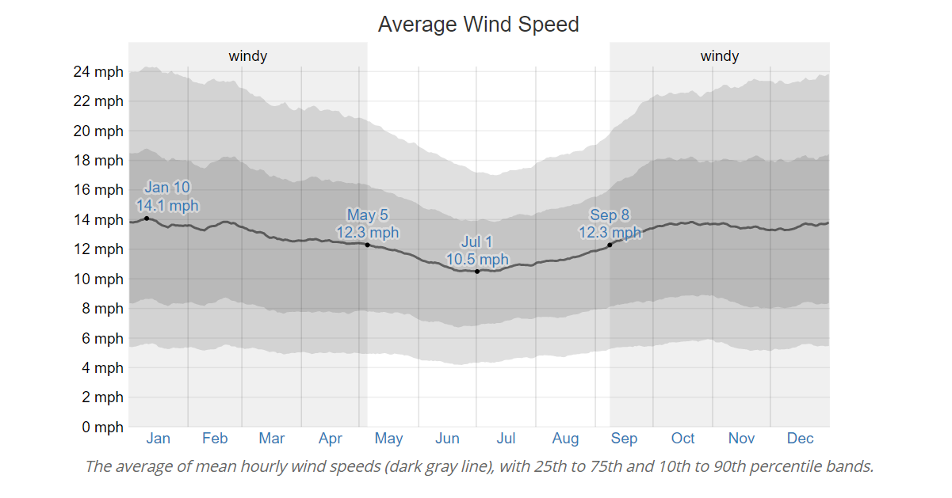
Figure 3.3.1.3 an average wind speed graph of Barlow, USA; On the Y-axis is the wind speed in mile per hour (mph). On the X-axis is the 12 months of the year. The darkest gray shading is representative of 25th to 75th percentile of average wind speed. The medium gray shading is representative of 10th percentile and the 90th percentile of the average wind speed. The dark gray line is the average wind speed throughout the year.

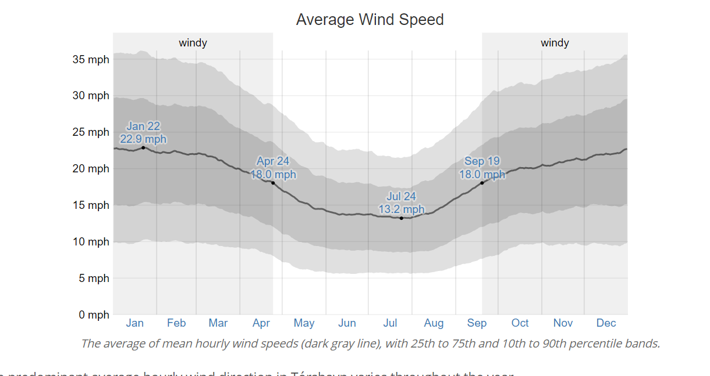
Figure 3.3.1.4 An average wind speed graph of Torshavn, Faroe Islands; On the Y-axis is the wind speed in mile per hour (mph). On the X-axis is the 12 months of the year. The darkest gray shading is representative of 25th to 75th percentile of average wind speed. The medium gray shading is representative of 10th percentile and the 90th percentile of the average wind speed. The dark gray line is the average wind speed throughout the year.

The above graphs clearly display a relatively high wind speed year-round in both places as well as the wind speed increasing during the winter months. It should be noted that while there is an increase in wind speed during the winter seasons, sunlight is decreasing during these same time periods as mentioned before. So, it would practical and advantageous to implement small wind turbines in these far northern areas, contrary to the usual solar panels that would be more viable in other regions of the world. Our design proposal of small wind turbine is focused towards that application and it is warranted by the data.

Pre-existing Small Wind turbine design
To optimize our design of a smart small wind turbine operating in low photovoltaic penetration areas it was necessary to research pre-existing designs or similar proposals by others. Additionally, to avoid potential hazards of copyright, existing patents, and/or all other forms of legal protection in terms of smart small wind turbine this research was applicable towards that end as well.

Small wind turbines for the most part are identical to their larger counterparts. The key aspect that distinguishes a small wind turbine from a regular one is the sizing of components and the amount of average power that the wind turbine can produce. Small wind turbines are generally considered to be with in power range of 1000 W (1 KW) and under. Some consider the upper range to extend even up to 3000 W (3 KW). In either case, the amount of power that small wind turbines produce is far lower than the generation of larger wind turbines and their average megawatt power yields. That is to be expected because most of the large wind turbines are used for commercial use while majority of small wind turbines are used for residential/local use. With these factors in mind most of the pre-existing small wind turbine designs that we came across had rated power up to 1 kW and were designed for local use only. Local use means small loads in the immediate vicinity without any power grid connections. The following paragraphs will give a summary of each of the most popular small wind turbine designs and will conclude with what out group gleaned from other designs to incorporate in our own small wind turbine design.

Xzeres Skystream 3.7
The first wind turbine designed to be fully integrated to the power grid for residential use, hence the term “plug-and-play”. This wind turbine comes with controls and inverter already built in. However, there is no tail rudder, which prevents the turbine from facing into wind at all times. The cost is list as $5399 and that does not include the price of a tower and installation materials, so the initial price would increase by sizable margin. Rated capacity is 1.9 kW continuous. Startup wind speed is 8 mph. Rotor diameter is 12 ft. with RPM range of 50-325. Designed for the potential of grid connection but can also be interconnected for just battery charging. Alternator is gearless and has a brushless permanent magnet. Voltage output is 240 VAC (Volts with alternating current). Estimated energy production is 400 kWh per month with a 12 mph (5.4 m/s) wind speed. The following two figures are of the Xzeres Skystream 3.7 wind turbine and some of the previously mentioned specifications in visual form.
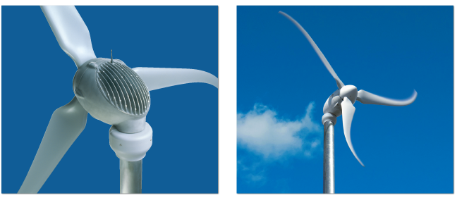
Figure 3.3.1.1: Xzeres Skystream 3.7
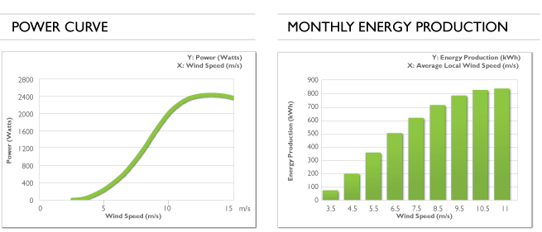
Figure 3.3.1.2: Power Curve & Monthly Energy Production

Xzeres Air X
One of the world’s bestselling small wind turbines, incorporates microprocessor based technology that increases performance and several other important parameters. It is designed to power small loads or appliances in off grid applications— i.e. remote communications. The wind turbine Cost is listed at $600. This is lowest cost out of all the top small wind turbines that will be discussed. It has a rated capacity of 400 watts or 0.4 kW, the startup wind speed is 8 mph, the rotor diameter is 3.83ft (1.14 m). Interconnection is designed for battery charging only. Voltage output varies from 12 V, 24 V, and 48 V VDC (Volts with Direct current). The estimated Energy production is 288 kWh per month at 12 mph (5.4 m/s) wind speed. The following two figures are of the Xzeres Skystream 50 wind turbine and some of the previously mentioned specifications in visual form.

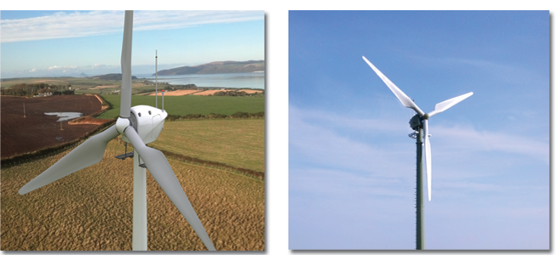
Figure 3.3.2.1

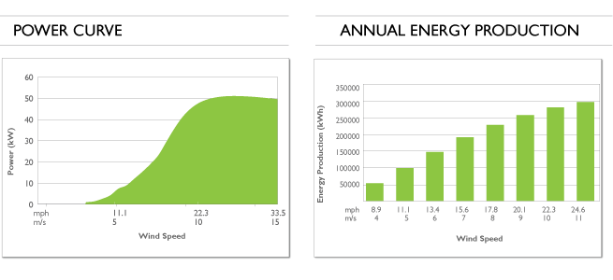
Figure 3.3.2.2 Power Curve & Monthly Energy Production

AeroVironment Architectural Wind
Small modular wind turbine system designed to be mounted in urban areas. Instead of using a support tower there is a modular housing that supports the tower without infringing upon the building's structure. The following figure is of the AeroVironment Architectural Wind turbine.

Figure 3.3.3.1

Xzeres Whisper 442SR
It is stated that it can produce enough energy to power a small to medium sized home. It is designed to work in harsh wind environments, has a patented angle governor to enable quiet operation in high wind speeds and can still operate in high wind speeds without dropping in power output. Listed cost is 7095. Rated capacity is 3 kW. Cut in wind speed is 7.7 mph. Rotor diameter is 15 ft. (4.6 m). The wind turbine can be connected either to the grid or for battery charging. Voltage Output can be either AC or DC. The VDC comes in 24 V, 32 V, and 48 V. The VAC only comes in 240 V. The estimated energy Production is 500 kWh per month at 12.5 mph wind speed. The following two figures are of the Xzeres Skystream 442SR wind turbine and some of the previously mentioned specifications in visual form.
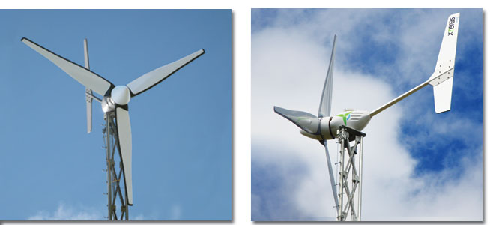
Figure 3.3.4.1
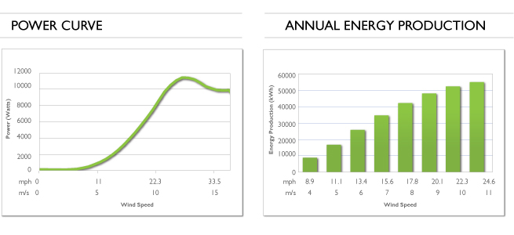
Figure 3.3.4.2

Bargey Excel
This wind turbine is designed to be automatic in hazardous weather conditions and can provide most of the energy that an average home uses. Listed cost ranges from $21,900-$27,000. Rated capacity is 10 kW. Startup wind speed is 7.5 mph. Rotor diameter is 22 ft. (6.7 m). The wind turbine can either be grid connected or connected for battery charging. Voltage output can be either VDC or VAC. VDC comes only in 48 V. VAC varies between 120 V or 240 V. The following figure is of the Bargey Excel.
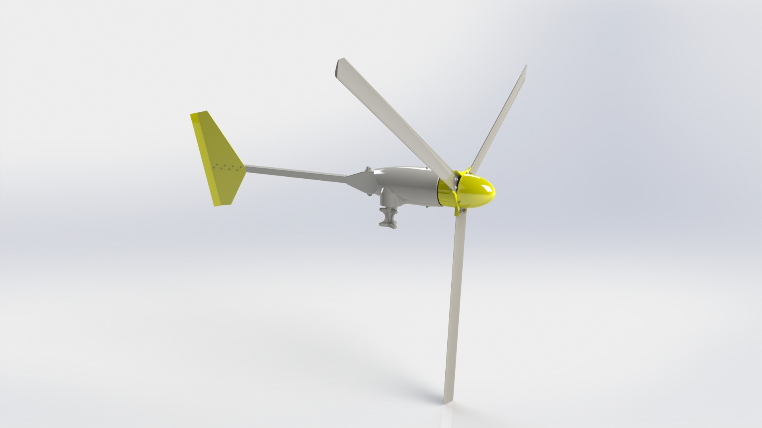
Figure 3.3.5.1

Design Comparison
After going over and reviewing the other popular small wind turbine designs, several design similarities became apparent. We will go through and elaborate on each design trend and compare it to the design parameters that we are aiming for. First is the wind turbine axis orientation or axis of rotation. All the small wind turbine designs implemented a horizontal axis orientation for their rotating blades. For those unfamiliar with this nomenclature, a horizontal axis wind turbine or HAWT is a wind turbine that has its rotor blades facing into a specific direction, hopefully the direction with the most wind speed and consistency. The following diagram is one of a traditional horizontal axis wind turbine.
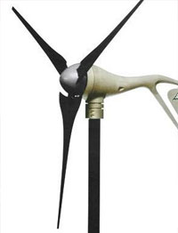
Figure 3.3.6.1
In contrast to the design of a horizontal axis wind turbine is the design of a vertical axis wind turbine or a VAWT. None of the popular wind turbine systems covered in this document made use of vertical axis wind turbine as will show in following figure.
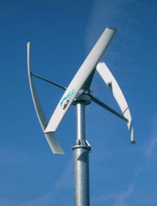
Figure 3.3.6.2

The primary reason that all the popular wind turbines covered probably implemented horizontal axis over a vertical axis was for the advantage of more potential power output. A major factor for the amount of power output possible for a wind turbine is the amount of wind captured by the rotating blades. The more surface area of the turbine blades the wind can come into contact with, the greater the power output and efficiency of the turbine. With a horizontal axis wind turbine, more wind can hit its blades as opposed to a vertical axis wind turbine. This fact is what all the other wind turbine designs are banking on. They’re aiming for the most power output possible versus cost. This is further evidenced by the power and annual energy models that are provided by their websites. However, a major drawback of horizontal axis wind turbines is their drop-in power output and efficiency when the wind is no longer passing through the specified direction that the horizontal axis is oriented to. Wind is volatile by nature and wind direction switches regularly so the occurrence of power output drops in horizontal axis wind turbines happens frequently. On contrary, vertical axis wind turbines do not possess this same weakness. The blades of vertical axis wind turbine are orientated fully around the exterior of the turbine. Wind passing by from any direction will still spin a vertical axis wind turbine. Albeit that the vertical axis wind turbine is more reliable because of the previously mentioned advantage, they are used less often due to their inherently lower power output. This lower power output is due in part to less surface area being hit by oncoming wind. As mentioned before none of the popular wind systems listed made use of vertical axis wind turbines because they’re focus was the most power output and efficiency possible and that realization is not possible with vertical axis wind turbine currently. However, the primary focus of our project is energy storage, reliability, cost, and space. Our wind turbine is not going to be used to power huge loads, but it does have to produce enough energy to power small loads continuously as well as store the rest of the power to a battery for later use. We also want our turbine to be as low as possible in cost both in monetary value and spatial value. With these goals in mind a horizontal axis wind turbine is the preferred choice for our application. Horizontal axis wind turbine produces more power than a vertical axis wind turbine, which is necessary to power all our loads and still have excess energy to store. In terms of space and cost, vertical axis wind turbines are slightly better, but it does not make up the gap in power production and efficiency.

The second design trend we noticed is the need for a control options for the horizontal axis wind turbines. As mentioned previously, horizontal axis wind turbines are most efficient when facing directly into oncoming wind but wind changes direction regularly. To keep a horizontal axis wind turbine facing towards the wind there must be additional control circuits and servo/motors added on to a wind turbine to turn the blades into the strongest wind. This is the case if active control is being used. However, some of the small wind turbines discussed above made use of passive control systems to rotate their turbines. Passive control is when wind power is used to rotate the turbine without the need for servos and added control circuits. This supplemental layer of complexity is not required with vertical axis wind turbine which can caught wind from any direction. Since one of goals is to reduce cost as much as possible but also produce as much power as well, it is imperative that we choose the horizontal axis wind turbine with a passive control system control, because additional control circuits and motors/servos would add on to cost significantly. It would also add more developmental time to our small wind turbine design in the form of buying more parts thus increasing delivery time and in the form of increased programming time for the logic required for the controls. Time is major constraint for our group as it will be discussed in constraints section of this document.

The third design trend that we notice was that all the small wind turbines came with generator already built. This answers an earlier question that was posed in the beginning of this document on whether or not wind turbines normally came with a gearbox and generator already integrated. For generators, the normal case is integration within the wind turbine case, but for gearboxes it can vary. For the wind turbines discussed some had a gearbox and others did not. It seems like it more common to have a gearbox though. We will work under assumption that our wind turbine will have a gearbox integrated unless proven otherwise.

The final design trend that is relative to our small wind turbine design is the interconnection of wind turbine to either a battery only or to the power grid with the option for battery connection as well. The wind turbines with the higher power output were the ones that offered the latter possibility of both grid connection and battery connection, while the wind turbines with the lower power outputs were battery connected only. With a power grid connection, a wind turbine could feed power back into the power grid thus providing incentives to the owner provided by the utility company. Although this advantage for a larger-scaled small wind turbine is warranted, the huge increase to the initial investment of one of these types of wind turbines is not cost effective in the short-term. It would take years for the returns on incentives and potential power savings to break even with the startup cost of larger-scaled small wind turbine. To meet our goals of low cost and supplemental energy use the former option of just battery connection only is what is needed for our project. The differences in interconnection will also affect the complexity of the wiring and power electronics used in the power system design for our project. This will further have elaborated in the power system design section.

Battery Technology
Since our focus requires a mini-wind turbine, the energy generation will be implemented on a smaller scale. Traditional wind turbines are large and harness wind energy that is sent to the grid. Our mini-wind turbine will generate energy in a localized area; therefore, this design will require energy storage using a battery. This section will go over some of the battery technologies that are readily available. It will also discuss which battery technology is best fit for this design.

To an average consumer, the battery technologies that come to mind today are probably alkaline, lead-acid, and lithium-ion— Alkaline being the most popular, because they have been around for decades and are pretty much available anywhere. Although that is the case, alkaline would not be a good fit for energy storage because they are classified as primary batteries. Primary batteries are essentially batteries that are disposable and cannot be recharged. Another classification of batteries, secondary batteries, which are better known as rechargeable batteries, can be recharged. Because this design will require a battery that stores and outputs energy, secondary batteries will be the right choice.

The general secondary battery types that exist today are lead acid, lithium-ion, and nickel-cadmium. There are many characteristics that these secondary batteries share. Table 3.5.1 shows some of these characteristics for each secondary battery type. Let us briefly define some of these characteristics:
- Specific energy: the energy per unit mass and is also referred to as energy density.
- Cycle life: the amount of charge/discharge cycles a battery can handle before its capacity falls under 80%.
- Charge time: the time required to recharge a battery.
- Cost: the value of the battery regarding money and materials.
These four characteristics should be enough to help determine which battery type is appropriate for this design, but all factors will be considered. Before this decision, some overview of these battery types is needed.

Lead Acid Batteries
Lead acid batteries have been around since 1859. This technology has had over one hundred years to develop, so it's clear why it is one of the most usable battery technologies to date. One reason it is still widely used is the fact that it has a low cost, per watt, while being a reliable source of power. The introduction of sealed lead acid (SLA) batteries in the 1970’s enabled lead acids to be placed in any orientation without the worry of chemical leaking. This new form of lead acid introduced a valve system that provided relief to high and rapid charging/discharging. Some of the most common SLA batteries today are valve regulated lead acid (VRLA) and absorbent glass mat (AGM). These two batteries are types of gel SLAs. Common SLA batteries suspend the electrolytes in a gel past, as do VRLA’s. AGM batteries suspend the electrolyte in a glass fiber mat. [1] Unlike the first lead acid batteries, sealed lead acid batteries were made to prevent excess gas from forming when the battery is charging. This is achieved through a valve system that releases any buildup of gas. This excess gas is caused from overcharging and can lead to the battery life depleting much faster than it should. Lead acid batteries are still very popular today and can be commonly used in applications such as automotive, motive power, and uninterrupted power supplies [1].

Lithium-ion Batteries
Lithium batteries didn’t start off with the lithium-ion chemistry. Instead, the first lithium battery used lithium metal as the anode, while lithium-ion uses graphite. Unfortunately, using lithium metal did not produce a stable battery [2]. Another problem was discovered when recharging these lithium metal batteries. It was seen that tiny particles, called dendrites, grew during cycling. It became a problem because these dendrites would grow into the separator of the battery and create a short. This would heat up the battery and cause permanent damage to the lithium metal. Since it was too risky to keep a lithium anode, different chemistries using lithium ions were developed—hence, the development of lithium-ion batteries.

Lithium-ion batteries are the fastest growing batteries in today's market. They have many advantages over other secondary batteries including high specific energy, high capacity, and a long cycle life. There are many chemistries that encompass lithium-ion batteries. One example of this is the chemistry of lithium nickel manganese cobalt oxide, also known as NMC. This battery uses a combination of nickel, manganese, and cobalt as its cathode. The sweet spot here is the combination of nickel and manganese. Nickel is known for producing high specific energy, but its stability is poor. Manganese offers low specific energy, but its structure allows for a low internal resistance [3]. Combining these two elements create a stable chemistry that can deliver a high specific energy. This type of Li-ion is commonly found in electric powertrains and power tools.

Another common Li-ion battery chemistry is lithium iron phosphate. Li-phosphate, for short, provides good performance with a low internal resistance. It can put out high currents and has a long cycle life with a reputable safety tolerance. Although it can boast these traits, Li-phosphate does have its own drawbacks. For one, it has a lower voltage per cell compared to standard cobalt blend batteries; therefore, its specific energy suffers. Compared to other Li-ion batteries, Li-phosphate also has a high self-discharge rate. Despite these issues, Li-phosphate is commonly used in applications that require high load currents and tolerance.

Nickel Batteries
Nickel batteries mostly provide an alternative to lead acid batteries. The first chemistry, nickel-cadmium, was introduced just before the coming on the 1900’s. It was the only other secondary battery aside from lead acid. Today, nickel-cadmium, NiCd for short, can provide a long cycle life, good load and low temperature performance, long shelf life, and an economic cost per cycle. It lacks in its specific energy and suffers from a memory effect. This memory effect ‘remembers’ a routinely charge and will not go above this rating. NiCd contains cadmium, which is a poisonous metal, so disposal is difficult for this chemistry.

Another nickel-based chemistry is nickel metal hydride, or NiMH. This chemistry can be thought of as the environmentally friendly replacement of NiCd. The chemistry can be commonly found in AA and AAA size batteries. It has an increased capacity from NiCd and does not suffer the memory issue that was previously discussed. Although it is any improvement from NiCd, it still has its own issues. One drawback is the short cycle life, and it also has a very high discharge rate. Instead of being able to hold a charge for years, this chemistry may lose its energy within a matter of weeks. Though it is rechargeable, this is not an idle case for most consumers.

An interesting nickel chemistry to mention would be nickel hydrogen, also known as NiH batteries. These batteries can perform as good as the previously two mentioned, but its setup is unique because it uses hydrogen gas as the anode of the battery. This chemistry is very popular in aerospace applications such as satellites. It can boast a high gravimetric energy density and high cycle life of about 50,000 cycles. Some disadvantages of this battery include low volumetric energy density, high self-discharge and high cost due to materials [4].

Deep Cycle vs. Shallow Cycle
One important factor, that has not been discussed yet, should be brought up now. That factor is whether this is a deep cycle or shallow cycle battery. A battery’s cycle can be split into its discharge and recharge cycles. To have a deep cycle means that the battery was made to provide energy for a long period of time. The important idea to note is that deep cycle batteries will go well below 50% of discharge before having to be recharged. Shallow cycle batteries are made to provide a lot of energy in a small amount of time.

An example of a deep cycle battery would be golf cart batteries, as seen below in the figure.
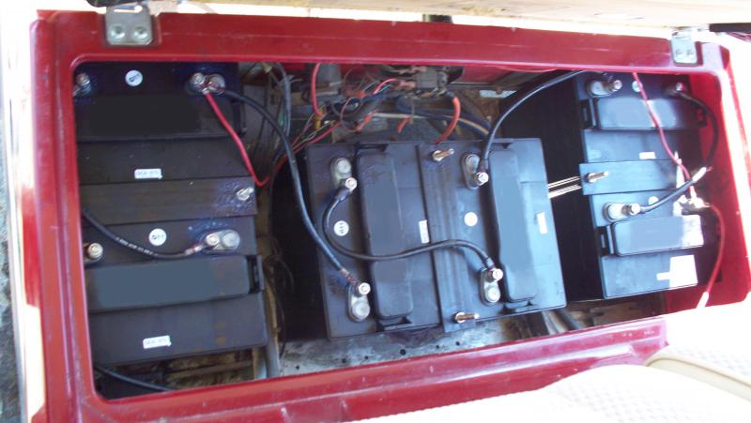
Figure 3.4.4.1 Golf cart batteries in compartment

To fulfill the uses of a golf cart, the batteries need the ability to be charged and used for a long period of time before having to be charged again. Let’s say the golf cart is not in use, and then the batteries should be able to hold as much charge as possible in case the cart needs to be used again. Another example would be the battery in a smartphone. As everyone knows, smartphones are typically in use for most of the day. The battery has a slow, continuous drain depending on how much it is in use. An example of smartphone batteries can be seen in the next figure. As seen, deep cycle batteries are used in many different applications, typically, because there are many things in today's world that need to be powered on the go.

A perfect example of a shallow cycle batteries is a car battery. As mentioned before, shallow cycle batteries provide a lot of energy in a small amount of time. A car battery is a perfect example because these are used to start a car’s engine. These batteries are called SLI batteries, where SLI stands for starting, lighting, and ignition. Most lead-acid batteries can be considered as shallow cycled, unless specified otherwise. The way so much energy is generated so quickly is due to the plates inside the lead-acid battery. The plates are very thin, and there a typically a lot of them. This allows for more surface area to produce energy. Having this setup does not allow the battery to be discharged too low. Deep cycle batteries are the direct opposite. They contain thick plates that are few in quantity. This allows for a slower discharge and the ability to discharge 50-80% of the battery’s capacity.

Battery Choice
To recap, this project design will need a battery that is able to discharge and recharge. It will recharge when it is receiving energy from the wind turbine’s generator. Energy will also be discharged when appliances need to draw power from it. From the last section, it is clear to see that this battery will have to be a deep cycle battery. Considering the battery technology today, a great choice would be lithium ion chemistry. Compared to when they first came out onto the market, prices for Li-ion are dropping at a considerable rate. They are slowly becoming the go to chemistries that an average consumer can use. Although this is the case, lithium ion batteries are still expensive up front. Especially if a deep cycle version is needed. Because of this, a lead-acid chemistry would be the best bet for this design. Lead-acid is already implemented all around the renewable energy world. Since the technology has been around for so long, costs for these batteries are more manageable up front. This upfront cost is important because this design will only be implemented over the next couple of months. In the long run, the lead-acid versus lithium ion argument shifts towards lithium ion, but this project will be satisfied with lead-acid.

Confidence in lead-acid technology can be trusted since it is already used for renewable energy purposes. Cost can be cut down here to leave more room for other factors of this project that may be a bit pricier. Looking at the table below, it may show that lead acid lacks in comparison to the others in terms of specific energy and cycle life. If this project was fully implemented for the long run, then lithium ion would be the best bet. Since this will only need to run during the next few months, SLA/AGM would do the trick. It should have enough capacity to power the design, and enough cycles to run tests.

One benefit of using SLA instead of a flooded (wet) lead acid is the fact that it requires less maintenance. Flooded lead acid batteries contain liquid electrolyte that requires frequent maintenance. The general way batteries work is through chemical reactions between the metal and electrolytes. In flooded lead acid batteries, each reaction reduces the battery’s capacity. This happens when the by product, lead-sulfate, builds up along the metal plates and causes damage. Since this happens, maintenance is important to ensure that the batteries are ready to use when needed. Having a sealed lead acid, absorbed glass mat prevents some issues that flooded batteries have. The glass mat gets rid of the liquid electrolyte and places it exactly where it needs to be. Not having the liquid electrolyte also eliminated the buildup of residue on the plates. SLA/AGM batteries are also sturdier than flooded lead acids. Using these batteries in the design will ensure that energy storage needs will be fulfilled while keeping the cost low.

Brand | Chemistry | Type | Voltage (V) | Capacity (Ah) | Cost (USD)
Duracell | SLA AGM | Shallow | 12 | 5 | 32.99
Duracell | SLA AGM | Shallow | 12 | 18 | 79.99
Might Max | SLA AGM | Deep | 12 | 35 | 65.00
Duracell | SLA AGM | Deep | 12 | 35 | 99.99
Renogy | SLA AGM | Deep | 12 | 100 | 199.99
Dakota Lithium | Li-ion | Deep | 12 | 10 | 99.00
Mighty Max | Li-ion | Deep | 12 | 24 | 155.00
Battle Born Batteries | Li-ion | Deep | 12 | 100 | 949.00

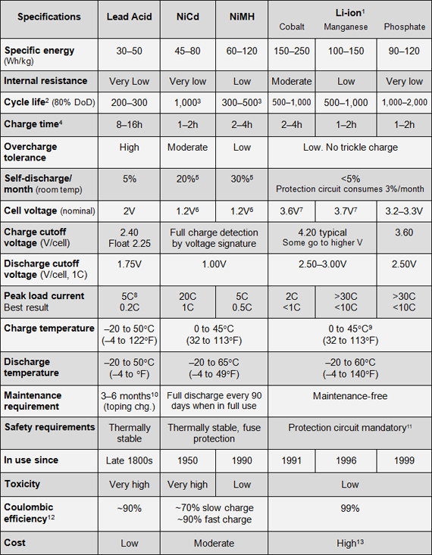
Table 3.4.5.1: Characteristics of commonly used secondary batteries

Sensors
For this project to be successful, the use of sensors will be a must. These sensors will provide the necessary data for testing the design and will also provide a way for the microcontroller to collect the necessary data that will be displayed graphically on our web server. For this wind turbine design, the sensors will be measuring wind speed, wind direction, energy output, and temperature. It will be important to measure wind speed and direction to ensure that the wind turbine is producing as much energy as possible. Measuring energy output could give data on how efficient the design is and how much energy is being stored in the batteries. An external temperature sensor will be used to monitor the temperature outside. Knowing the temperature outside will just be an extra amenity and will serve as more data to be pushed to the microcontroller.

Wind Speed Sensor
Wind turbines can be oxymoronic. They produce power from the wind, and from a theoretical standpoint, the faster the wind, the more energy produced. However, as seen above in the graphs for existing wind turbines, there is a diminishing returns effect as the speed of the wind gets faster. So, at some point it would be ideal to stop the blades from turning to both account for the diminishing returns effect, but also the overall integrity and lifespan of the blades and rotor. To do this, we would have to use a combination of software and hardware. From the hardware side, we would need to use an air speed sensor. Below is an example of an air speed sensor:
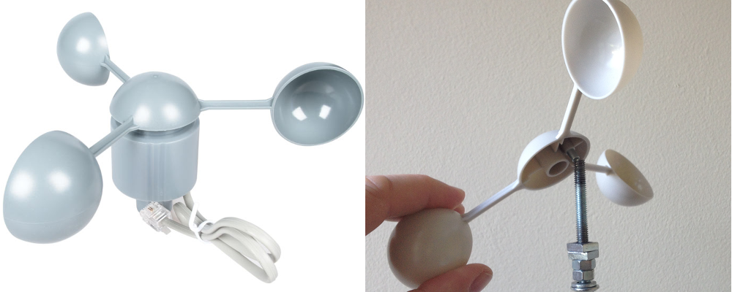
Figure 3.5.1.1 An Anemometer (wind speed sensor)
A wind speed sensor consists of three spoon-like cups attached to a rotating assembly. The cups catch the air and cause it to spin. Underneath the top part of the sensor is a reed switch, pictured below.
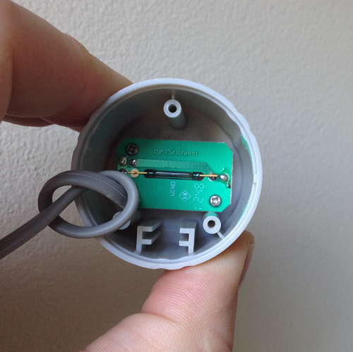
Figure 3.5.1.2: Reed Switch inside anemometer

Further, inside the cap on the top part of the sensor, is a magnet. The way reed switches work is that when a magnetic field is applied to them, they allow a current to be passed through and when there is no magnetic field, they act as an open switch. This makes calculating wind speed easy. The magnet will trigger a signal on the reed switch for twice for every full rotation of the cups. With this information, you can calculate the speed by measuring the diameter of the base that the reed switch resides in (pictured above) and then calculating the time in between reed switch signals and using the speed = distance / time formula to calculate the wind speed.

Signal wise, the wind speed sensor works by causing an interrupt every time the magnet passes over the reed switch under the cap. The microcontroller counts the number of interrupts that occurred in between readings and multiplies by approximately 1.5 mph, and then divides by the number of milliseconds that occurred in between readings. This will give a value in miles per hour that could then be converted to other units of measurement if needed.

There are also digital sensors out there that can be used to calculate wind speed. One of the main drawbacks of using this instead of the analog wind speed sensor shown above is that there is no way for this device to communicate with a microcontroller which is necessary for our purposes. Because of this, we will not be using a digital anemometer, as it doesn’t meet the requirements of our project. Therefore, due to its small size and ability to communicate with a microcontroller with ease, the best suited air speed sensor for our project would be the reed-switch variant pictured above.

Wind Direction Sensor
Due to the unpredictability of wind, and the direction of it, it would behoove of us to include a wind direction sensor to our project. Wind direction designs have been around for ages. They could often be seen on old farm buildings, and the current sensors are extremely reminiscent of that design. Thus, the most efficient way to do this is to use a wind vane. An example of a wind vane is pictured below in figure 3.5.2.1.
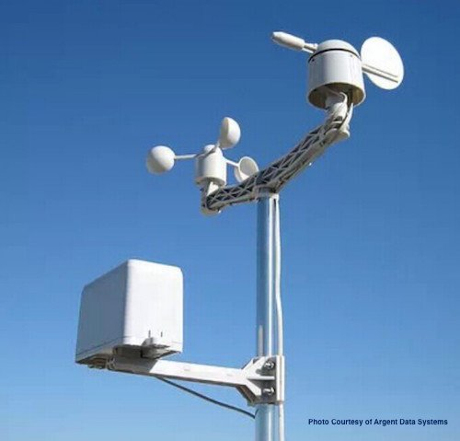
Figure 3.5.2.1 Weather Rack - Anemometer / Wind Vane / Rain Bucket
The wind direction sensor, or wind vane, works very similarly to the wind speed sensor. It uses 8 reed switches coupled with different resistors, aligned in the 8 cardinal directions. The vane on top contains a magnet and when this magnet meets the reed switch, the circuit is completed, and a voltage is produced. This analog signal is then sent to an analog to digital converter that will convert the voltage received to a digital value via program code that can be discerned by a human. Since this uses an analog to digital converter, we will have to add one to our project. Figure 3.5.2.2 below shows the reed switches inside the wind vane.
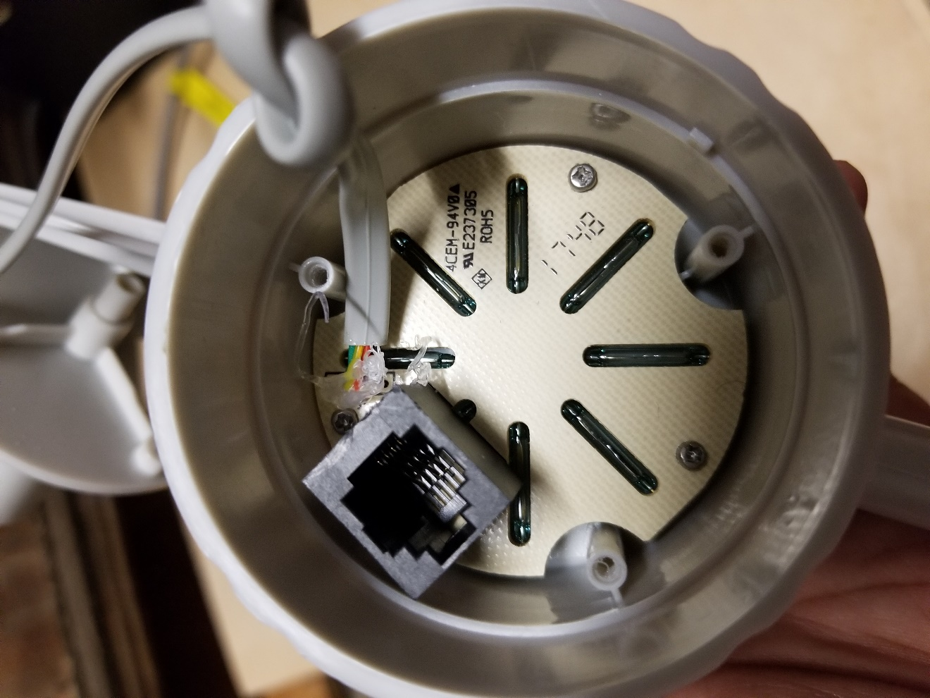
Figure 3.5.2.2 Inside of Wind Direction sensor showing the 8 reed switches

Figure 3.5.2.1 shows a combination of a wind direction and wind speed sensor. This would suite our needs for our project. However, we would like to avoid having to mount physical sensors if necessary. Since the wind turbine that we are using has one of these attached to it, we determined that we could use a magnetometer to determine the wind direction by attaching the magnetometer to the direction indicator on the turbine and then passing that data to the microcontroller.

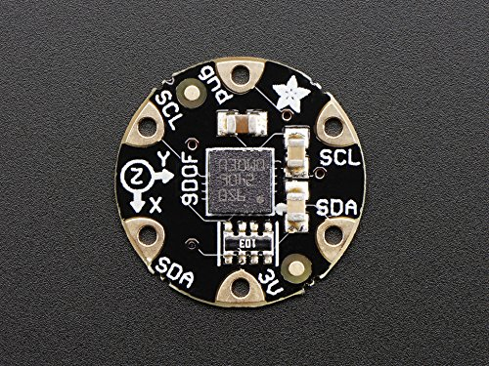
Figure 3.5.2.3: FLORA 9-DOF Accelerometer/Gyroscope/Magnetometer Breakout
Figure 3.5.2.3 below shows an example of a magnetometer. It is about the size of a quarter. However, upon further evaluation after obtaining the sensor, we determined that it would not be easy to implement onto our turbine as we originally thought due to having to have a wire that would be free to rotate 360 degrees. For this reason, we decided to go with the analog wind vane shown in figure 3.5.2.1.

Rain Sensor
Figure 3.5.2.1 shows a combination of 3 sensors. We have already discussed two of them, the wind direction sensor and the wind speed sensor, however there is a third sensor in the figure. This is a rain sensor. Figure 3.5.3.1 below shows the inside of the rain sensor.

The way the rain sensor works, is that it has two contacts on either side of the bucket. Inside the bucket is a teeter-totter like device as shown above that collects rain water from the hole in the top of the bucket. As each side of the teeter-totter fills up, it dumps the water out of the bottom through holes on either side of the bucket. Each one side of the teeter-totter holds approximately 0.01 inches of rain and each time it clicks the contact, it sends an interrupt to the microcontroller, which keeps a record of the number of interrupts and then takes that information and determines the amount of rain that occurred in between readings.

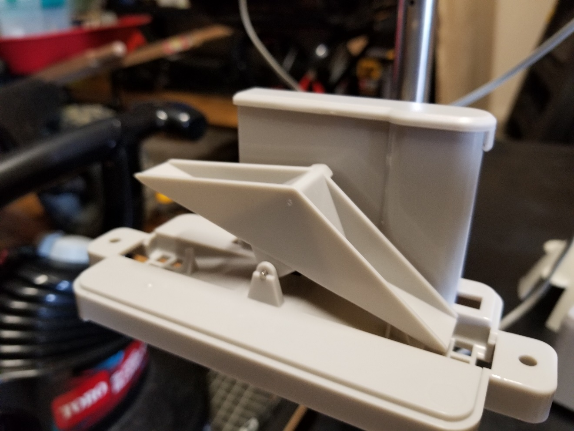
Figure 3.5.3.1 Inside of Rain Bucket sensor

Noise Sensor
While researching existing wind turbine designs, we encountered some turbines that utilized a noise sensor because the noise generated by the turbine was excessive. The idea behind the noise sensor is that if the turbine reached a threshold level of noise, it would be effectively ‘turned off’ until the noise level died down and then it would start back up again.

It turns out, that an effective noise sensor could just be a standard microphone that connects to a microcontroller that would then capture the decibel levels from the microphone and based on the data, turn the wind turbine on or off.

Adafruit makes a noise sensor that can be used on a microcontroller such as an Arduino or Raspberry Pie. It’s small, but since it has an adjustable gain, this can be overlooked. Having the adjustable gain would allow us to fine tune the microphone to only pick up the sounds we need to check versus the ambient sounds that don’t contribute to the sound of the turbine.

However, upon further discussion and research, we concluded that since our wind turbine was a mini-turbine, there was no need for this noise sensor, as the decibel levels produced by the turbine would be minimal.

Temperature sensor
In addition to airspeed, there are other variables that we want to have sensors for, temperature being one of them. There are several reasons as to why we should implement a temperature sensor into our design. However, two reasons stand out: being able to tell what the temperature is and if it is too low, turning off the generator to prolong its life and reduce unneeded wear and tear as well as to monitor conditions for the battery we are going to be using. At the time we were researching these temperature sensors, we were not sure as to which microcontroller we would be using. Therefore, we started by looking at sensors that could be used directly with the Raspberry Pi. The sensor that we found was the Raspberry Pi Sense Hat. It sat directly on top of the Pi, which we didn’t think would be an issue. However, there were a lot of reviews that said it had overheating problems and would also incorrectly calculate the temperature of the CPU on the Pi. The reviews strongly suggested to utilize a heat sink to help alleviate some of the heating issues.

We found a case for the Pi that included heat sinks and would alleviate the mis-readings that the reviews mentioned occurred frequently. However, we quickly realized that we need to be researching sensors that will work with any microcontroller, so that we do not limit ourselves when having to choose one to work with.

Table 3.5.5.1 below shows different temperature sensors we considered.
Sensor | Manufacturer | Mountable | Humidity | Price
DHT22 | Adafruit | No | Yes | 9.95
TMP36 | Adafruit | No | No | 1.50
AM2320 | Adafruit | No | Yes | 3.95
AM2315 | Adafruit | Yes | Yes | 24.95

Table 3.5.5.1
The sensor we decided to go with is the AM2315. Although this sensor is the most expensive in terms of price, it is the only sensor that is mountable. Because the sensor is mountable, it will be easier to install onto our tower and it will also be easier to create a cover for. Also, it integrates well with the other sensors we will be using.

The AM2315 utilizes an I2C bus to communicate with the microcontroller. This means that it receives its power from the microcontroller, which also make implementing it easier. The sensor is also very low power, only pulling 500 micro amps when taking a measurement, which aligns with our goals of making our project energy efficient and to produce more energy than we consume.

The AM2315 is pictured below in figure 3.5.5.1. While it does have a robust design, which makes it ideal for outdoor use, it is not waterproof, which means we will have to encase it in a protective material so that it does not get water damage.
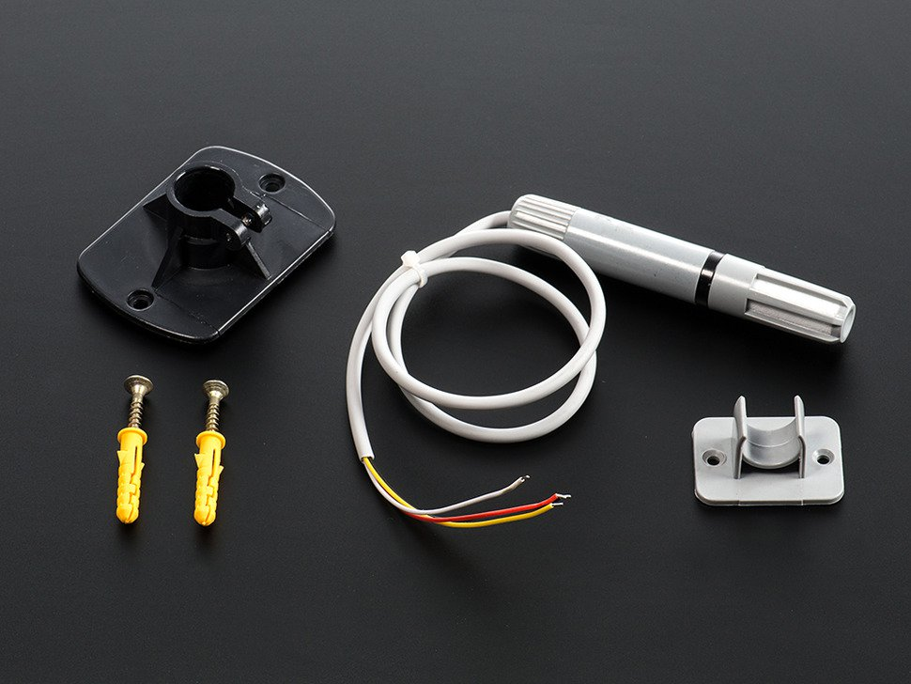
Figure 3.5.5.1 AM2315 Temperature and humidity sensor. Reprinted with permission
So, we would have to create some sort of waterproof shield enclose the AM2315 enough that it could still get an accurate reading but would also not get any water damage. The biggest issue with this method though, is that it will make the temperature readings inaccurate. This is not ideal for us because we want there to be little to no variance in our weather data measurements. We found several designs online where people have used various methods to create this weather shield, one of which is pictured below in figure 3.5.4.3
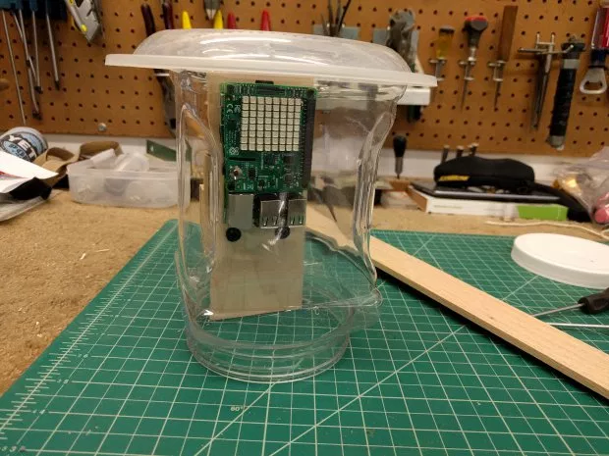
Figure 3.5.5.2: Example of a water shield for the Pi with Sense Hat

In figure 3.5.5.3, the designer used some plywood and some plastic containers to create the shield. Then, to help with the temperature readings, he drilled holes into the top in bottom. Doing this helps equalize the temperature between the outside air and the air inside the plastic container. The result is a shield that is moreover waterproof while achieving a temperature reading that is still relatively accurate.

The issue with this, is that we only need to enclose our temperature sensor, as our PCB and other electronics will be enclosed inside the base of our wind turbine tower. Upon further research, we found a 3D printable schematic that was made specifically for the AM2315 and is pictured below in figure 3.5.5.4.

While all the sensors we researched interface well with most microcontrollers, we wanted to investigate other alternatives for measuring the temperature inside the electronics enclosure. We looked into thermistors for this purpose. However, due to time constraints, we did not implement them.

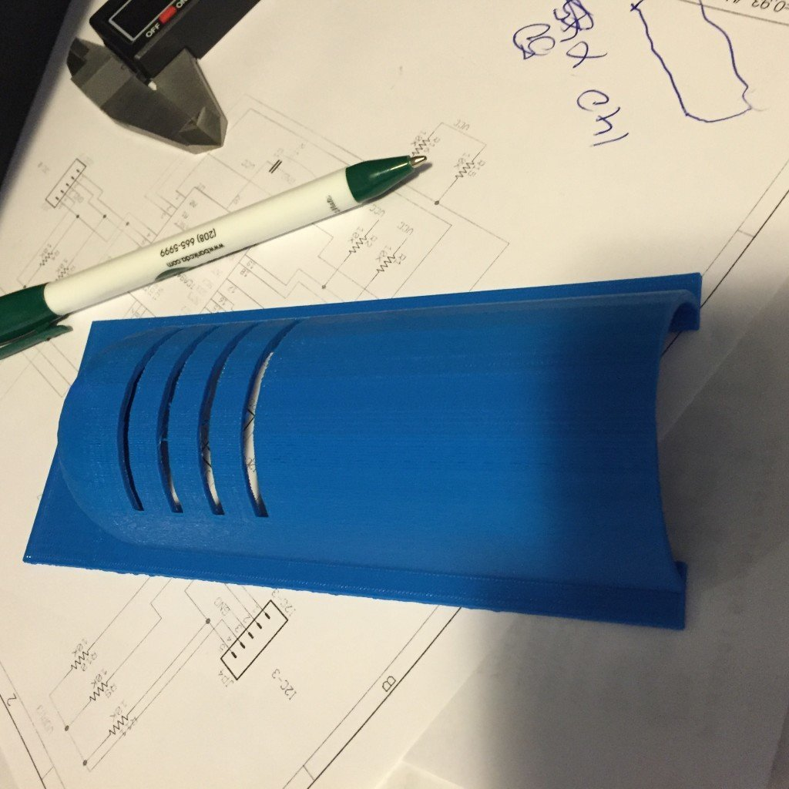
Figure 3.5.5.3 Weather Shield for AM2315. Reprinted with permission. Not utilized in final build, though space and dimensions for it were accounted for.

Energy Sensor
Since the main purpose of our project is to create a system that can produce energy on a tighter budget, one other sensor we would need to use would be an energy output sensor. Now, moreover, this is just a glorified way of saying a multimeter, however, said device must be a compatible peripheral of the microcontroller we are using. This is so we can monitor the amount of energy being produced. This is essential, because we are going to be displaying this value on our display. It has a built in 0.1 Ohm resistor which makes it capable of measuring a current up to 3.2 A. Since we are using a 12v battery, and only using the battery to power things that don’t require a lot of power, this 3.2A limitation is adequate for our purposes. The INA219 is pictured below in figure 3.5.6.1.
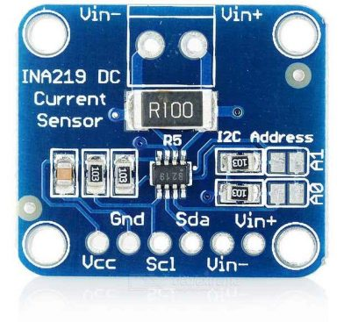
Figure 3.5.6.1: INA219 Current and Voltage Sensor

Charge Controller Data
The wind turbine that we will be using will come with a charge controller included. The charge controller can provide us with valuable information as shown below. Unfortunately, the data shown below in table 3.5.7.1 is only available on MPPT charge controllers, and the charge controller that comes with our wind turbine is a PWM charge controller. Regardless, the main purpose of the charge controller for our purposes is to down convert the high output voltage of the turbine, down to 12V. Subsequently, we will also make our own step-down voltage converter because the MCUs we are researching all have a power intake of 5V.

We did a lot of searching to try and locate a wind turbine charge controller that would provide at least some of the information listed in the table below, but we were unable to find one. Pretty much all the charge controllers that can provide this data are exclusively for solar use, as they have different integrated circuits that prevent them from being able to be used with wind turbines. However, the charge controller that does come with our wind turbine does provide at least some data—it has a battery status indicator which turns on when it is connected to a battery, a charging light that turns on when the battery is being charged and a brake light that turns on when the battery is fully charged. While this is not all the data we would like to have, it is adequate for our project.

Table 3.5.7.1
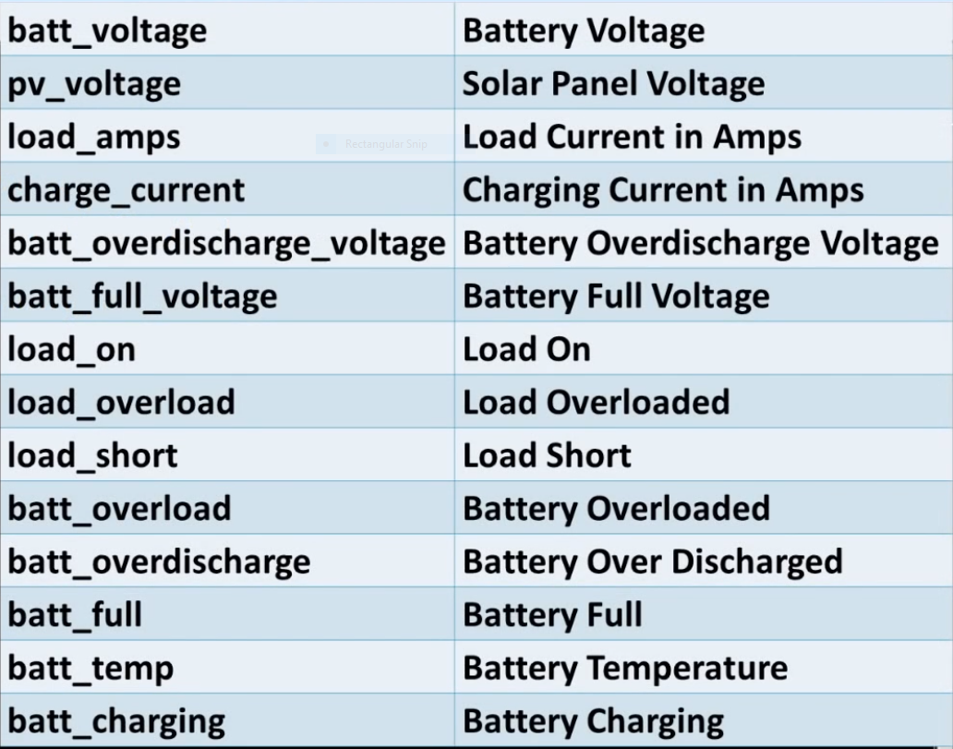

LCD Display
Since we will be generating power with our wind turbine, and we have these sensors to measure different aspects of environmental variables, it makes sense to have a display that displays the relevant information. In addition to displaying the readings of the various sensors our wind turbine will have, utilizing a display will allow us to show alerts for various conditions and how to best proceed when those conditions arise.

When choosing a display, one of the first aspects that would need to be looked at is the use of the display. The data that we want to display is not going to be persistent—that is, we want to display at a first level very basic information but then be able to expand that information into more detail on demand. For this reason, a standard display would not be ideal because we would have to implement a mouse and keyboard for the display. While in most cases this would not be a deal breaker, one thing we must consider is the distance of the display from our MCU. Since ideally the display would be inside, it would not be practical to have a mouse and keyboard be wired up that distance from inside, to the outside where the MCU and PCB is located. Thus, we will utilize a touch display.

A touch display will allow us to display the data in the way that we want. In addition, it only requires a single HDMI cable and a single USB cable. The specifications of these cables are discussed in section __. This will allow us to have the display inside and not have the extra burden of protecting it from the weather elements outside, not to mention a display outside doesn’t amount to much when that is information that a homeowner would like to be able to see without having to go outside to the wind turbine to read the data.

Sensor Summary
Given all the data that we will have access to, and with the arrangement of sensors we will deploy alongside our wind turbine, we would have enough data to use this data for describing the climate conditions on a more widespread scale. Since one of our goals with this project is to make this design cost-effective, a byproduct of that would be that more people would be able to access it from a consumer standpoint. With that in mind, it is general knowledge that the more people that have your device, the more data about said device you receive.

So then ideally, a lot of consumers would have this design and would be collecting data as it relates to airspeed, wind direction, temperature, humidity, and energy generation. All this data would be posted to the web and could then be used to draw more accurate conclusions about the weather in certain areas of the world regarding those factors and could aide researchers and other professional entities in better catering to the population in those areas regarding how the weather impacts them specifically.

Sensor Changes in Senior Design II
While the above research has been added to, bringing it up to speed with the extra research we did in SDII, we felt it necessary to condense that information into a section where we talk about difficulties with our sensors and ultimately which sensors we used in our project.

So, for sensors that we did not use, we did not use the magnetometer, nor the INA219. As mentioned in section 3.5.2, we ran into problems in how to design our wind turbine tower to accommodate the magnetometer. This inability to come up with a sound proof design that wouldn’t require a lot of further design changes led to the axing of that sensor from our project. Secondly, the INA219 sensor, namely the current sensing IC within it was not used primarily because of difficulties integrating it into our circuits. Since we did not want to use the break out board, which is what the INA219 is, we attempted to integrate it into our PCB schematic but fell short of implementing it successfully. Additionally, the current being passed through this sensor, given our USB charging circuit and all our electronics would surpass the 3.2 A threshold with this sensor design. While this is easy to overcome, we opted instead to ax the sensor from our project. And, we will not be measuring internal temperatures due to similar circumstances.

For wind speed, we went with the wind speed sensor mentioned in section 3.5.1 and pictured in figure 3.5.2.1. For wind direction, we went with the wind vane pictured and mentioned in section 3.5.2. For rain, we went with the rain sensor pictured in figure 3.5.2.1 and mentioned in 3.5.3. For temperature, we went with the AM2315 as discussed in 3.5.5. For energy, we utilized the calculated wind speed coupled with the power curve for our wind turbine to estimate the amount of power being produced.

Lastly, we opted to not use an LCD display for our project, but rather use a combination of a website and iPad to show the data. The website will be discussed in detail in a later section.

Microcontrollers
Microcontrollers are one of the largest aspects of this project. These pieces of silicon will allow us to monitor our sensors and perform different actions based on the readings. Some of these microcontrollers can run an operating system and allows for creation of a server to send data over the network via various methods such as Bluetooth, Wi-Fi, or Ethernet. Most microcontrollers have very low power requirements and

MSP430
The MSP430 from Texas Instruments are a line of microcontroller units with varied specifications. Most of the MSP430 MCUs use a 16-bit processor running between 16 to 25MHz. The MSP430X uses a 20-bit processor instead. With this 16-bit processor limitation, the MSP430 can only address up to 64KB whereas the MSP430X can address up to 1MB. The MSP430 MCU can contain up to 64KB of RAM with up to 512KB of flash storage memory. External storage can be used because it contains a DMA controller; it is difficult to do because it lacks a DMA output strobe.
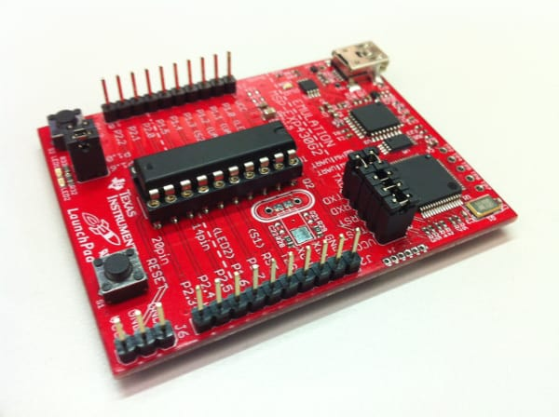
Figure 3.6.1.1: MSP430 Launchpad with a MSP430G2553 processor
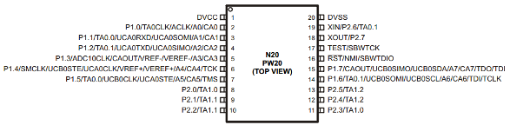
Figure 3.6.1.2: MSP430G2553 pinout diagram

The MSP430 can have up to eight ports that are 8-bits wide and has eight associated I/O (Input/Output) pins with most of them functioning as General Purpose I/O (GPIO) pins. Only the pins in Ports P1 and P2 support interrupts. Each I/O pin has configurable pull-up/pull-down resistors and each port has an associated group of registers used to control its individual pins. The MSP430G2553 only supports up to two ports. The MSP430 can communicate through UART, I2C, and SPI.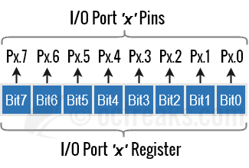
Figure 3.6.1.3 - MSP430 Port Grouping
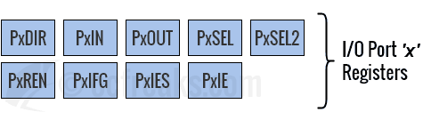
Figure 3.6.1.4: MSP430 Register Mapping

The MSP430 specifies its VCC at 3.3V. Pins are marked high and low via how much voltage is running through them. High is marked at VCC + 0.3V and low is marked at VCC - 0.3V, but it is not recommended to pass VCC as this may damage the board. The MSP430 uses a Schmitt-Trigger at the input of each pin to determine whether the voltage represents a logical high/low. By default, the MSP430 clears all registers to 0, therefore all pins are generally configured as inputs with high impedance where the pins draw almost no current and avoid disturbing the circuit.

All MSP430 devices have a JTAG interface. This can either be done with Spy Bi-Wire or using a 4-wire JTAG with a 14-pin header depending on the model of the MSP430.
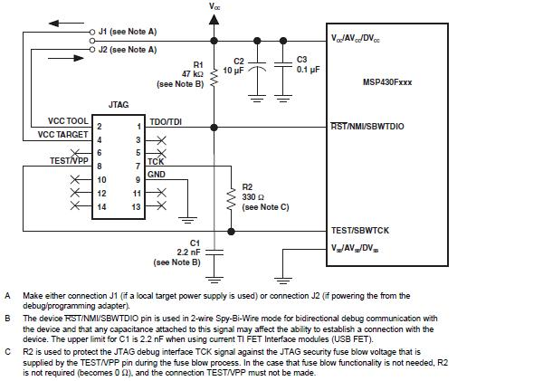
Figure 3.6.1.5: MSP430 JTAG Diagram

The MSP430 primarily uses Code Composer Studio (CCS) for software development. This piece of software allows for software based JTAGing on any MSP430 device and allows for code editing, code building, and debugging programs on the MSP430. The primary languages allowed for code editing in CCS is either embedded C or embedded C++. These are supersets of their respective languages as they do not contain most of the standard functions and libraries that are used in most other pieces of software. Embedded C++ does allow one to make use of classes, but you cannot use templates. The MSP430 does not handle allocating dynamic memory very well as malloc and new because this function/operator will fragment the heap.

MSP432
The MSP432 line of microprocessors is like the MSP430 line but have a few fundamental differences. While the MSP430 uses a 16-bit processor and MSP430X uses a 20-bit processor, the MSP432 uses a 32-bit ARM Cortex-M4F processor that supports up to 4GB of memory address space. The MSP432 also supports floating point natively as it has a 32-bit FPU. The amount of RAM on the MSP432 ranges between 64KB to 256KB of SRAM and depending on the model, the amount of flash storage ranges between 256KB to 2MB.

Most MSP432s have 40 pins for peripherals. The MSP432 can also support a display through the SPI interface at 320x240 pixel resolution. Optionally, a CC3100—an integrated ARM processor with a Wi-Fi adapter, can be attached to the MSP432. This would allow the MSP432 to connect to a network to transfer data and act as a server/client. The MSP432E401Y is an MSP432 with integrated Ethernet with 80-pins for peripherals which would allow for direct connections to a network. The CPU’s clock speed is increased to 120MHz, 1MB of flash storage, and 256KB of SRAM.

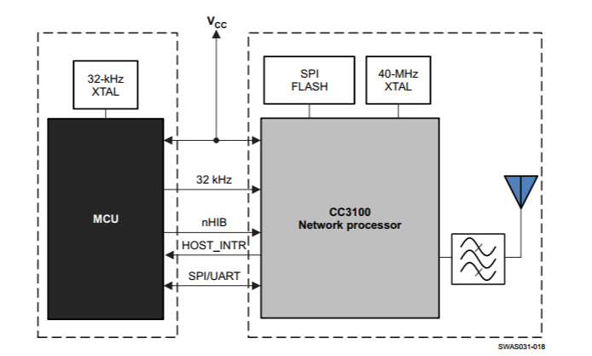Figure 3.6.2.1 - Block diagram of CC3100. (Reprinted from TI with permission)

Kinetis K66
The Kinetis K66 is a microcontroller created by NXP. It features a 32-bit ARM Cortex M4F processor with a native FPU. The processor runs at a clock speed of 180MHz and features up to 2MB of flash storage and 256KB of SRAM. This microcontroller features 5 UART modules, 4 I2C modules, and 3 SPI modules and also features a number of GPIO pins and touch sensor interface (TSI). This microcontroller also features dual USB ports up to 480Mbps (USB 2.0) and features a 10/100 Fast Ethernet port. This chip also has a DSP and supports audio processing and audio input/output. This chip can come in both the BGA (Ball Grid Array) and LQFP (Low-profile Quad Flat Package) form factors.
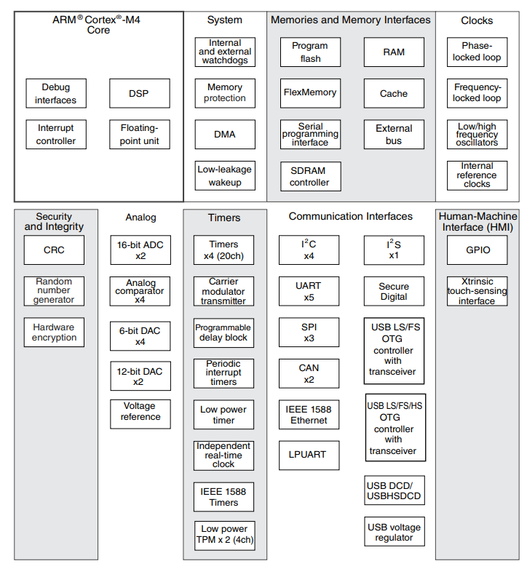
Figure 3.6.3.1 - K66 block diagram

PIC Series
The PIC Series are a set of microcontrollers from Microchip. The main series of chips include the PIC18, the PIC24, and PIC32. The PIC18 microcontroller was created in 2000 after the PIC17 series. The PIC18 features a 16-bit processor but only has a 12-bit RAM space. Instead of using assembly for programming as with many microcontrollers at the time, the primary development language switched to C instead. The PIC24 was released in 2004 and was Microchip’s first inherently 16-bit microcontrollers. All its registers are 16-bits wide making its memory address space 64 KB. Instructions are 24-bits wide to allow for modifying the Instruction ROM which is 24-bits wide. Software access to the ROM can access the first 16-bits in one word whereas the next 8-bits are accessed in another word where the top of the bits are zeroed out.
The PIC32 series was released in 2007. These microcontrollers are based on the MIPS32 M4K Core where the first 18 models in the series are pin-to-pin compatible and share the same peripheral set as the PIC24. The MIPS32 M4K is a 32-bit processor running as low as 25MHz and can run as fast as 252MHz. The amount of RAM will vary between 512KB to 32MB of DDR2 DRAM as with the PIC32MZ DA. The PIC32MZ DA also features an integrated GPU. Most models will have up to 2MB of flash storage. The PIC32 models feature CAN, USB OTG, and most importantly, Ethernet. There is full JTAG support on every model.

Raspberry Pi
Raspberry Pi’s are a series of small single-board computers. They do not contain keyboards, mice, or cases. All the models feature a Broadcom system on a chip (SoC) with an ARM CPU and an integrated GPU. The ARM processor’s speed ranges from 700MHz to 1.4GHz depending on the model. The storage medium for the Raspberry Pi are SD cards and depending on the model, full size SD cards or microSD cards. All models contain an HDMI port for video output, a 3.5mm jack for audio output, and USB ports. The B-models have an Ethernet port while the Pi 3 and Pi Zero W have onboard 802.11n Wi-Fi and Bluetooth. All models contain GPIO pins that support protocols such as I2C. Power requirements are low on the Pi only requiring 5V at 2.5A to fully function. All models can run a lightweight Linux distro where the Pi Foundation recommends the use of Raspbian, a Debian-based Linux distro, but one can install any OS that supports an ARM processor such as Arch Linux ARM, Ubuntu, Windows 10 IoT Core, LibreElec, etc.
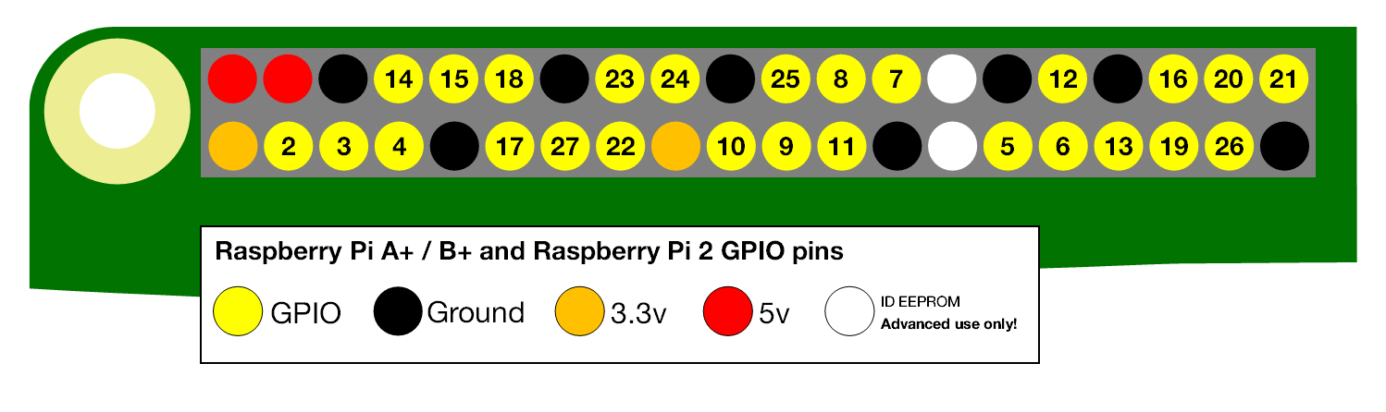Figure 3.6.5.1 - Raspberry Pi GPIO pinout

For our purposes, we would use the Pi 3 model for our GPIO needs as it has 1GB of RAM, the 1.4GHz processor, and has the full count of GPIO pins that will be needed for our sensors. This model has 26 GPIO pins with both 5V and 3.3V rails. Pins are marked as high when the voltage is at 3.3V and low at 0V. The devices connected to the pins can communicate using I2C, SPI, or UART. JTAGing on the Raspberry Pi involves using specific GPIO pins. The JTAG uses the TDI, TDO, TMS, TCK, TRST, and RTCK pins.

Since the Raspberry Pi can support multiple Operating Systems (mostly Linux-based), a number of different programming languages and libraries exist for controlling the GPIO pins onboard. These languages include C, C++, C#, Python, Java, JavaScript, and so forth with their libraries such as WiringPi (C, C++), WiringPi.NET (C#), RPi.GPIO (Python), Pi4J (Java), and Node.js (JavaScript). Most of the libraries allow for full access of the GPIO pins and allow for UART, I2C, or SPI communication.

A10-OLinuXino-LIME
The A10-OLinuXino-LIME or the A10-LIME is an open-source microcontroller/development board. Since it is open source, all CAD files and schematics are freely available and licensed under GPL. The board by Olimex features an ARM Cortex-A8 CPU running at 1GHz, an integrated Mali 400 GPU, and 512MB of DDR3 RAM. For storage, a microSD card is used and optionally a 4GB NAND chip can be installed as well. It features a SATA port that can be used for additional storage if necessary as well as 4 USB ports that can be used for more storage or peripherals. For networking, the A10-LIME comes with a native 100Mbps Fast Ethernet port. For video display, an LCD connector can be used, or the HDMI port can be used for Full HD (1920x1080px) video display. The A10-LIME features 160 GPIO pins on three GPIO connectors with support for UART, SPI, and I2C.
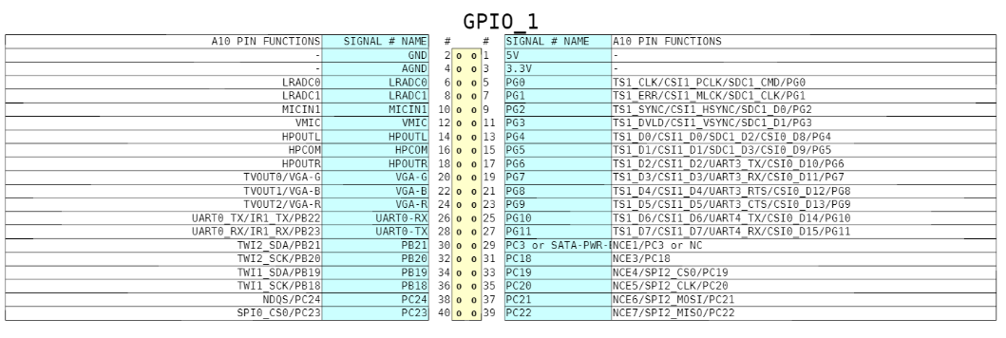Figure 3.6.6.1 - A10-LIME GPIO 1 pinout (Reprinted from Olimex under GPL)

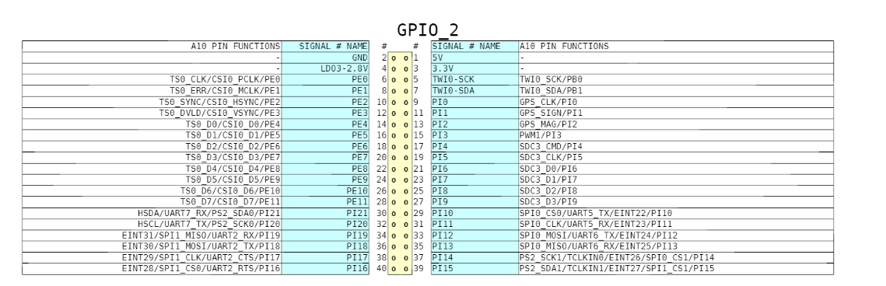Figure 3.6.6.2 – A10-LIME GPIO 2 pinout (Reprinted from Olimex under GPL)

Design Constraints
When thinking about constraints on our design, we were hard-pressed to find many constraints overall. However, there are economical and time constraints which must be addressed during the course of the project. And while we couldn’t find any other constraints, it is indeed possible that they may arise throughout the course of our project. Therefore, this is just a preliminary list of constraints. We will monitor any potential new constraints as we build our project.

Economic Constraints
Economically, this project is somewhat pricey. Prices can shift, but the most expensive component of this project is the wind turbine itself. Depending on the height, the wind turbine can range in cost anywhere between $100 and $500 for a turbine that is around 4 feet in height. This can make expanding system quite costly at $1,000 per unit. The microcontroller and other components are inexpensive with the only other component exceeding the $100 mark is the motor.

Time Constraints
Timewise, as soon as we finish ordering the parts, we need to test and assemble the components. We have 12 weeks to test, debug, tweak, and finalize this project. Testing most of the sensors will be simple as they can be quickly tested with the microcontroller. Most of the sensors are simple GPIO devices that can be quickly interfaced. Writing the software will be much simpler since there are libraries available for interfacing with the GPIO pins. PCB creation will also take some time, as PCB components must be finalized, sent away, created, shipped back, and then finally tested to make sure it all works. This increases the time crunch as we may need to make multiple PCB revisions before completely finalizing the design and having to wait for each new revision. Also, if any component fails, we would have to reorder, wasting more time as we wait.

Environmental Constraints
This project will not pollute the environment and will attempt to harness the power of the environment to generate energy that can be used to power something such as lights or the system itself, though the power and efficiency of the system will depend on the environment itself. Since we are primarily using a wind turbine to generate energy, we require that it is windy out and the turbine can generate more electrical energy. This is mainly a problem in this location as it is not as windy as other places. This can be somewhat resolved by increasing altitude, but this increases other problems such as temperature. The colder temperatures may introduce condensation to the system and could potentially short out the electrical system if not sealed properly. Rain could also make the system short, so that should be taken care of as well.

Social Constraints
Socially, this could be seen as something new and unique as I don’t think it will be marred from society considering it is a wind turbine that generates electricity. I do see where it may seem odd to put one of these systems on top of a house or building as it is generally not done as there are usually solar panels that are put there instead. The only problem with solar as that it will only be at most 30% efficient unless it angled towards the sun at all times when the sun is out. As stated before, the problem with wind if that it depends on the speed of the wind which is also inconsistent, so there are pros and cons to both approaches.

Political Constraints
Politically, there are not many constraints when it comes to this project. The project, to my knowledge, does not violate any laws, as it will not interfere with airspace and will not pollute the environment. Unless we raise one quite high to harness wind from that altitude, I do not believe we have to worry about polluting the airspace and getting a notice from the FAA about this.

Health and Safety Constraints
Health and safety constraints will be an important part to consider when running through design ideas. Mechanically we will have a structure that will have rotating blades. Generally, any objects around the wind turbine system will need to be at a safe distance away from these blades to prevent any collisions while rotating. The turbine will also be mounted on top of a platform. It should be stabilized from all sides to avoid any toppling during extreme weather.

Electrically this system will be generating electrical energy that will be stored in batteries. This power will need to be transported safely and in a way that does not accidently discharge any dangerous current levels. The batteries being used will be sealed lead acid batteries. Even if these are designed to be much safer than flooded lead acid batteries, there is still a chance that electrolytic fluid can be released in extreme situations. Because of this, they should be stored in a safe location, away from anything that produces a considerable amount of heat.

Manufacturability and Sustainability Constraints
Once the PCB layout is finalized, the most difficult points of manufacturing will be creating a base to hold the components and to make sure it is balanced and will not topple over onto itself. Certain components would have to be checked such as the lead-acid batteries and those leaking could spell certain doom. If the PCB fails and it does not regulate power correctly, there may be problems with the system and components could fail over time or sporadically. This may even cause undefined behavior within the system. As long as most of the electrical components hold, the system will do fine and will be sustainable. The most important thing about this system is its sustainability and its ability to generate electrical energy from wind so if there is wind, it will generate power.

Hardware Design and Details
A big portion of this project is related to hardware. This section will discuss how we intend to implement the hardware and also give schematics and tables concerning certain aspects of our hardware design.

Hardware Design Overview
This section will focus on the hardware design and how it will be implemented into a real, working, system. We have already done the research into the different components needed in this design, so now we will ultimately select the specific components we will be using in the design. This project focuses on a wind turbine, so naturally the whole design depends on what turbine will be used. For our purposes, and for its cost, a 500W 12V wind turbine will be used. Since this is a turbine, the gearbox and generator are already built in. A tower is not provided with the turbine, so we will discuss what will be used as a mounting place for the turbine. One thing that comes with the turbine is a charge controller. This will be very important to the design because it steps the voltage from the generator down to 12V. This will be important because our energy storage is a 12V battery.

Sensors are the next big part of this project. The sensors will provide us with all the necessary data we wish to display. The sensors include, but are not limited to, wind speed, wind direction, power/energy, and temperature. These sensors will ultimately be connected to a microcontroller chip on a printed circuit board that we will design. If we are going to power this system with the turbine alone, then we must drop the voltage down to 5V and 3.3V to accommodate for the smaller components that run at these voltage levels. To accomplish this, resistors will be used in a voltage divider circuit.

Once again, there will be quite a bit of data being collected from the sensors. This information will be fed to the microcontroller. From here, the information will be displayed on a touch LCD display to add more interaction to the design. More of this will be discussed in Section 6 of this document. On another note, this will not be possible without the development of a printed circuit board that will contain all the necessary components needed to run the system.

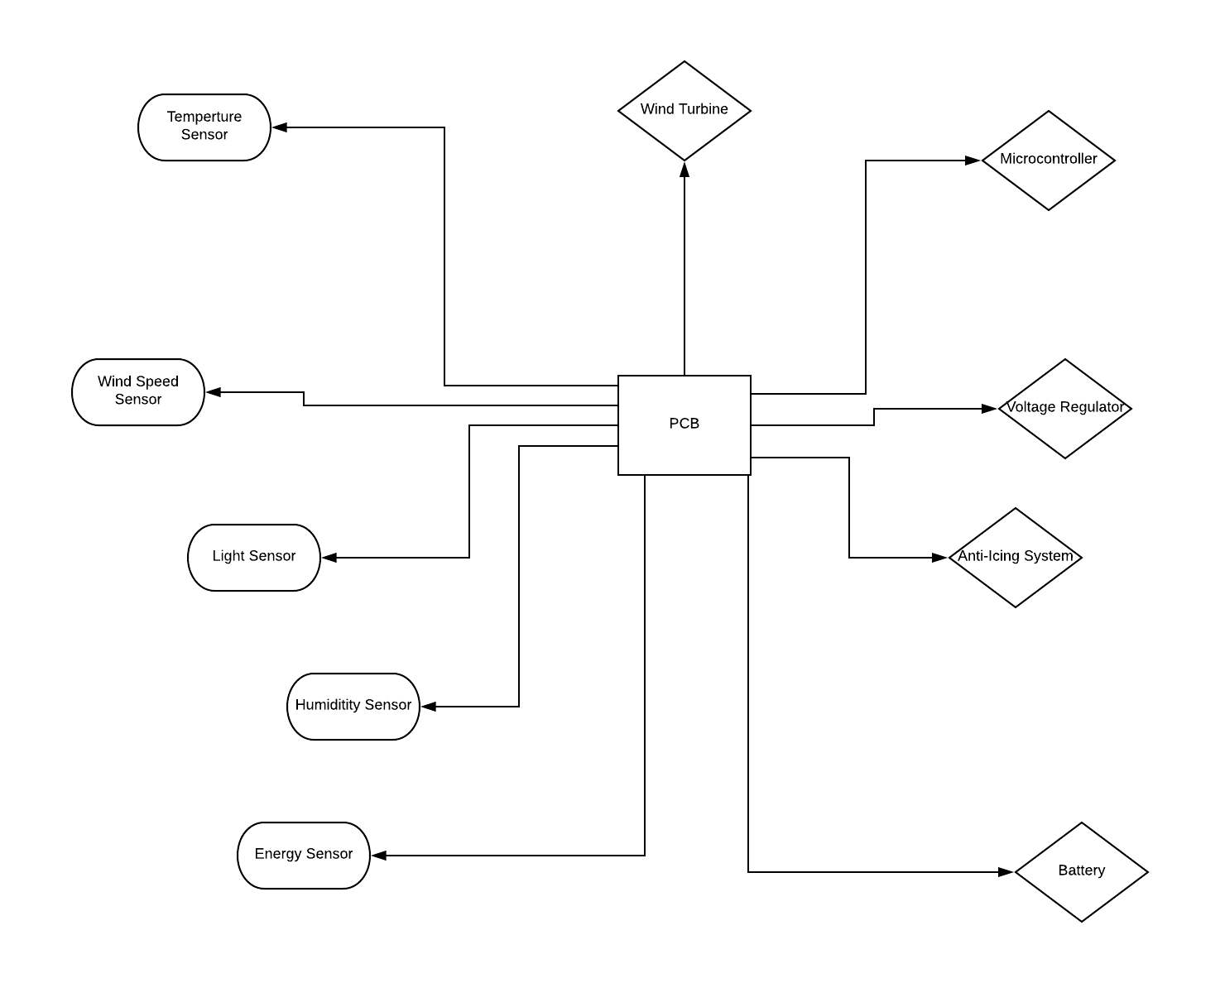
Figure 3.6.6.1

Wind Turbine Selection and Design
This section is dedicated to the comparison and selection of a wind turbine that will fit our design expectations determined previously in section 3. Pictures of each turbine will be shown as well as the complementary specifications for each wind turbine. Theses specifications will be contrasted in the following subsections with the purpose to select the optimal wins turbine for specific application. Each of following three wind turbines is very similar but there are a few key differences that have narrowed done the selection to one. Additionally, each wind turbine comes with its own generator and gearbox. In the subsequent main sections, the generator and gearbox will also be discussed

Wind Turbine 1
This is wind turbine designated as wind 1. It is unbranded, and the manufacturer is unknown so will refer to this wind turbine as wind turbine 1. The specifications are below as well as a picture. The turbine is listed on eBay for the price of $154.99. Has a DC voltage output and comes with a charge controller.
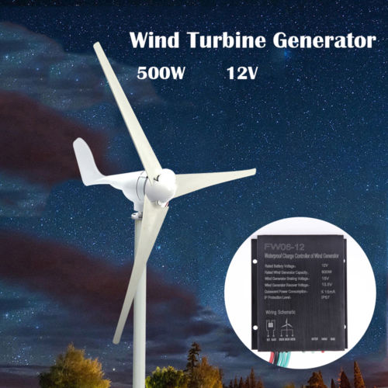Figure 5.2.1.1

Specifications
- Color: White
- Number of Blades: 3
- Rated Power: 500W
- Maximum Power: 510W
- Rated Voltage: 12V
- Start-up wind speed: 2.0m/s
- Rated wind speed: 13.0m/s
- Survival wind speed: 50m/s
- Top net weight: 6.8kg
- Wheel diameter: 1.4m
- Blade length: 55cm
- Blades material: Nylon fiber
- Generator: three phase permanent magnet ac synchronous generator
- Magnet: NdFeB
- Generator case: Casting aluminum alloy
- Control system: Electromagnet/wind wheel yaw
- Speed regulation: Automatically adjust windward direction
- Working Temperature: -40C-80C
- Package size = 67x29x23cm

Wind Turbine 2
This is wind turbine designated as wind 2. It is unbranded and the manufacturer is unknown, so will refer to this wind turbine as wind turbine. The specifications are below as well as a picture. The turbine is listed on eBay for the price of $140.59. Has a DC voltage output and comes with a charge controller.
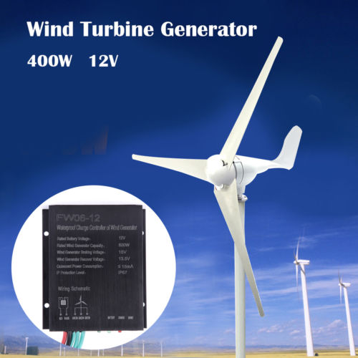Figure 5.2.2.1

Specifications
- Color: White
- Number of Blades: 3
- Rated Power: 400W
- Maximum Power: 410W
- Rated Voltage: 12V
- Start-up wind speed: 2.0m/s
- Rated wind speed: 13.0m/s
- Survival wind speed: 50m/s
- Top net weight: 6.8kg
- Wheel diameter: 1.2m
- Blade length: 55cm
- Blades material: Nylon fiber
- Generator: three phase permanent magnet ac synchronous generator
- Magnet: NdFeB
- Generator case: Casting aluminum alloy
- Control system: Electromagnet/wind wheel yaw
- Speed regulation: Automatically adjust windward direction
- Working temperature: -40C-80C
- Package size = 67x29x23cm

Wind Turbine 3
This wind turbine is designated as wind 3. It is unbranded and the manufacturer is unknown so will refer to this wind turbine as wind turbine 3. The specifications are below as well as a picture. The turbine is listed on eBay for the price of $179.99. Has a DC voltage output and comes with a charge controller.
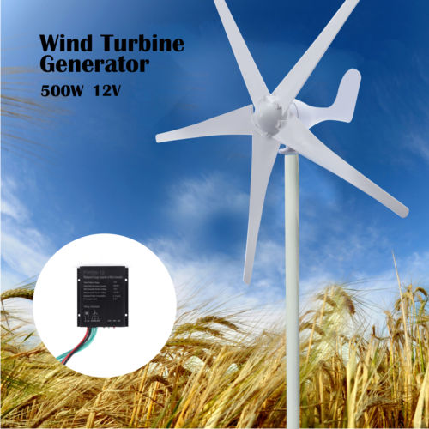
Figure 5.2.3.1

Specifications
- Color: White
- Number of Blades: 5
- Rated Power: 500W
- Maximum Power: 510W
- Rated Voltage: 12V
- Start-up wind speed: 2.0m/s
- Rated wind speed: 13.0m/s
- Survival wind speed: 50m/s
- Top net weight: 6.8kg
- Wheel diameter: 1.3m
- Blade length: 57cm
- Blades material: Nylon fiber
- Generator: three phase permanent magnet ac synchronous generator
- Magnet: NdFeB
- Generator case: Casting aluminum alloy
- Control system: Electromagnet/wind wheel yaw
- Speed regulation: Automatically adjust windward direction
- Working temperature: -40C-80C
- Package size = 67x29x23cm

Wind turbine comparison and selection
We decided to select wind turbine 3 for our project due several reasons. The first reason was because the price versus power generation of wind turbine 1 was the most optimal by our standards. Wind turbine 1 is listed at $154.99 and is expected to produce 500W of power at a rated wind speed of 13m/s. Wind turbine 2 is indeed cheaper than wind turbine 1 with wind turbine 2 having a listed price of $140.59. However, wind turbine 2 can only produce up to 400 W at the same rated wind speed of wind turbine 1, that being 13 m/s. One of goals is to produce as much power as possible while being as efficiency as possible. Thus, the 500W provided by wind turbine 1 would be more optimal to meet that goal rather than the 400W provided by wind turbine 2. The initial price difference between the two is compensated by increased power output. The following example and figure will show this.

We will be using one of the northern cities mentioned in a previous section 3.2.3, Barlow, USA, as an example for the energy savings for between wind turbine 1 and wind turbine 2. The average cost of energy per hour in Barlow, USA is shown below in the following figure.

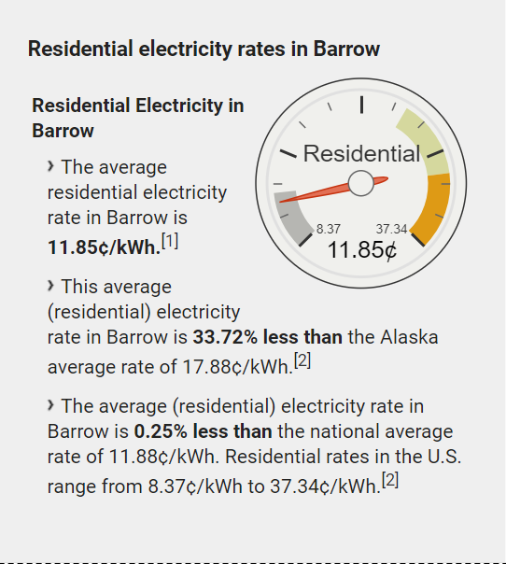
Figure 5.2.4.1 Residential electricity rates in Barrow
The average price of energy in Barlow, USA is 11.85 cents per kilowatt-hour or 0.01185 cents per watt-hour. There is 168 hours in a week. Multiplying this amount time by the cents per watt-hour in previous line and the energy cost in a week is approximately $1.99. Now multiply $1.99 by the 100W difference between wind turbine 1 and wind turbine 2 and the total money difference between the turbines for a one-week period is $199.08. Within the first week alone the initial price difference wind turbine 1 and wind turbine 2 of $14.40 has been overcome significantly. Therefore, wind turbine 1 higher initial cost of $154.99 is justified because the savings produced in one week will make up for it when compared to wind turbine 2. Therefore, wind turbine 2 will eliminated from the consideration because its only difference from other turbines was price and power production, which has been proven to be inferior to the other two wind turbines under consideration. Wind turbine 3 was not used in this cost comparison because it has the same power rating as wind turbine 1 albeit a higher initial cost which will lead to reason two.

Reason two is that although wind turbine 3 has a notable higher initial cost, $170.99, than wind turbine 1, $154.99, the added benefits of more blades of wind turbine 3 is unwarranted in our application. The use of more blades pass the number of 3 blades, which is standard number of blades for a wind turbine, is to lower the startup- speed for a wind turbine and to provide more stability. This has to do with aerodynamics of the blade itself but in terms of our project we will not go into more details about the aerodynamics because that is a mechanical aspect. Instead we will focus on fact that that wind turbine 3 is supposed to have a lower start-up wind speed and be more stable than wind turbine 1. On the contrary, in the specifications for wind turbine 3 the start-up wind speed is 2.0 m/s, the same as the start-up wind speed for wind turbine 1. We are assuming this is a discrepancy or a rounding up of the start-up wind speed to nearest meter for wind turbine 3. If this assumption of fallacy or rounding up is correct than this perceived advantage of a lower start-up wind speed that wind turbine 3 possesses over wind turbine 1 still would not be necessary for out particular application because we will have more than sufficient wind supply in the specific areas we are designing for. As shown in previous sections, the average wind speed in northern areas are about 12 m/s and up so therefore the need for a lower start-up wind speed is unnecessary, especially at a cost of $25 more. On the other hand, if this assumption of fallacy or rounding up is false than the only other possible advantage would be stability but this too would be unnecessary for our project. All the wind turbines have a survival wind speed of 50 m/s and the maximum wind speed in the areas of interest do not come anywhere close to this value. The max wind speed we must consider is 28 m/s, so stability is not a concern. Wind turbine 2 was not used this analysis because it has the same number of blades as wind turbine 1.

There are no other differences to between the turbines so with these comparisons listed above, wind turbine 1 will be the one selected for out project. We will base our specifications off those specifications provided with wind turbine 1 and will we now discuss the gearbox and generator in our design impact based off the ones provided with wind turbine 1

Senior design ll Changes
For senior design we ended up going with turbine 3 because there was a shipping error in ordering turbine 1 from eBay. We were sent the wrong part instead of wind turbine 1. We than decided to place order through Amazon because we felt Amazon was more reliable and shipping was free. On Amazon there was not a wind turbine similar to wind turbine 1 or 2, so we had to go with wind turbine 3. All the specifications between the turbines are the same except for the number of blades which has negligible impact on the overall system. Wind turbine 3 has 5 blades instead of 4 blades. The price was also higher on Amazon, with a price of $212.

Gearbox
The gearbox in our application will already come assembled and integrated with the purchase of the wind turbine and that is why we did not do any prior research into different types of gearboxes because the selection was determined by wind turbine component. However, the gearbox located within wind turbine might have an impact on our overall design or safety concerns, so farther inquiry is required now. As of now there is no listed information on EBAY about the gearbox for wind turbine 1 so we have sent a request to the supplier for additional information about the gearbox but in the meantime, we can do our own research and based the other information already provided. Based on the 500 W power output of wind turbine 1 the gearbox is most likely in the medium range of gear ratio of 1:30. The gear ratio is amount of revolutions inside of the generator versus the amount of revolutions of the rotor. The top gear ratio is 1:90 for larger wind turbines the larger the ratio the more the revolutions were increased from the rotor to the generator. For some of the megawatt wind turbines there is no gearbox in fact and the use of direct-drive or directing using the revolutions produced by the rotor inside of the generator is used instead. The use of direct-drive is due impart because the use of a gearbox comes with drawback of increased concern of stress and ware for other supporting components inside the wind turbine like the bearings. In fact, the higher the gear ratio to more stress there is to the supporting parts.

As previously stated, wind turbine 1 will probably have a gearbox because it is not a megawatt wind turbine, so the ability to use direct drive is not viable, and the gear ratio is probably in the ball park of 1:30 because of sizing of the wind turbine 1, which should not cause significant stress and ware to the supporting parts of the wind turbine. We should not have considered this as safety issue than according to our assumptions and no additional is needed to account for the gearbox. The follow picture below is picture of general 1:30 gearbox that we would expect to be in the wind in turbine 1.
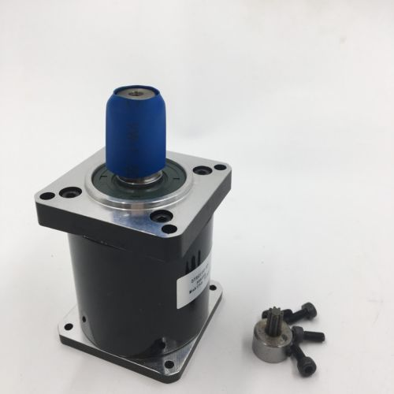
Figure 5.2.5.1 30 Gearbox
If the seller of the wind turbine that we are purchasing replies with the information regarding the gearbox and that information differs from our expectations as seen in the picture above, then this section will be reviewed again and the design will be updated.

Senior Design ll changes
The manufacturer never responded to our request for more information about the gearbox. We also did not want to open up our wind turbine and interfere with internal workings of our component. So we decided that the gearbox was not major component in our design and went with assumption that the gearbox ratio was probably 1:30. The wind turbine system functioned the way it needed to without further research of the gearbox.

Generator
A similar investigation into the actual generator within wind turbine 1 is needed just as with the gearbox in the past section. Similar to the situation with the gearbox, there was no need to research different generator designs and/or trends in the research sections of this document because the wind turbine we chose comes with its own generator already integrated. Also similar to the gearbox situation there is a need to consider the potential impact that wind turbine 1’s generator will have on our overall design. We plan to incorporate several different types of sensors around and on the wind turbine, as well as cable runs leading to these sensors. Some of these sensors could be located wit in the immediate proximity of the wind turbine 1’s generator. The potential impact of generator is even more prominent than the gearbox because the generator’s internal magnet field might have a detrimental effect on some of our sensors/measuring instruments and/or the cabling with current flowing through it. Also, the opposite could be possible, with the sensors and current carrying wire possibly affecting the inner workings of the generator. The generator’s magnetic field could be a possible issue in two ways. The first way could be that the magnetic field from the generator could be large enough to reach and affect the measurement of some of our sensors. This is the case because the sensors we plan on implementing will rely on outputting a voltage signal to transmit their sensory information to the pins of our microcontroller. The intruding magnetic field and thus the magnetic flux could produce undesired voltages on our sensors input due to induced Electromotive forces (emf) as shown in Faraday’s law below:
$$ε= -\frac{dΦ_{B}}{dt}$$

For Faraday’s law to be valid in sense the magnetic flux has to be time varying, which is the case because the generator is operating with alternating current (AC). If there are indeed unforeseen voltages on our instruments than our measurements could then become erroneous and therefore ineffective for data collection.

The second way that the generator’s magnetic field could be harmful is the possibility of magnetic forces moving cables and/or interfering with internal workings of the sensors. Due to Biot-Savart’s law, a current carrying wire in the presence of an external magnetic field will experience force acting upon it as shown in following equation:

$$B= \frac{μ_{0}}{4π}∫\frac{Idl ×r^{'}}{\left|r^{'}\right|{^}^{3}}$$

If cables were moved or sensors were disrupted than this could mess with the operation of our wind turbine. Given these two scenarios of interference it would beneficial to learn exactly what type of generator is in wind turbine 1. From the specifications provided with wind turbine 1, the generator type is listed as a three AC synchronous generator with a permanent magnet. Since the generator is an AC synchronous generator with a permanent magnet, most likely the magnet is a 1st stage exciter for the main exciter, the concern for interfering magnetic fields is farther confirmed because the 1st stage exciter and main exciters rely on their magnetic fields to operate properly. The magnet has even more detail and is listed as an NdFeB type. An NdFeB type magnet, also known as neodymium magnet, is the most popular magnet used in commercial settings due to it being the strongest type of permanent magnet available commercially. Since NdFeB is considered for its magnetic strength, calculations will have to be done with these parameters in mind. The NdFeB parameters are listed below in the following two figures figure.

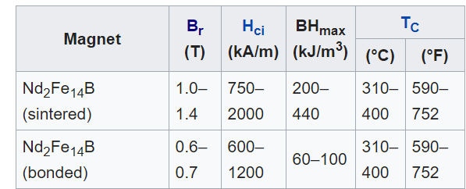
Figure 5.3.1.1 NdFeB Parameters 1

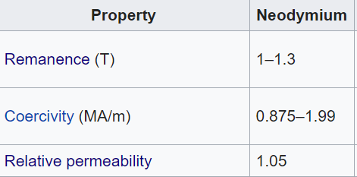
Figure 5.3.1.2 NdFeB Parameters 2

The first figure shows magnetic field values of an NdFeb sintered versus bonded. We need to do testing to see which one type we have because this is not listed. The second figure shows other related values of magnetic properties that could be used in calculations if needed.

Wind Direction Control System
To produce as much power as possible, a wind turbine needs to face in the direction of oncoming wind as much as possible. To achieve that there is often a control system that pivots or rotates the wind turbine to face the wind the wind no matter the direction its coming from. There was no need to research wind turbine control systems because one was provided with wind turbine 1. Our small wind turbine will have a passive control system as stated by the seller. A passive control system is a system that uses wind power to turn a back fin on the wind turbine towards to downwind direction. An active control system requires using a servo and internal control system to provide feedback to produce the rotation towards the wind. We could have implemented an active control system, but we decided that it would be unnecessary due to the extra cost monetary and time-wise to buy and integrate a servo and more cabling to purchase. Also, we decided the viability of passive control system was already effective enough. The following figure is of the back fin on wind turbine 1 that will provide the passive control needed to rotate the wind turbine 1 into the wind.
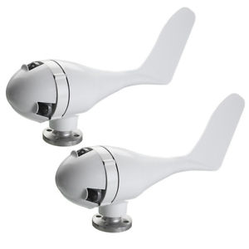
Figure 5.5.1 Back Fin

Charge Controller
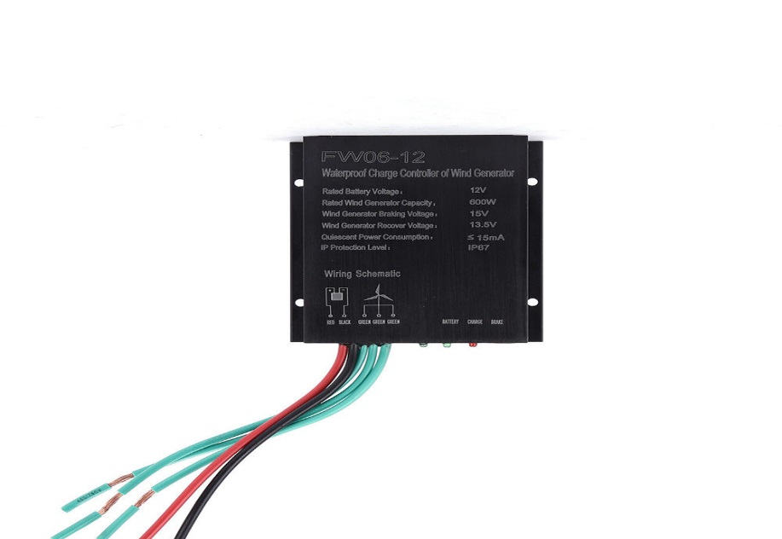
The power coming out of the generator is three phase AC current that is then converted to DC by a charge controller. This charge controller is provided with the wind turbine 1. The charge controller comes with its own specifications and these should be listed and analyzed as well because the charge controller will have an impact on the overall design. The following figure is of the charge controller provided with wind turbine 1. The specifications are shown on the picture but will also be listed out after the figure for clarity.
Figure 5.3.1.1 Wind Turbine 1 Charge Collector
- Charge Controller Specifications:
- Rated Battery Voltage: 12V
- Rated Wind Generator Capacity: 600W
- Wind Generator Braking Voltage: 15V
- Wind Generator Recover Voltage: 13.5V
- Quiescent Power Consumption: < 15mA
- IP Protection Level: IP67
- Model Number: FW06-12

From the picture the three green wires are from the turbine and are carrying three phase AC current. The red and black are DC current; the red wire being the positive terminal and the black is the negative terminal.

Most of these specifications will not have a substantial impact on our design of our circuit, except for maybe the Quiescent Power Consumption. This might affect our current of our main circuit connecting the wind turbine to the battery and PCB. Will account for this in hardware testing and if it has an effect we will add the charge controller as power consuming load.

Wind Turbine Tower
With wind turbine 3 now selected as the turbine for our project, it is now necessary to select an appropriate tower to support it. Research into tower designs was not needed because the most used tower design is a monopole tower/ single tower. All the other wind systems mentioned in the research section used a monopole and this because it is simple to design and is the cheapest. One of goals for our project is to be as cheap as possible so the monopole design is the best to fit that goal.

Although research is not needed into different tower types, there is need to compare different monopole towers for the selection for best one that fits our project and this analysis shall be done subsequent subsections.

Wind Tower Research
Based off our research of looking for a commercial tower that would fit our project design, there was not a tower that we could find that would match our exact design. All the towers being sold were monopole towers but they had tower diameters that were tiny. The towers were basically just single poles being held up by several tethers for stability and the base of these towers is just flat with no enclosure like structure. In our design we are hoping to have a monopole tower with a big enough tower diameter in order to house a few cables. These cables would run from generator and our printed circuit board (PCB) through the hollow pole and connect to our wind turbine and sensors mounted on the wind turbine. We also want to have a hollow, box-like base for our tower in order to house all our PCB, battery, other electronics, and cabling. Our tower and base will double as the support for wind turbine 1 and a protective enclosure for everything else. With this concept in mind we have decided to build our own wind tower as of now.

Wind Tower Design
This section will explain the design of the tower and base for our project through visual representation of schematics. The first schematic will of the tower portion and the second schematic will be of the base. Figure 5.7.2.1 is a 3D CAD model of what we envision our wind turbine tower to look like. The tower will be about 4 to 5 feet tall, which leaves adequate clearance for our wind turbine blades. The base itself will be about a foot tall, which will provide enough room for all of our electronics including the battery.

Figure 5.7.2.2 shows a rough schematic of what the inside of our base will look like. We would like to add some sort of light source inside the base that you can turn on if you need to work on the electronics inside. The base would need to be waterproofed so that it can withstand inclement weather conditions.

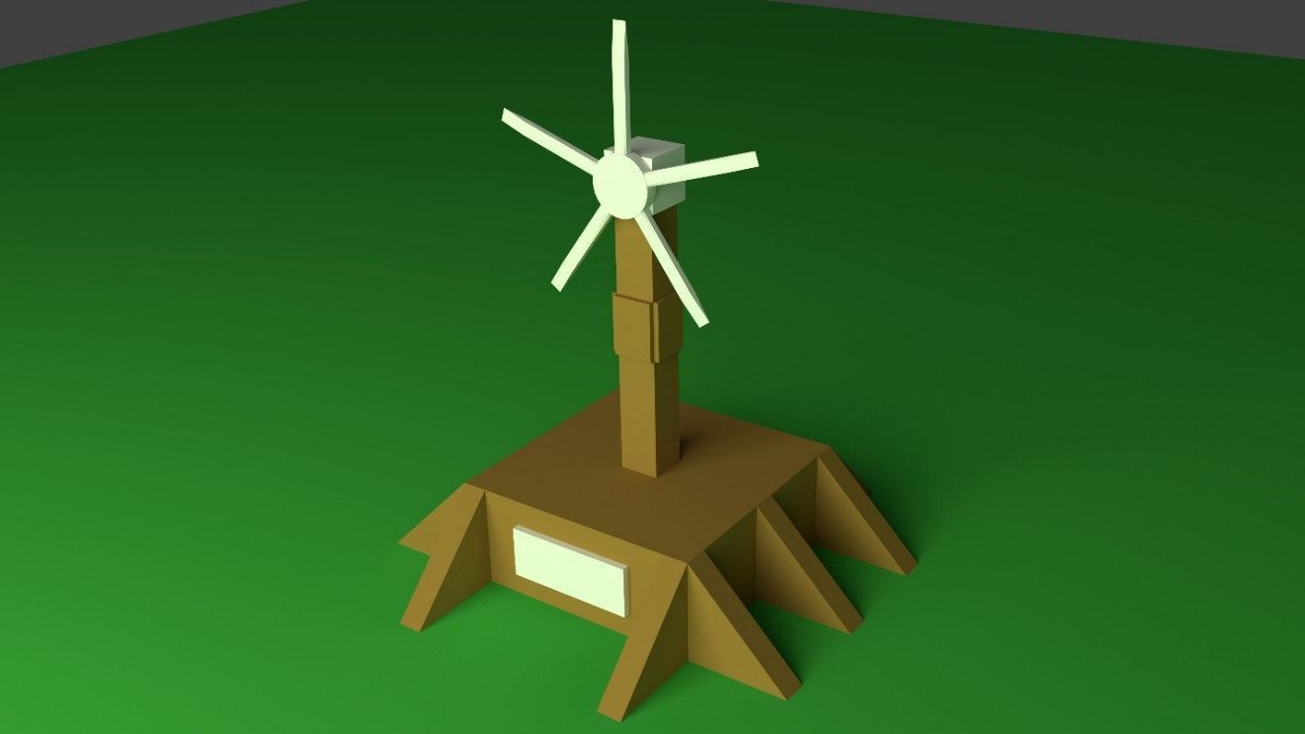
Figure 5.7.2.1 Wind Turbine Tower CAD Model

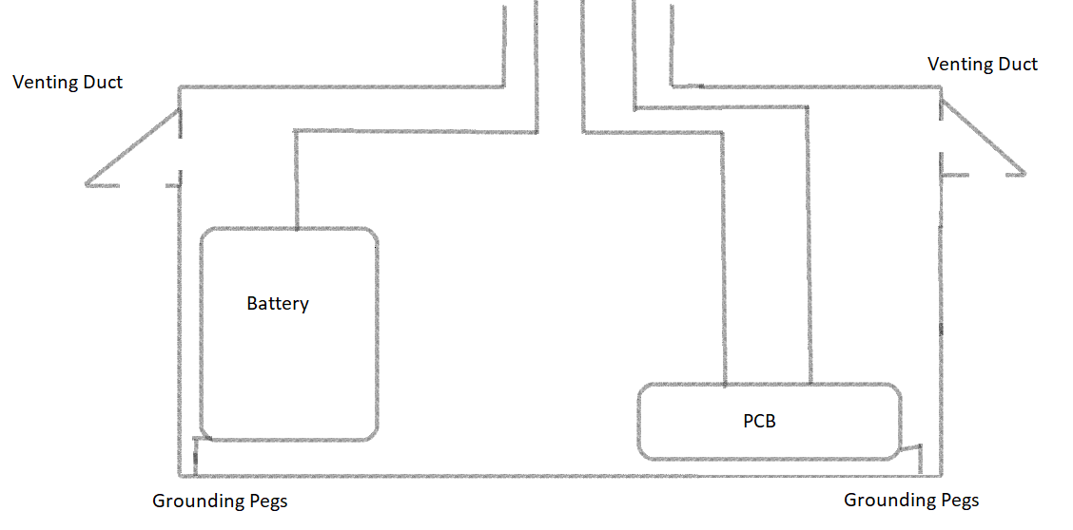
Figure 5.7.2.2 Wind Turbine Base
This is simple base schematic to the orientation of the major components internally. The three cables from the last figure will be connected to the following loads in this way. The battery and PCB will be on opposite sides of the base structure to ensure there will not be any interference with each other. The loads will be elevated from the base’s floor for grounding of the loads. The ground pegs are there for the same purpose. There also are venting ducts attached to the base structure for the purpose of cooling air flow to avoid overheating of the loads inside. The ducts are pointed downwards in order to prevent too moisture from penetrating the inside of the base and thus affecting the electrical loads on the inside. This schematic is meant to reflect the main circuit schematic shown in figure 5.7.3. There is one main wire connected to the battery and two main wires connected to the PCB. The two-wire connection is needed for MCU and peripherals devices respectively.

Wind Turbine Tower Final Design
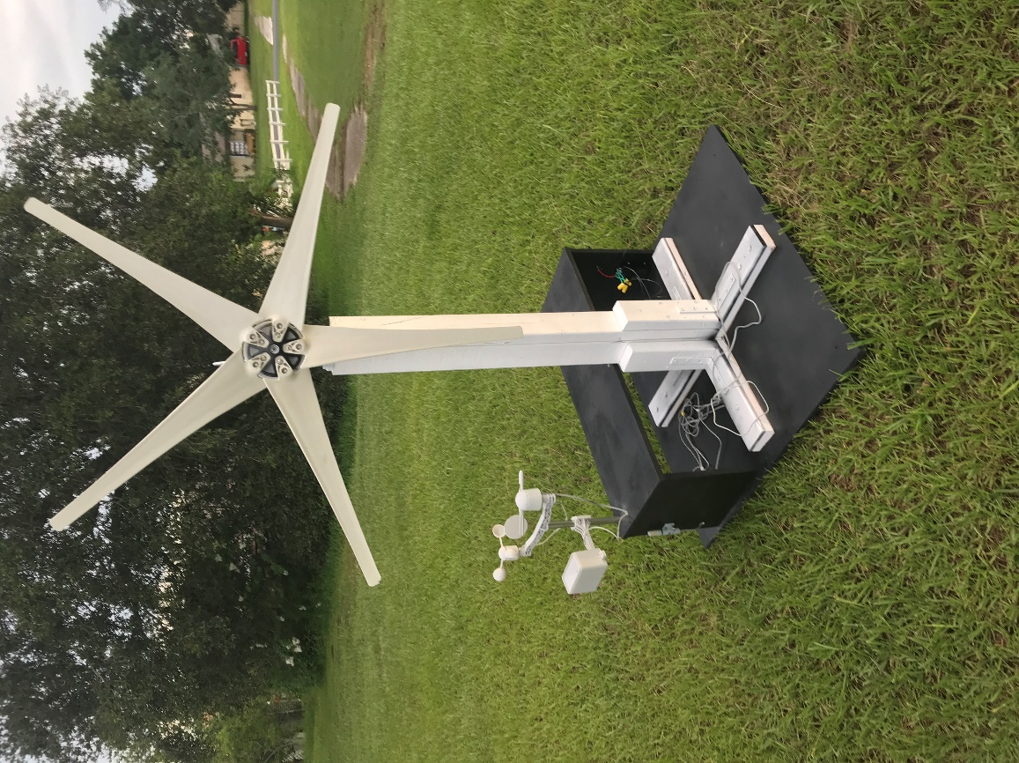
After beginning to build our wind turbine tower, we realized that the scope of our original vision was a bit too enthusiastic. So, we changed our design slightly. We got rid of the full base enclosure and instead opted for a rear enclosure that was one third the size. We kept the tower 4 feet tall and the base 3 feet by 3 feet. TO give the tower extra support, we added L-brackets and legs and bolted the legs to the base. The base ended up being just a 3x3 piece of plywood. Figure 5.7.3.1 below is a picture of our final tower design.
Figure 5.7.3.1 Final Wind Turbine Tower Design

Resistors
Resistors will have to be added to the main circuit in order to drop the voltage and current coming from out of the charge controller. The voltage coming out of the charge controller will be 12 V and current coming out will vary depending on the amount power being produced by the wind turbine. This drop in electrical parameters is necessary to meet the requirements of the electronics on our PCB and to make sure these parameters will not exceed the upper safety limits of those same electronics. Our initial main circuit design will be shown in the section about the PCB layout. Prior to that section will be give design details in this section about the resistors values chosen for main circuit in order to describe part selection.

Resistor Calculation
The two resistor values that we will need in our initial design are 1.47Ω and 0.7Ω. 1.47 Ω was chosen to drop the 12V coming out of the charge controller to 5.5V, which is required voltage for the MCU. Notice that this resistor is after the branch containing the battery. This is because our battery will require 12V to charge adequately; therefore the 3.25 Ω resistor was purposely placed after. The 2.2 Ω was placed after the MCU load in the first branch for the same reason. We needed to farther lower the voltage of 5.5V to 3.3V for our peripherals load in the second branch. The peripherals are our sensors and other various electronics mounted onto the PCB. The following calculations discussed above will be shown below through equations to provide clarity.

R1 calculation:

$R_{1}=\frac{V_{G}-V_{MCU}}{I_{G}}$ = $\frac{12V-5.5V}{2A}$ = 3.25 Ω

R2 calculation:

$R_{2}=\frac{V_{MCU}-V_{P}}{I_{P}}$ = $\frac{5.5V-3.3V}{1A}$ = 2.2 Ω

Vg: Voltage from the Generator
$V_{MCU}$: Voltage for the MCU
$I_{G}$: Current from the Generator
$V_{P}$: Voltage for the Peripherals
$I_{P}$: Current for the Peripherals
$R_{1}$: First Resistor to drop Voltage
$R_{2}$: Second Resistor to drop Voltage

Resistor Selection
We have already selected the resistors we are planning to purchase and there was not really a need to compare different types because our resistor values were so specific and normal resistors are extremely low price anyway. The following figures are of resistors will have selected. These images are provided in order to separate visually the two types of resistors when they are mounted on the PCB. The first figure is of the 3.25Ω resistor and the second figure is of 2.2Ω resistor. The pricing for an individual resistor is $0.20 and under so its cost is negligible. We will be purchasing bundles of these types of resistors for prototyping and testing, so the cost of the bundles will be added to the bill of materials.

Main Circuit with Resistors Values
The diagram shown below is of main incoming circuit that connects the generator of the wind turbine to the battery, MCU, and various other peripherals on the PCB. The emphasis of this diagram in these sections is show the resistor values and their orientation in the circuit.
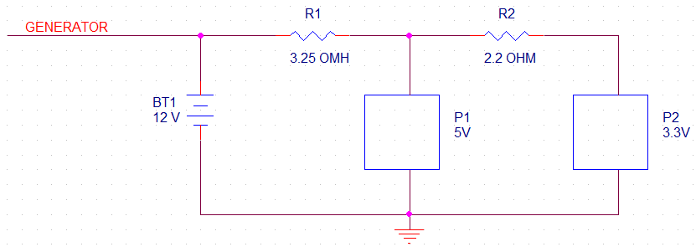
Figure 5.8.3.1 Main Circuit Visualization w/ Resistors

Senior Design II Changes
These resistor calculations were made before the design of the PCB. While creating the design for the circuit board, we discovered that the current would be taken care of through the voltage regulators that were being implemented into the circuit. These regulators output a fixed voltage, but also output a certain current level. Because of this, the circuitry following the regulators were deemed safe enough for operation. It was good practice going through this calculation because it made us aware of the dangers associated with high current running through a circuit. The previous description talked about two resistors and their calculated values. These two resistors to be used were axial through hole resistors that are commonly used in the labs on campus. For the actual design implementation, the electrical engineers used surface mount chip resistors to increase the level of difficulty of the design. The following is a short table of resistors used on the PCB and some characteristics they have.

Manufacturer P/N | Resistance (Ω) | Tolerance | Power (W) | Device Package (in)
ERJ-6ENF54R9V | 54.9 | ±1% | 0.125 | 0805
ERA-6AEB1400V | 140 | ±0.1% | 0.125 | 0805
ESR10EZPF1200 | 120 | ±1% | 0.4 | 0805
ERA-6AEB361V | 360 | ±0.1% | 0.125 | 0805
RR1220P-103-D | 10k | ±0.5% | 0.1 | 0805
Table 5.8.4.1

Sensor Technology
This section will go over the sensor selections made for this design. After going through the research, we were able to determine what is needed for the system to work. Instead of buying an external wind speed sensor, we discovered a way to tell wind speed from a turbine specification. To do this, we had to consider what type of energy sensor we would be using. There were a lot of ways to measure temperature and it was clear what was easiest and more cost effective. All these topics will be discussed in the following sections.

Wind Speed Sensor
In our sensor research we discussed many different wind speed options that can help us obtain the data we need. After looking at various options and other form factors, we realized that the wind turbine could be used to measure speed. Since we are purchasing our wind turbine, we are already aware of its specifications. Along with these specifications is a power curve for the turbine. This power curve represents the power generated according to different wind speeds. We will have a way to track the power being produced by our generator; which will be discussed in the next section. Using the data gather from the power readings, it can be compared to the power curve to output a specific wind speed. An example of a power curve can be seen below.
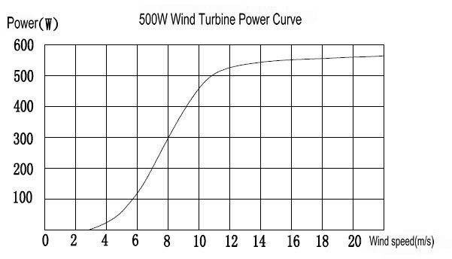
Figure 5.9.1.1: Example of a power curve for a wind turbine
We believe that this approach for a wind sensor would allow us to showcase our engineering knowledge better than just buying an external sensor. It will also decrease the budget of our design. Of course, there will be some downsides to this approach. The biggest downside is the increase in complexity for the design. Another may be some inaccuracies when trying to determine the right wind speed. Although this is the case, we believe that this can be implemented and will work for our design.

Power/Energy Sensor
Along with our wind speed sensor idea, we had to come up with a way to measure the power being produced. As mentioned in the sensor research, this sensor will mainly be measuring the voltage or current, in this case it will measure current. We know that the wind turbine is rated for 12 volts; therefore, we can just read the current and convert these two values to a power reading. The TI INA219 current sensor and power monitor will provide the capability of measuring the current coming from the generator. The sensor contains eight pins to make this all possible—two pins for the positive and negative inputs, two address pins, and one voltage supply pin, one ground pin, and two pins for serial bus clock and serial bus data.
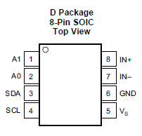
Figure 5.9.2.1: Pin configuration for TI INA219
An important thing to note is that this sensor requires a shunt resistor. This resistor will be of a low resistance. The sensor works by reading the voltage drop across the resistor through the two input pins. This is the shunt voltage and it is compared to the voltage from the negative input with respect to ground. The calculations are done by the IC and this comparison is translated into a current reading. Knowing this, we will connect this sensor and shunt resistor between the charge controller and microcontroller on the printed circuit board.
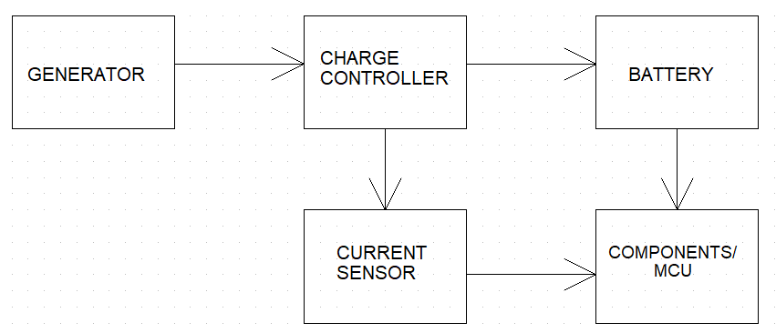
Figure 5.9.2.2 Flow diagram showing current sensor placement.

Temperature Sensor
As mentioned in the research, thermistors will be the sensor choice for measuring temperature—specifically, NTC thermistors. Negative temperature coefficient (NTC) thermistors are great for temperature measurement. Another option of thermistor is positive temperature coefficient (PTC) thermistors. NTC’s decrease in resistance as the temperature increases. PTC’s do the opposite and increase resistance when the temperature increases. For our design, the thermistor is needed to keep track of the outside and inside the system enclosure. We want to keep track of the outside temperature as data to display on the touch LCD. We will also use a thermistor inside of the system to make sure the enclosed environment does not heat up too much. For this application, a NTC thermistor will be used because of its capability to change resistance over a large temperature range.

To implement the thermistors, we will use a simple setup shown in Figure 5.8.3.1. As shown, there will be a thermistor connected between loads. Having two wires will allow for a current to be passed through the thermistor while also providing a way to measure the voltage of the resistor. From here, the resistance can be calculated from the current and voltage reading. This resistance is then translated to a temperature according to resistance-temperature curves provided by the thermistor’s manufacturer.
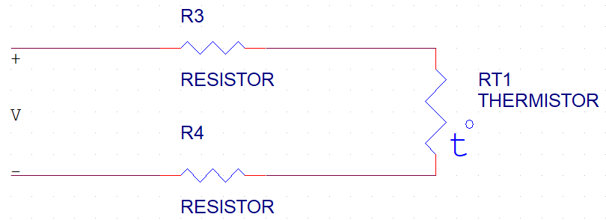
Figure 5.9.3.1: Example of two-wire setup for NTC thermistor.

Wind Direction Sensor
The wind direction sensor we will use was briefly mentioned in Section 3.5.2. This would be the LSM9DS0 inertial module that contains a gyroscope, magnetometer, and an accelerometer. The module will be electrically connected to the circuit board, but it will need to be placed in an area that rotates with the wind turbine. As mentioned previously, the wind turbine comes fashioned with a tail that will allow it to rotate in the direction of incoming wind. Therefore, the LSM9DS0 module will need to be housed and placed on the exterior of the turbine system. Initially, we thought of securing this to the base of the rotating section of the turbine but realized that this would not work, the reason being that the base would need to stay static to allow the turbine to rotate freely.

Microcontrollers
This section is dedicated to the comparison and selection of a microcontroller that will fit our design expectations determined previously in section 3. Specifications will be shown once again, and block diagrams of the microcontroller setups will be pictured. Theses specifications will be contrasted in the following subsections with the purpose to select the optimal microcontroller for this project. There will be four different microcontrollers that will be compared: the MSP432, the A10-OLinuXino-LIME, the FRDM-K66F, and the Raspberry Pi 3. The following criteria are what will determine what microcontroller will be supported: price, clock speed, memory, networking support, Operating System, graphics processor, open-source hardware schematics, and GPIO.

Microcontroller Pricing
Right off the bat, we can determine that MSP432 is the least expensive option followed by the Raspberry Pi, A10-LIME, and finally, the FRDM-K66F respectively. This will allow us to create a price to performance metric to determine whether we are getting a good deal on the microcontroller compared to the hardware that is available on it.

Microcontroller | Price
A10-OLinuXino-LIME | 30 EUR (approx. $38)
MSP432 | $19.99
FRDM-K66F | $63.75
Raspberry Pi 3 | $35.00
Table 5.10.1.1 - Microcontroller pricing comparison

Microcontroller Processors and Clock Speeds
In the case of clock speed, the MCF2553X has the lowest clock speed by far followed by the MSP432; however, these microcontrollers require much less lower power requirements than the remaining two. All MCUs feature an ARM Cortex processor that are at least 32-bits wide (the Raspberry Pi uses a 64-bit processor), so similar toolsets can be used because the processors should have most of the same assembly instructions if writing code using a native language such as C, C++, or even hand-written assembly. The Raspberry Pi is the only microcontroller that features a multicore processor.

Microcontroller | Processor | Clock Speed | Data Width
A10-OLinuXino-LIME | Allwinner A10 | 1GHz | 32-bit
MSP432 | ARM Cortex M4F | 120MHz | 32-bit
FRDM-K66F | ARM Cortex M4F | 180MHz | 32-bit
Raspberry Pi 3 | ARM Cortex-A53 | 1.4GHz | 64-bit
Table 5.10.2.1 - Microcontroller processor and clock speed comparison

Microcontroller Memory
Both the MSP432 and the FRDM-K66 have 256KB of SRAM whereas the A10-LIME and the Raspberry Pi feature different generations of DRAM. The generation is not so important rather that it is running DRAM. The problem with those microcontrollers is that allocating memory on the heap is not effective and can even cause problems in programs because of heap corruption due to the microcontroller wanting to keep the heap contiguous and malloc/new not abiding by that. This is the main reason why allocating memory is not recommended on these microcontrollers and why templates should not be used if writing C++.

Microcontroller | Amount | Type
A10-OLinuXino-LIME | 512MB | DDR3 DRAM
MSP432 | 256KB | SRAM
FRDM-K66F | 256KB | SRAM
Raspberry Pi 3 | 1GB | DDR2 DRAM
Table 5.10.3.1 - Microcontroller memory comparison

Microcontroller Networking
All the listed microcontrollers can use network communication over Ethernet and all the microcontrollers have a Fast Ethernet (10/100) 100Mbps connection other than the Raspberry Pi. The Pi has a Gigabit controller, but it is somewhat incorrect. While the controller itself is 1Gbps, it uses a USB to Ethernet adapter limiting the speed to 300Mbps due to the limitations of USB 2.0 which can transfer data up to 480Mbps. The MSP432 and the Raspberry Pi can network over Wi-Fi as well with the Pi having a native Wi-Fi adapter whereas the MSP432 requires the use of the CC3100 to do so. The Pi and the FRDM-K66F both can use Bluetooth as well where the Pi has a native Bluetooth module that occupies a UART slot and the FRDM-K66F has it as an add-on board. The Bluetooth module can be disabled on the Pi if the UART is required.

Microcontroller | Type
A10-OLinuXino-LIME | Ethernet
MSP432 | Ethernet (Wi-Fi with CC3100 module)
FRDM-K66F | Ethernet/Bluetooth (with add-on board)
Raspberry Pi 3 | Ethernet/Wi-Fi/Bluetooth
Table 5.10.4.1 - Microcontroller networking type comparison

Microcontroller Operating Systems
Both the MSP430 and FRDM-K66F are pure microcontrollers as they do not feature the ability to install an operating system. You have direct hardware access in software to manipulate registers, GPIO, etc. On the flipside, the A10-LIME and the Raspberry Pi can run an operating system and are encouraged to. Most applications on them will run a variant of Linux or UNIX. The OS will have a built-in memory manager that will allow us to allocate memory without heap corruption not to mention the fact that these microcontrollers have an abundance of memory to spare once the OS has booted. Even if we don’t have direct access to all of the registers, we can still make use of the GPIO given that they show up as device drivers within Linux and we can read values and can even write kernel extensions to play around with it or use a pre-built library.

Microcontroller | OS
A10-OLinuXino-LIME | Linux/Android
MSP432 | N/A
FRDM-K66F | N/A
Raspberry Pi 3 | Linux/Windows IoT/Unix derivatives that support ARM
Table 5.10.5.1 - Microcontroller Operating System comparison

Microcontroller Graphics Processors
Neither of the true microcontrollers have any sort of graphics processor available. The MSP432 can run some graphics using a display over a SPI interface, but this is quite limited due to lack of processing power on this microcontroller as everything will have to be rendered in software. This will only allow the hardware to output at 320x240 with eight concurrent colors at a low framerate. The FRDM-K66F does not have the ability to output any sort of graphics whatsoever.

The Linux-based microcontrollers both have a GPU integrated within their microprocessors. Both also have a full-size HDMI port included on-board allowing for a resolution up to 1920x1080 at a refresh rate of 60Hz. This can also be actively and passively converted to other forms if needed with appropriate adapters such as HDMI to DVI, HDMI to VGA, etc. Both also feature an LCD connector that can be used with appropriate displays, but this can be at a lower resolution but with touch integration. The Pi can also natively output composite video at 720x480i with NTSC displays and 720x576i with PAL displays.

Microcontroller | GPU | Max Supported Resolution
A10-OLinuXino-LIME | MALI 400 | Full HD (1920x1080p)
MSP432 | N/A | 320x240 at 8 colors over SPI
FRDM-K66F | N/A | N/A
Raspberry Pi 3 | Custom Broadcom SoC | Full HD (1920x1080p) over HDMI, 720x480i (NTSC) or 720x576i (PAL) over composite
Table 5.10.6.1 - Microcontroller GPU and resolution comparison

Microcontroller Hardware Schematics
All boards other than the Raspberry Pi feature some sort of hardware schematic available for their respective board. Since the Raspberry Pi uses proprietary code and hardware, the Raspberry Pi Foundation does not want to release the schematics for any of the Raspberry Pi models. On the other hand, within the documentation, TI, NXP, and Olimex have explicit circuit diagrams and schematics for their board. Olimex also has all their board schematics and example software on their GitHub repository freely available to use and is licensed under GPL.

Microcontroller | Hardware Schematic Available?
A10-OLinuXino-LIME | Yes (documentation and GitHub)
MSP432 | Yes (documentation)
FRDM-K66F | Yes (documentation)
Raspberry Pi 3 | No
Table 5.10.7.1

Microcontroller GPIO
All the microcontrollers feature some sort of GPIO and all of them contain UART modules, I2C modules, and SPI modules. Most of the microcontrollers have a decent amount of GPIO with several modules listed above, but the FRDM-K66F does not have the amount of GPIO pins listed within its datasheet.

Microcontroller | Pin Count | Supported Methods
A10-OLinuXino-LIME | 160 pins | UART, I2C, SPI
MSP432 | 80 pins | UART, I2C, SPI
FRDM-K66F | Unknown | UART, I2C, SPI
Raspberry Pi 3 | 40 pins | UART, I2C, SPI
Table 5.10.8.1 - Microcontroller GPIO pin count and method comparison

Microcontroller Final Result
From the above sections, we can determine which microcontroller we will ultimately go with. Let’s consider price to performance: the pricing wildly varies with the FRDM-K66F being the highest. With its feature set, it does not offer enough for this project to justify that price as this project does not require the DSP chip that it boldly advertises, but the magnetometer and accelerometer would benefit us. The fact that the GPIO count is hidden hurts it as well as not having any GPU.

The MSP432 is the weakest in terms of processing power. While this project does not require the fastest processing times, it does make sense that this device is the weakest due to the low price. GPIO is clearly listed and that the schematic is available to see is a plus, but the biggest drawback is the lack of somewhat high-resolution display. 320x240 is way too low to effectively show off the data with graphical displays and since it would be rendered in software, this would affect the overall performance of the microcontroller.

The Raspberry Pi is the strongest of all the microcontrollers. Its price is in the middle ground of all the above microcontrollers. It features a high clock speed, multicore processor and the most amount of RAM available compared to the others. It also features an LCD connector, HDMI, composite, and a good amount of peripheral support using its GPIO. The Pi can also run an operating system, allowing for the use of higher-level languages other than embedded C/C++ and has an abundance of libraries for its GPIO. The biggest downfall of the Pi is its closed-source nature as we cannot obtain hardware schematics due to proprietary code and JTAGing is quite difficult on a Pi.

The final microcontroller that was looked at is the A10-OLinuXino-LIME. This is the second most expensive microcontroller that was compared. The clock speed and memory amount are second to the Raspberry Pi, but it is the fastest single-core processor on the list. As with the Pi, it can run an Operating System, but its number of libraries is lacking as there is only one written in Python and one written in C++. The A10-LIME, by far, has the most amount of GPIO available with four times the amount in the Raspberry Pi. The A10-LIME also features an LCD connector and HDMI like the Pi. The A10-LIME also all of its schematics freely available for the public in both its datasheet and Olimex’s GitHub repo.

To conclude, the real battle was between Pi and the A10-LIME. The other two microcontrollers lacked the ability to really process any sort of graphics, so they were tossed out somewhat quickly. The Pi is more powerful than the A10 and has quite a few more features, but it does not have an open-source design. Even though it would be easier to write code for the Raspberry Pi and there are many more third-party peripherals for it, ultimately, the closed-source nature is what removed it from the running; the A10-LIME will be the designated microcontroller for this project as its open-source nature allows us to quickly and easily integrate the parts of the board we need into our own design and some code can be simplified because of the few libraries that have been written for it.
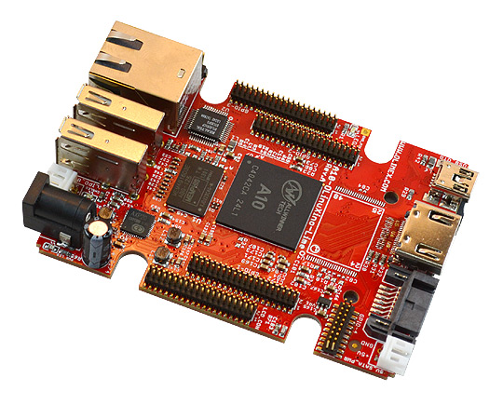
Figure 5.10.9.1 - A10-OLinuXino-LIME

Microcontroller Changes in Senior Design II
This is truly one of the largest changes within the project. Initially, we wanted a one microcontroller system where it could act as a jack-of-all-trades. This would allow the server to run locally and grab data from the sensors. We realized that the A10-LIME was too weak for our needs to run a GUI based Operating System, so we bit the bullet and went with the dual-core A20-LIME2. This was shortly vetoed as well when we realized that the only package available for the A20 was a BGA package. This would have been extremely difficult and time consuming to solder. Instead, we went with a traditional microcontroller and Wi-Fi chip due to time constraints. From research, we saw that the Ardiuno UNO and in turn, the Atmega 328P, were popular choices for most projects on the internet. The reason for this is the low power requirements, the simplicity of the Arduino IDE, and the large software library support. The Atmega typically draws around 5.2mA at 5V and peaks around 9mA, although we measured it to be around 20mA. In addition to the Atmega 328P, most projects that require the use of the internet use an ESP8266 product. This Wi-Fi chip is quite cheap and low power as well. It supports most encryption methods such as WEP, WPA, and WPA2 and can act as an access point and a client, both individually and simultaneously. Overall, this reduced our power consumption from 5W with just the microcontroller running to 4W with the entire system running at peak load.

Display
We will also need to consider a display as well to show our information from our sensors. Ideally, we would want this to be an interactive display that would dynamically update and show the user details in some time interval. A color display would be nice to implement an informative GUI application and display size is important as well to strike a balance between convenience and readability. Touch would also be nice to have so that the user can tap the screen and not have to fumble with a mouse.

Model | Price | Size | Resolution
LCD-OLinuXino-10-TS | 75EUR (~$91.00) | 10” | 1024x600
SunFounder | $125.99 | 10.1” | 1280x800
LANDZO | $42.88 | 7” | 800x480
Table 5.10.10.1 - Comparison of display prices and resolution

Model | Touch? | Power | Weight
LCD-OLinuXino-10-TS | Yes | TBD | TBD
SunFounder | Yes | 24W | 1.87lbs
LANDZO | Yes | 10W | 13.9oz
Table 5.10.10.2 - Comparison of display touch capabilities, power requirements, size, and weight. (The TBDs were on the datasheets)
The pricing varies quite wildly between the displays, but the higher the resolution, the higher the price point. The least expensive option by a country mile is the LANDZO display, but the resolution is poor, and the actual display is not large. It does feature a touchscreen by using a USB port to create the HID I/O device and requires the least amount of power and is the lightest.
On the other hand, the SunFounder display is the most expensive display on this list. This display also has the largest screen size and resolution at 10.1 inches and 1280x800 respectively, making this an HD resolution. It also uses USB for the touchscreen to act as a HID device. This device is normally meant for a Raspberry Pi as it has a Pi mount that probably can be repurposed for our microcontroller, but this may not guarantee compatibility with our MCU. However, as both the Pi and the A10-LIME can run both Debian and Ubuntu, so this may allow this product to be cross-compatible. For the main video input, this unit uses HDMI.
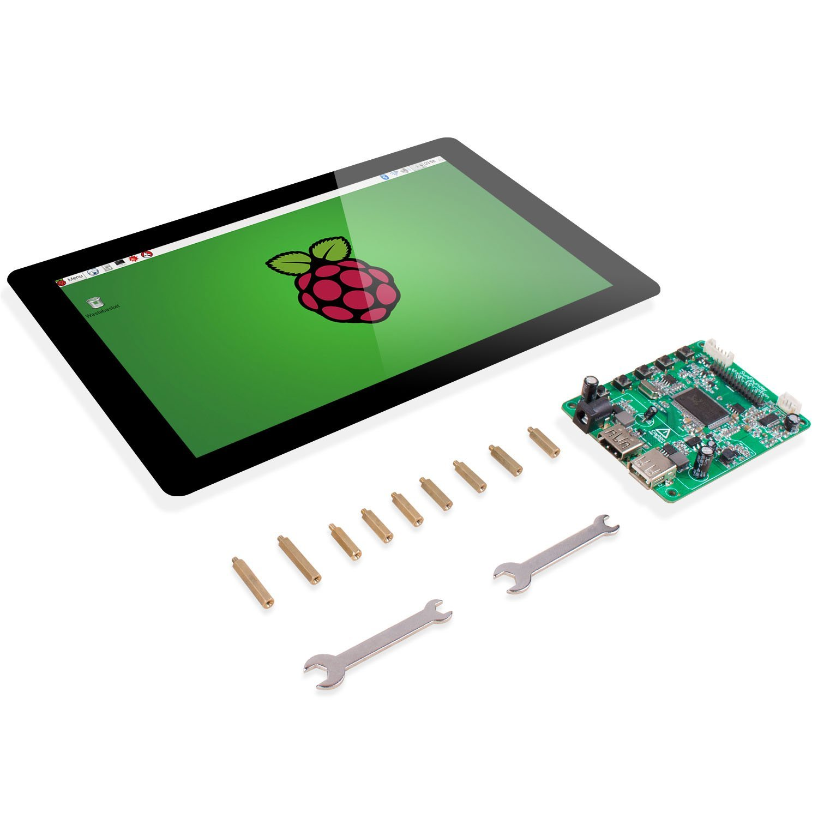
Figure 5.10.10.1 - SunFounder display
The final display that was chosen is one directly meant for the A10-LIME. This A10-display features a 10-inch screen with a maximum resolution of 1024x600. Instead of using HDMI as with the other two displays, this display uses an LCD ribbon cable that directly attaches to the microcontroller. The way the touchscreen is intercepted is unknown but possibly uses some form of GPIO. Not much information is given about this display from the datasheet including power and weight.
All these displays are quite functional and can be used for this project. While 7 inches on the LANDZO display is a bit too small for this project, the resolution is also quite poor, but it does use HDMI and is the least expensive. The A10-display has the middle ground resolution and price but uses an LCD Connector and an unknown method of translating touch to HID clicks or taps. THE LCD Connector limits how far the display can be from the device as the parallel devices such as a ribbon cable cannot be lengthened past a certain point otherwise there will too much noise and crosstalk on the connection. In contrast, the HDMI cable used on the SunFounder display also has a maximum range, but it is quite a bit farther than the LCD Connector. An HDMI cable can be around 100ft in length before the signal starts to degrade due to its serial nature. The USB cable that is used for touch can also be that length before signal degradation happens. It is for that reason that we will be going with the SunFounder display. It is the most expensive display in this comparison, but it is the most feature-packed and will suit our needs so that we can move the display around. While there is the possibility that the touch portion may not work due to conflicting hardware, there is a good chance that it will due to how Linux handles HID devices as this device is driverless and both microcontrollers run a form of Linux, specifically Debian and Ubuntu.

Display Changes in Senior Design II
We are not using a display for this project any longer. This is because our microcontroller does not have any means for displaying anything due to its low power. Instead, we are fully relying on a web application to display the sensor data in a cohesive way.

Printed Circuit Board (PCB)
The printed circuit board will be designed using OrCAD PCB Design Editor. This design software was chosen because of a team member’s familiarity with it. OrCAD Capture CIS will also be used to create schematic drawings for the project. Using these two programs together will provide an easy way of transferring any circuit connections and PCB footprints from Capture CIS to the PCB Design Editor.

Designs will begin in OrCAD Capture by creating schematic drawings. These drawings will show each electronic component that has been chosen and all the connections between them. OrCAD capture has the capabilities to accurately add these needed components through default, or even custom, libraries. Most discrete components can be found in the default libraries. Custom libraries will be created to ensure that the sensors implemented are accurately represented. Block diagrams will also be created and used in the schematics. These diagrams will help illustrate and create a better understanding of how the system should operate.
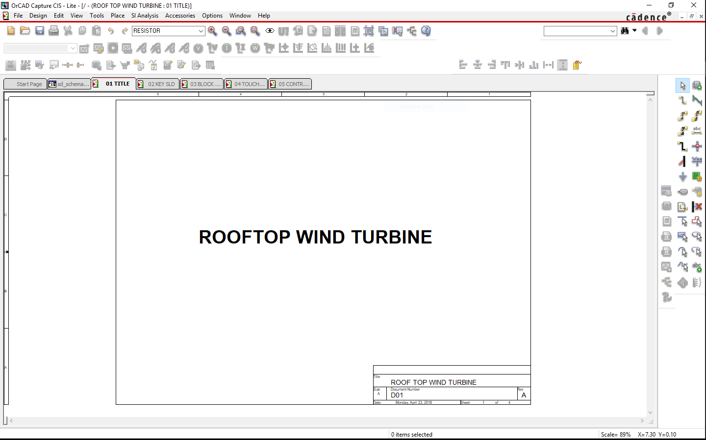
Figure 5.11.1.1: OrCAD Capture CIS Interface
The final step of the circuit design will be placing components onto a PCB. OrCAD PCB editor will be used to create the layout of the board. PCB footprints will either be downloaded from libraries online or created using a wizard that is integrated into the software. Simple components like resistors and capacitors are readily available in SMD package types like 1206 and 1812. These types of components will likely be found in PCB design libraries. More complex parts like microcontrollers and RAM modules may not be easily found in libraries. These are the parts that will likely be created using the part wizard.

When all part footprints and pad stacks are accounted for, the challenge of placing components on the board will begin. At this point, all characteristics of the electric circuit should be known. This will help determine board characteristics like trace widths, annular ring radii, and the number of layers needed. We have not officially gotten to this point yet, but we have an idea of what is needed to complete a board. This knowledge will help us prepare for this part of the design.
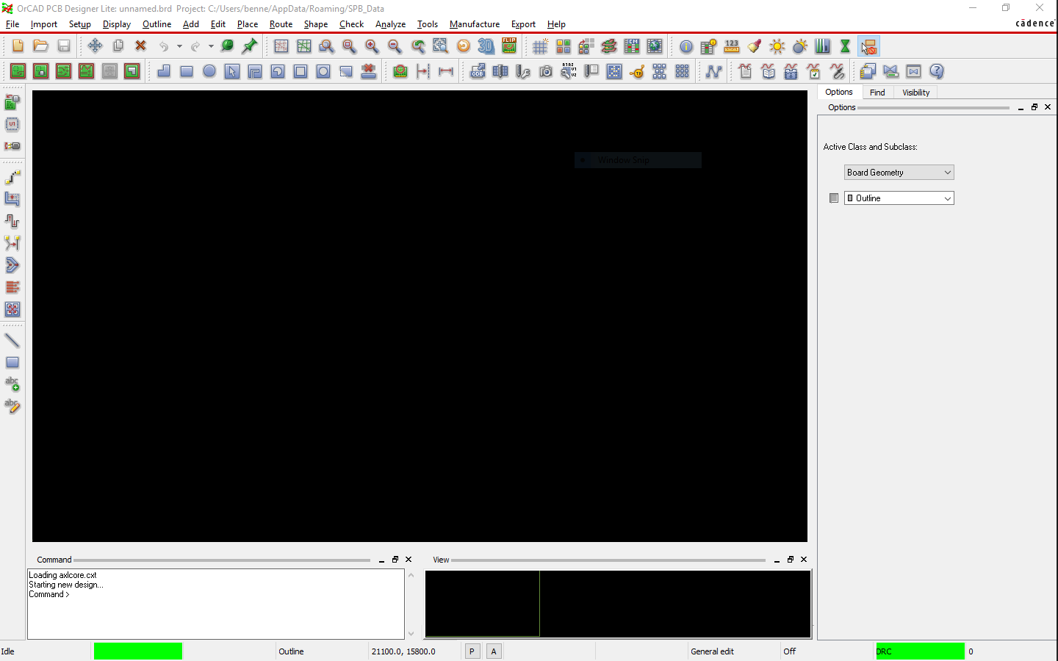
Figure 5.11.1.2: OrCAD PCB Editor Interface

Senior Design II PCB Implementations and Changes
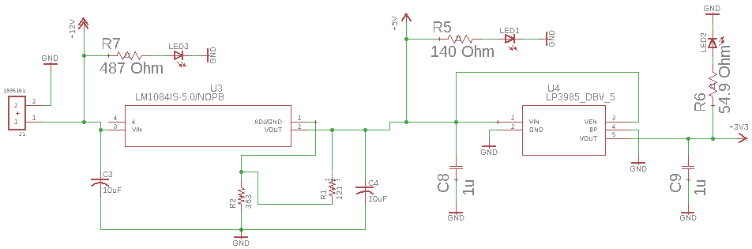
Our PCB design was created during the beginning of Senior Design II. OrCAD PCB editor was not used to create this because of complications with the software installation. Because of this, we relied on Eagle to create the design schematics and circuit board layout. First, the schematic shown in the next two images will be discussed.
Figure 5.12.1.1: Power Regulation Circuit
The schematic in Figure 5.12.1.1 displays the power regulation of the circuit. A terminal block takes the 12 volts from the battery and this voltage gets regulated by the two voltage regulators seen in the schematic. The first regulator, the LM1084, outputs a fixed 5 volts. The external circuitry for this regulator contains some input and output capacitors for noise reduction. There are also two resistors that we implemented. After testing the board, it was realized that these two resistors were not needed for the regulator. This set up was mistakenly implemented as an adjustable regulator. Because of this, the resistor R1 was removed and R2 was replaced with a short to ground.

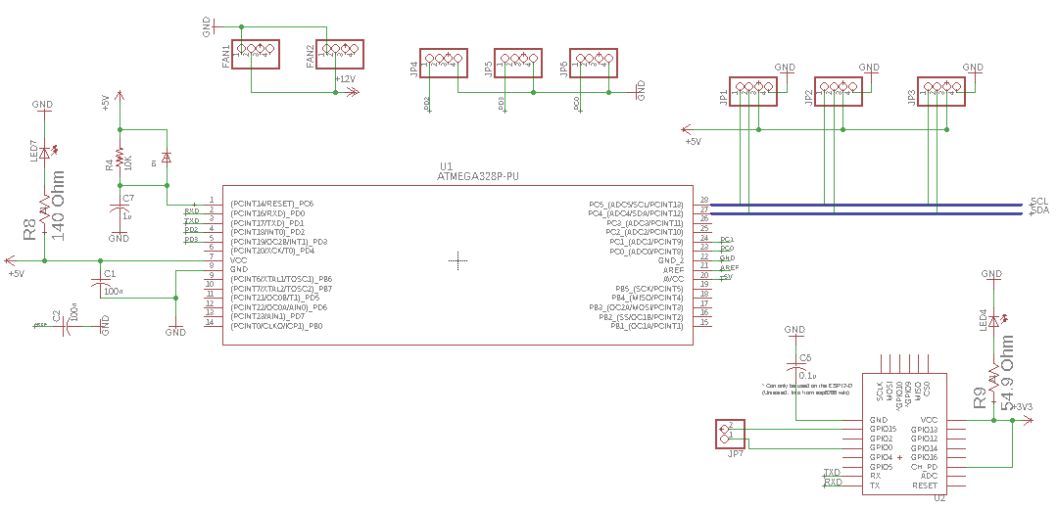
The 5 volts coming out of this regulator is taken by the 3.3 volt regulator. This is the fixed LP3985 regulator made by TI. As seen in the schematic, the external circuit only requires an input and output capacitor. This is how the first regulator should have been set up since they have fixed outputs. One issue that became apparent with the LP3985 was pin 4, the BP (bypass) pin. In the schematic, it is shown that this pin is connected directly to ground. After testing the circuit, it was discovered that the 3.3 volt regulator was not outputting any voltage. This is because the bypass pin was shorting the output pin. On the physical pcb, the trace from the bypass pin to ground was scratched out so it could be left open as it should have been.
Figure 5.12.1.2: Microcontroller and Wi-Fi Module Schematic
Next, the schematic above in Figure 5.12.1.2 will be discussed. This shows the microcontroller and Wi-Fi module used in the design. The microcontroller is the ATMega328P, which is the large component on the schematic. The Wi-Fi module in the bottom right corner is the ESP-12E, which uses an ESP8266 chip. The ATMega328P is connected to the ESP-12E through the TX and RX pins on both components. As seen in the schematic, the microcontroller is also connected to various header pins for sensor communication. An I²C bus on the right side of the ATMega328P is used for the temperature sensors and any possible I²C compatible devices that may be added. Headers JP4, JP5, and JP6 are connect to the anemometer, wind vane, and rain bucket, respectively. Two extra headers were initially connected to the 12-volt input to provide power to fans. In the end, the purpose of these two headers changed to power a USB charging circuit and an external voltage regulating circuit.

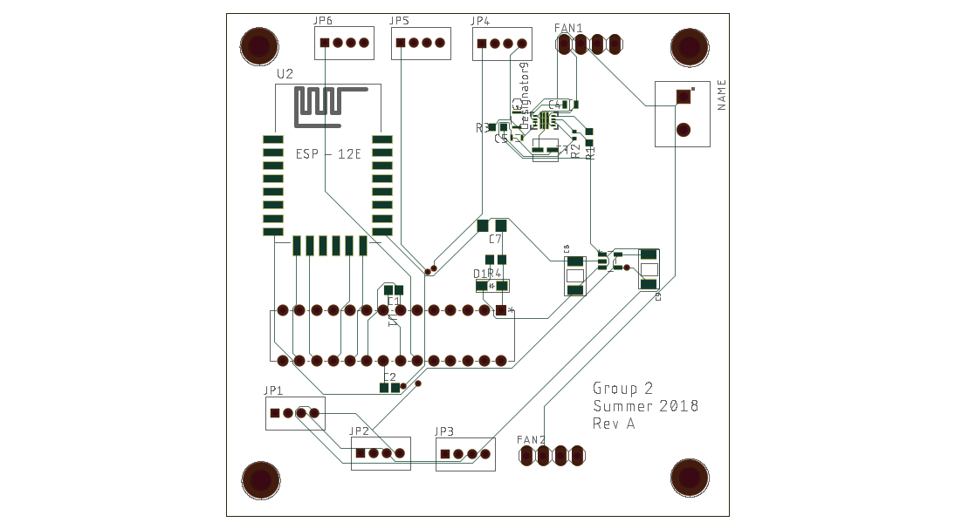
The next two images below show the layout of the PCB. Figure 5.12.1.3 shows the first revision of our board. One of the main issues here was the size of the 5 V regulator and its external circuit. The physical size of each component was completely overlooked when first designing this because of the lack of knowledge when choosing parts. Other issues existed with the ESP-12E. First, the orientation of the Wi-Fi module was not ideal because the antenna was not placed at the edge of the board like the data sheet suggested. This current orientation would allow for possible interference from any parts near the antennas.
Figure 5.12.1.3: Rev A of PCB Layout
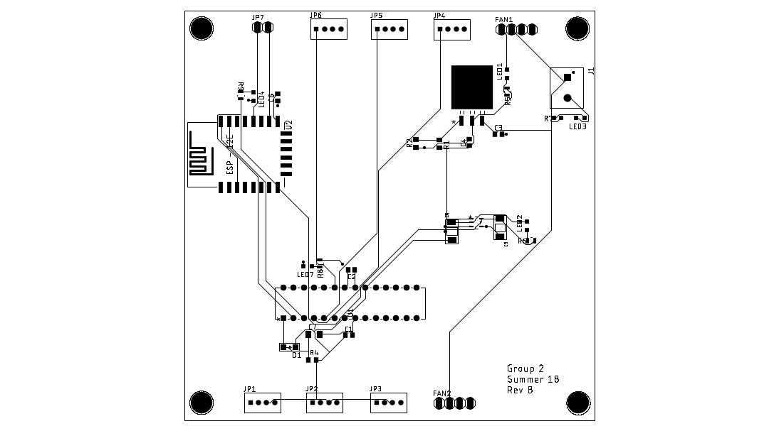
This first revision connected the ATMega328p and ESP-12E using their corresponding SPI pins, but a connection between the TX and RX pins were forgotten. All of these issues were addressed in the second revision of the board. A new 5 V regulator was selected for it’s larger size and ease of soldering. The ESP-12E was also oriented so that the antenna was directly at the edge of the board and the TX and RX connections were made to the ATMega328P. The board size was also increased to 4”x4” to allow for more room to solder.
Figure 5.12.1.4: Rev B of PCB Layout

Electrical Load List
A table displaying all the electrical loads for the project and the basic complementary parameters for the loads. The listed parameters of voltage, power consumption, type of current, and phase are important for determining connecting parts in the overall design such as regulators and cables.
Loads | Voltage (V) | Power Consumption (mA) | AC/DC
Temperature/Humidity Sensor | 5 | 5.2 typical | DC
Anemometer | 5 | 5.2 typical | DC
Wind Vane | 5 | 5.2 typical | DC
ATMega328P | 5 | 9 | DC
ESP-12E | 3.3 | 70 (idle)  320 (start-up)  120 (transmitting) | DC
Battery | 12 | N/A | DC

Table 5.12.1.1

Software Design and Details
While the heavy burden of our project relies on sensors and hardware, the software side of things is just as important. The software is what is going to read the data from the sensors and push it to the display and web page. The software will also control the web page and display. Therefore, it is crucial that a solid software design is followed so that all the pieces can interact correctly with one another.

Software Design Overview
Since the A10-OlinuXino-LIME is Linux based, it can use multiple programming languages. This is beneficial because it will allow us to make the web server run on the MCU itself. Additionally, it will allow us to utilize object-oriented programming languages instead of assembly or C. This will make writing the software much more streamlined. As discussed in the final code plan, we will be using python as our programming language of choice. It will be good experience for us, as neither of us has much experience writing code in python. For the server end, we will be using Node.js as our programming language.

The software will at a fundamental level, take data from the various sensors and pushes it to the display and to the web server. To do that, however, it will have to communicate with the hardware. Since most of our hardware has high compatibility with our MCU of choice, this will turn into just a matter of loading the appropriate libraries and getting and then pushing the data to the server and display.

Class Structure
The core nature of object-oriented software design is the use of different objects and classes to compose a project and for those separate entities to talk to each other. Thus, a rough outline of what our class structure will look like is as follows:

Main class:
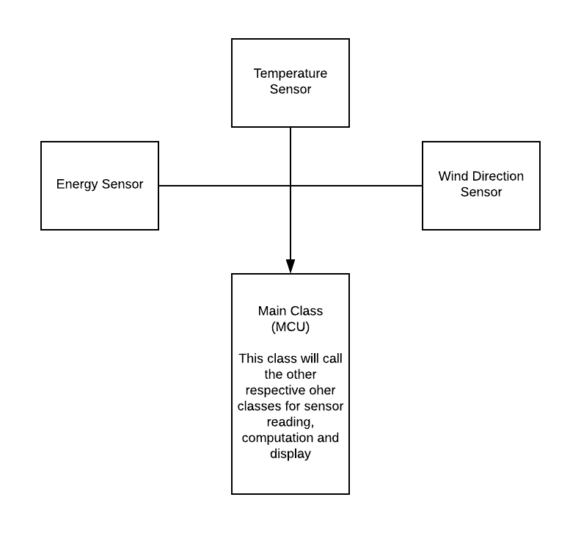
This class will be responsible for connecting every class together and transferring the data between the classes for processing. In the diagrams below, this will be referred to as the MCU.
Figure 6.2.1.1

Energy Sensor Class:
This class will be responsible for reading the data from the energy sensor and calculating the power being produced and then passing that data to the display driver class, the web server class, the energy data class and the wind speed class.

Some potential methods in this class include:

readEnergyFromSensor()

pushEnergyDataToDisplay()

pushEnergyDataToStorage()

pushEnergyDataToServer()

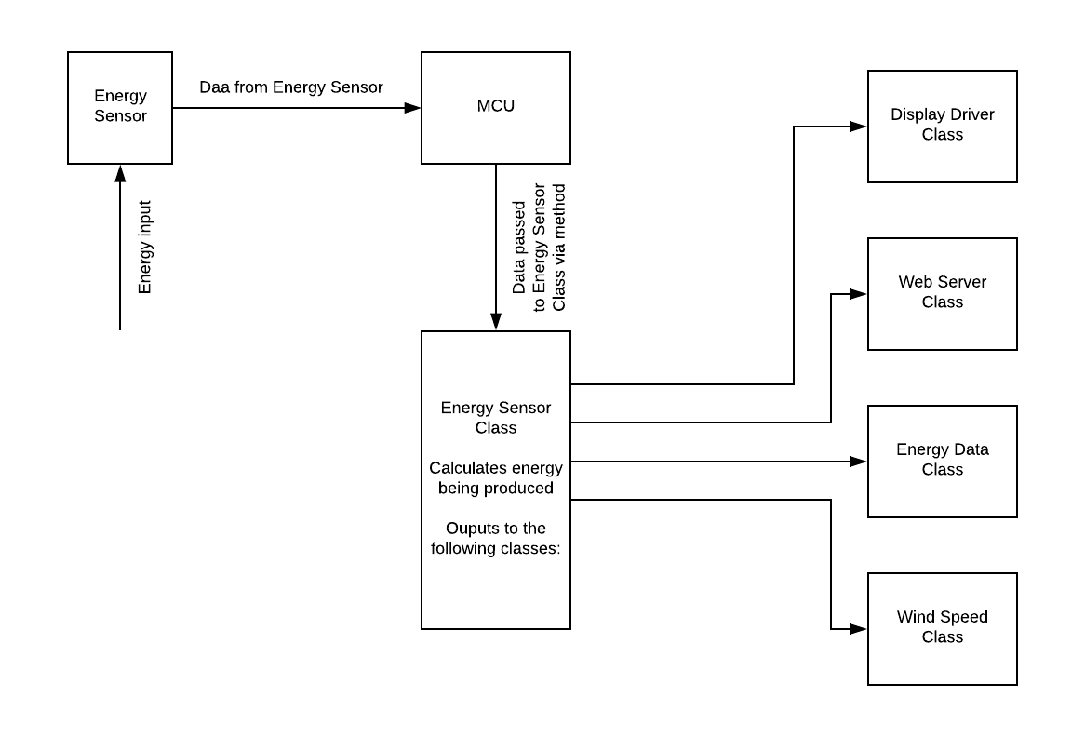
pushEnergyDataToWindSpeed()
Figure 6.2.2.1 Software and Hardware integration for the Energy sensor.

Wind Speed Class:
This class will take in the readings from the energy sensor and compute the approximate wind speed based on that data and then send that data to the Display Driver class, the Web Server class and the wind data class.

Some potential methods for this class include:

calculateWindSpeed()

pushWindSpeedDataToServer()

pushWindSpeedDataToStorage()

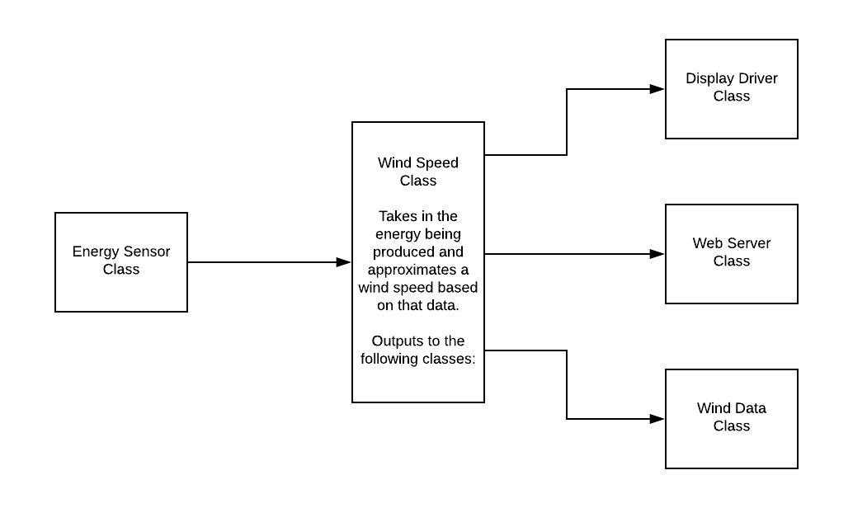
pushWindSpeedDataToDisplay()
Figure 6.2.3.1 Software Diagram for Wind Speed

Wind Direction Class:
Will take readings from the magnetometer sensor and compute the approximate direction of the wind and then push this data back to the main class where it will be pushed to the display and to the server.

Some potential methods for this class include:

calculateWindDirection()

pushWindDirectionDataToServer()

pushWindDirectionDataToStorage()

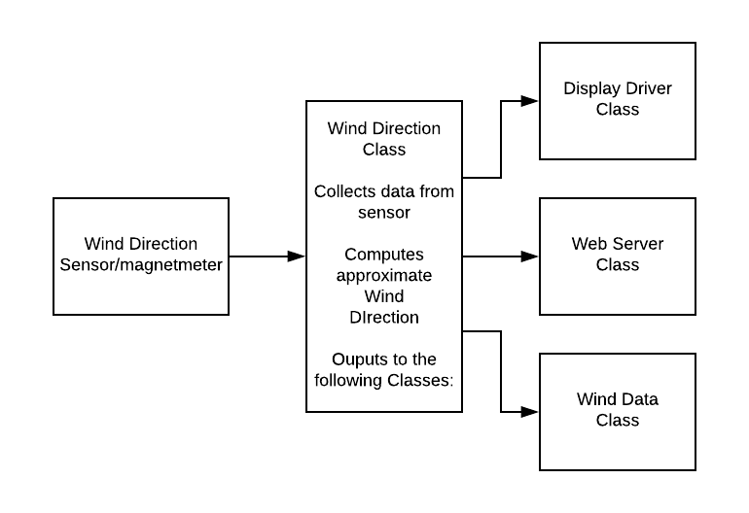
pushWindDirectionDataToDisplay()
Figure 6.2.4.1

Temperature sensor Class:
Will take in the readings from the energy sensor and compute the approximate temperature based on the data that is passed to it. It will then push this data to the display diver class, the web server class and the temperature data class.

Some potential methods for this class include:

calculateTemperature()

pushTemperatureDataToServer()

pushTemperatureDataToStorage()

pushTemperatureDataToDisplay()
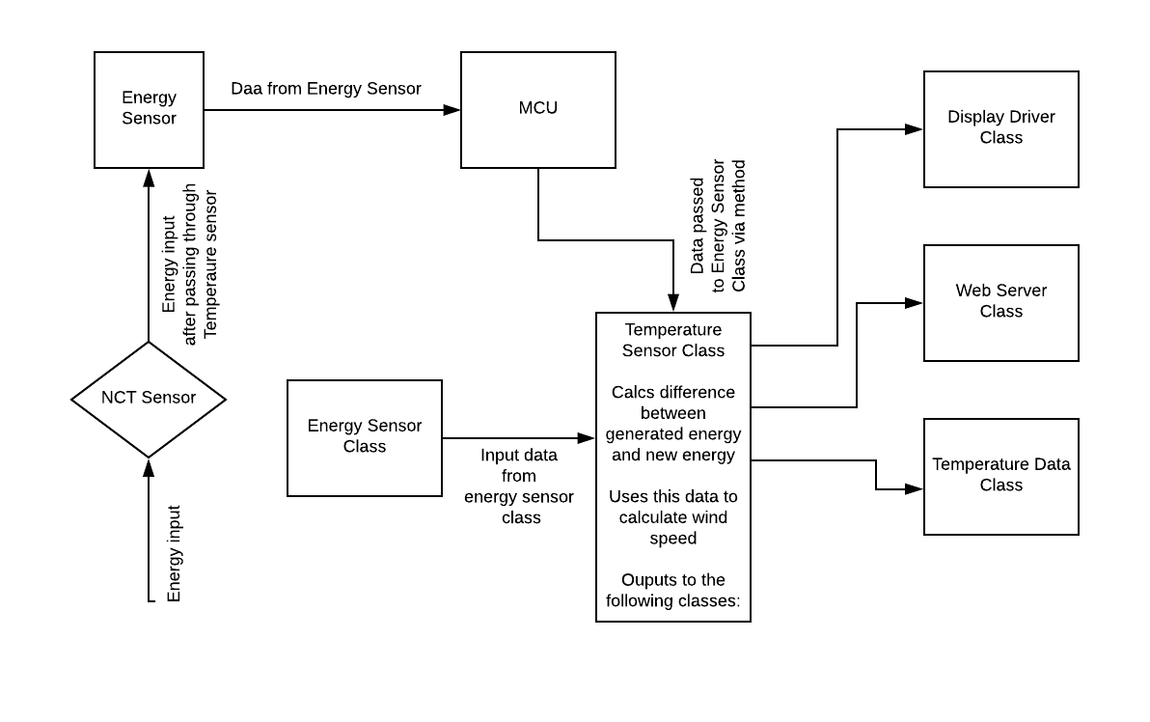
Figure 6.2.5.1 Software and Hardware interaction of Temperature sensor

Display Creation Class:
This class will be responsible for creating the boxes we see in the GUI screen, which is described more in the next section. This class will mainly let us choose the background color and add text and labels to the box before adding it to the screen. An example of a generic layout is shown below.

Some potential methods for this class include:

createDisplaySegment(bkgdcolor)

Energy Data Class:
This class will take in data from the energy sensor and average it over 15 minutes. It will then copy that average over to a text file for storage. If the user clicks on the additional information tab on the GUI, this class will also load the relevant data from the text file and create a graph representation of it and push that to the GUI for display.

Some potential methods for this class include:

averageEnergyData()

pushEnergyDataToTextFile()

pushEnergyDataToDisplay()

pushEnergyDataToServer()

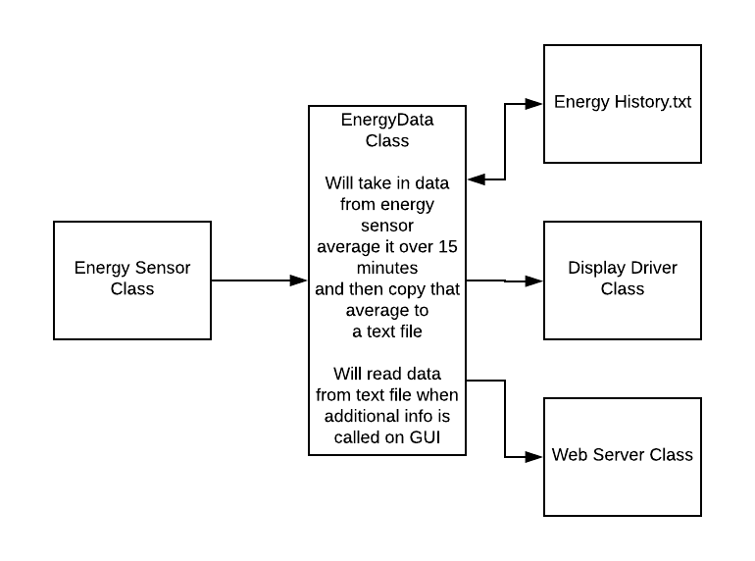
readEnergyDataFromTextFile()
Figure 6.2.7.1

Temperature Data Class:
This class will take in data from the temperature sensor and average it over 15 minutes. It will then copy that average over to a text file for storage. If the user clicks on the additional information tab on the GUI, this class will also load the relevant data from the text file and create a graph representation of it and push that to the GUI for display.

Some potential methods for this class include:

averageTemperatureData()

pushTemperatureDataToTextFile()

pushTemperatureDataToDisplay()

pushTemperatureDataToServer()

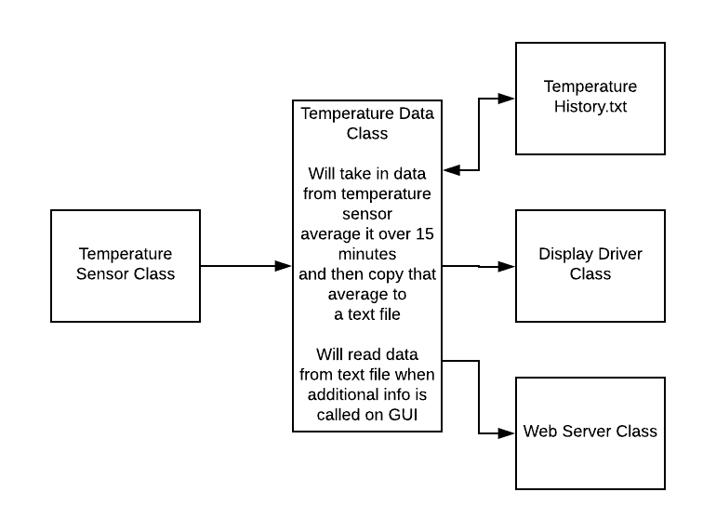
readTemperatureDataFromTextFile()

Figure 6.2.8.1

Web Server class:
This class will take in data from all sources and push it to the web server. If the user clicks on additional information on the web page, this class will request that data from the data classes. Otherwise, it will push the data from the sensor classes to the web page every minute so that the web page is as accurate as possible. The server will be using Node.js for its display, so the data would have to be converted to a JSON format before being pushed to the server.

Some potential methods for this class include:

createDisplayBox()

addDataToDisplayBox()

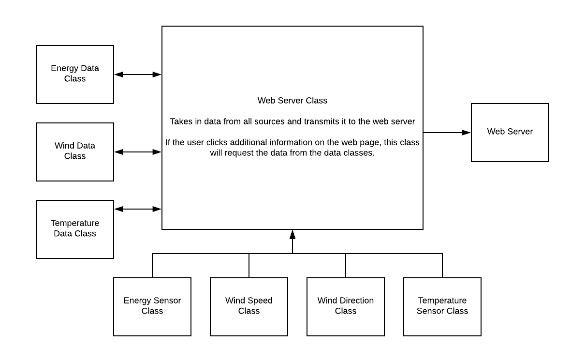
pushDisplayBoxToServer()
Figure 6.2.9.1 Web Server class

Display Driver class:
This class will operate in a very similar fashion to the web server class. It will take in data from all the sources and if the user clicks additional information on the GUI, it will request that information from the data classes.

Some potential methods for this class include:

createDisplayBox()

addDataToDisplayBox()

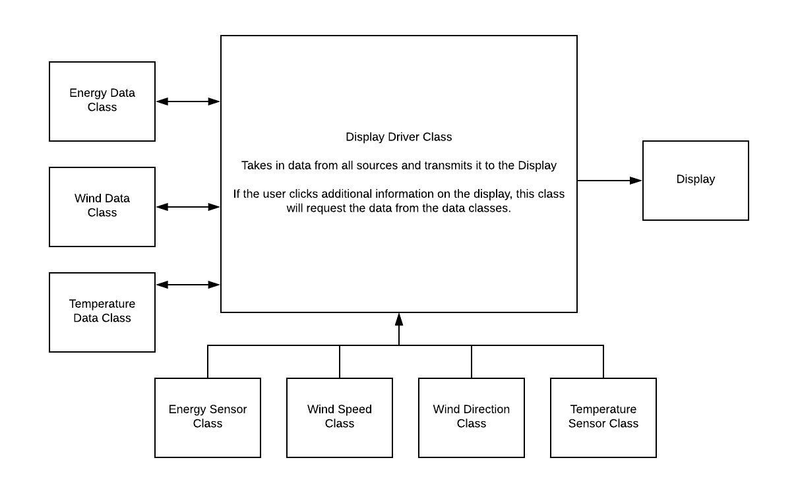
pushDisplayBoxToDisplayr()
Figure 6.2.10.1

Wind Data Class
Like the temperature data class and the energy data class, this class will save data about wind speed and direction and every 15 minutes, push the data to the text file to save RAM.

Some potential methods for this class include:

averageWindData()

pushWindDataToTextFile()

pushWindDataToDisplay()

pushWindDataToServer()

readWindDataFromTextFile()
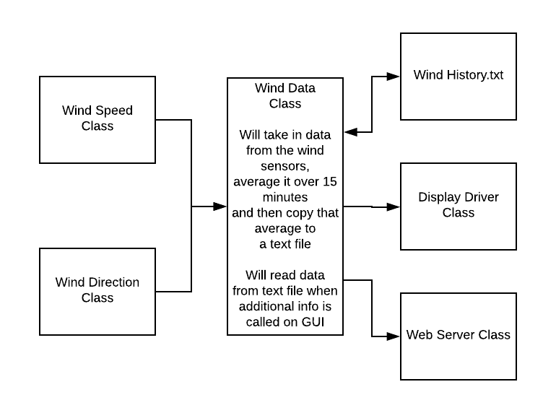
Figure 6.2.11.1

GUI Design
For our GUI for both the server and the display, we want the most relevant data to always be present, so the GUI will always display the most recent recording of wind speed, wind direction, temperature, and energy. Each piece of data will have its own dedicated section on the GUI. And while the information that is continuously shown is basic in nature, there will be an option to click to view more detailed information. Clicking this button will bring up a graph showing the various data in 15-minute increments over the past 2 hours.

Main Page Sketch
Figure 6.3.1.1 below shows a sketch of what we envision our home webpage on our website to look like. The different sensor measurements would be in separate sections and each one would have a button to expand the data in that section to show more data such as a graph.

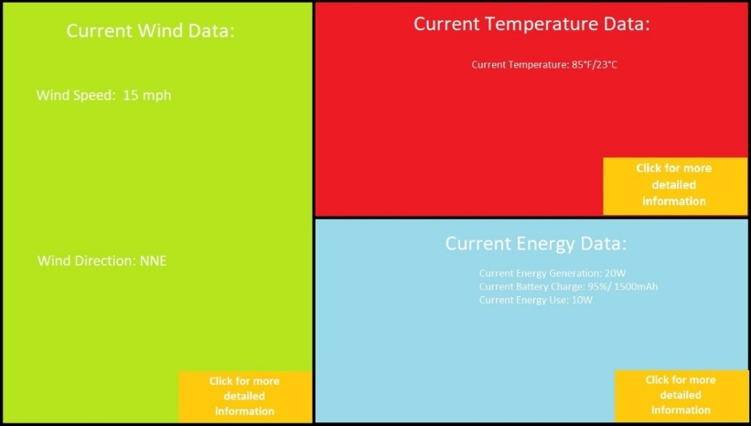
Figure 6.3.1.1 Sketch of what we envision our website homepage to look like

Detail Sketch
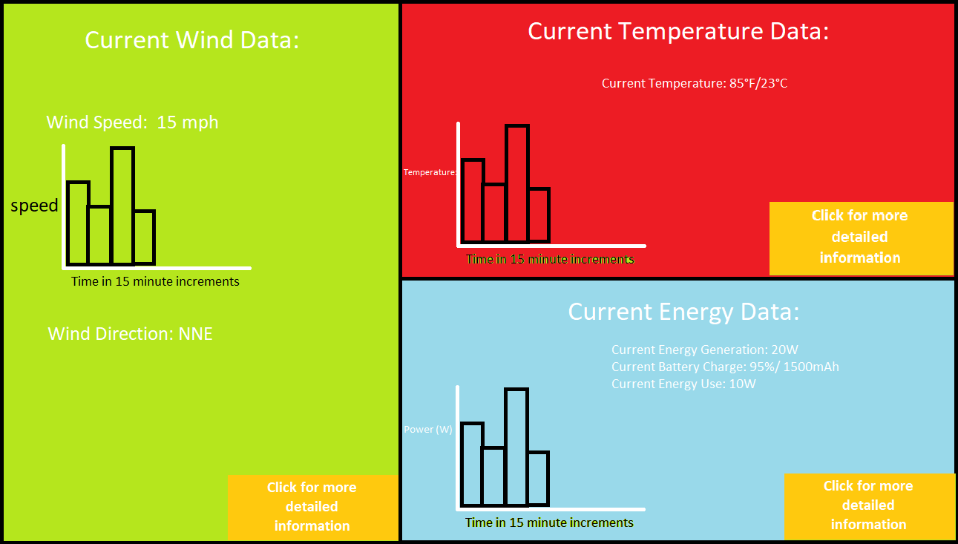
Figure 6.3.2.1 below shows what we envision our webpage to look like after you have clicked more details on a section. We want to have a graph that shows the most recent data, preferably from the last 2 hours or last 10 or so data readings
Figure 6.3.2.1 Preliminary view of our GUI after clicking the more detailed information in each box

As the project moves along, more data could be added to either screen, but what is currently shown will be the absolute minimum shown on the server/display at any given time. The current data will be data that is pulled and will be refreshed every 1 minute to provide the most accurate up to date information.

When it comes to the 15-minute time intervals, the data for those graphs will be the average over those 15 minutes. Additionally, some data that we could put on the graph could be max speed/temp/energy over the 15-minute time span as well as the low for that time span. On the server, an additional option could be added to load and display the text file that stores the data, if you wanted data that was older than 2 hours.

Software Design Changes in Senior Design II
Our software design had a lot of big changes in Senior Design, mainly because we switched from the A10 microcontroller, to the Atmega328P microcontroller.

Class Structure changes
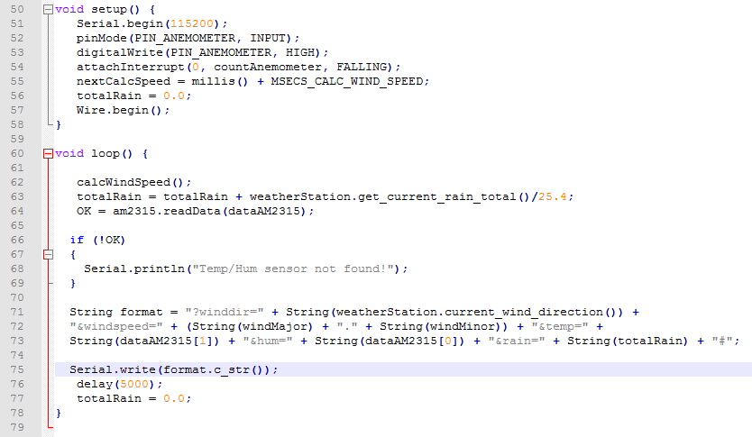
Firstly, the programming language used for the microcontroller changed from Python to C++. This is because the Atmega we are using utilizes the Arduino Uno Dev board and the default programming language for that is C++.
Figure 6.4.1.1 Main loop for Arduino

Another big change is the coding structure. Since we will no longer be using a display, there is no need for the display driver classes. The sensors we are using came with their own C++ libraries, so that also eliminated a lot of the extra code we would have had to write. In addition, our code would no longer be as heavily object oriented as we previously envisioned. So, all our class structures shown above will not be used.

Instead, we will have a single C++ file that includes the header files and libraries for our sensors. The data flow will be shown in the block diagram in section 8.2. This code will call functions from the sensor libraries in the main loop. The Atmega will take interrupts from the sensors as defined in their respective libraries. Figure 6.4.1.1 above shows a brief excerpt from our main loop.

GUI changes
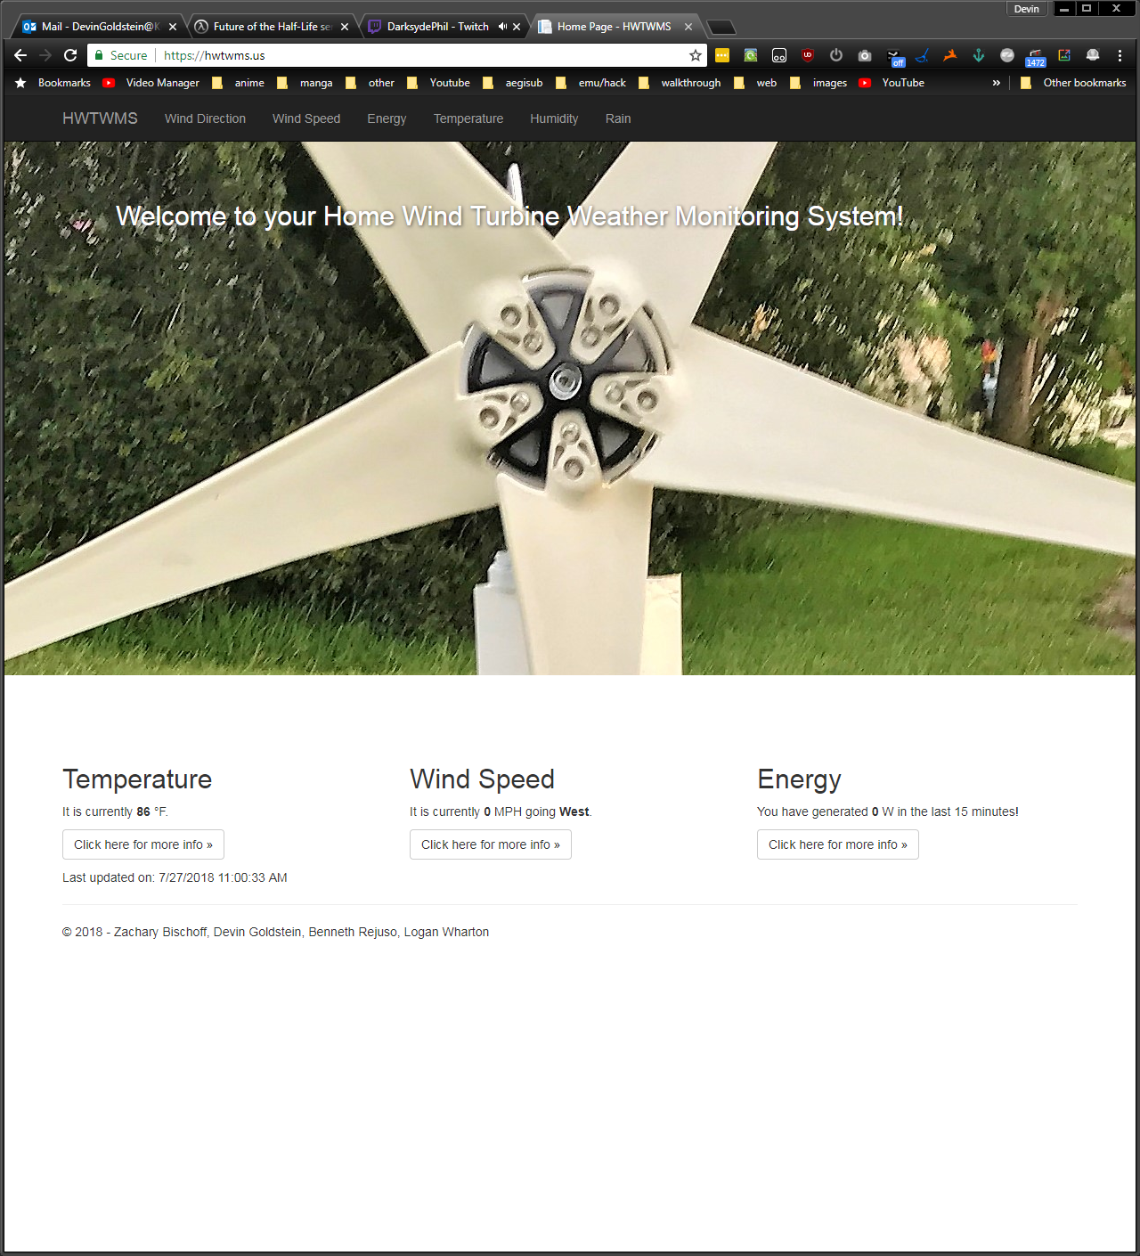
Another big change is our UI design. We had previously envisioned using a display in conjunction with a website for our project. However, we eventually settled on just using a website and using an iPad or other portable electronic device to display the website. This accomplished the same function as a display, but eradicated the need for an HDMI port on the microcontroller as well as the extra code we would have had to write to support the display. Figure 6.4.2.1 shows the final result of our homepage on our website. It contains a picture of our wind turbine itself, as well as the current/last recorded temperature, wind speed and direction and how much energy was produced in the last 15 minutes. Across the top we have links to the individual webpages for each measurement as well that contain graphs and the last 24 data readings.
Figure 6.4.2.1 Final Website Homepage

In figure 6.4.2.2 below, the final rendition of our detailed measurement page is shown. All of the pages contain a graph except for the wind direction page. The wind direction page contains only a table with the last 2 SQL database entries. The other pages default to showing a graph with an option to toggle a data table that will show the last 24 entries into the SQL database. The graph is coded in JavaScript, specifically Chart.js. This makes the graph mobile friendly, which will allow us to view the data on an iPad as we previously mentioned.

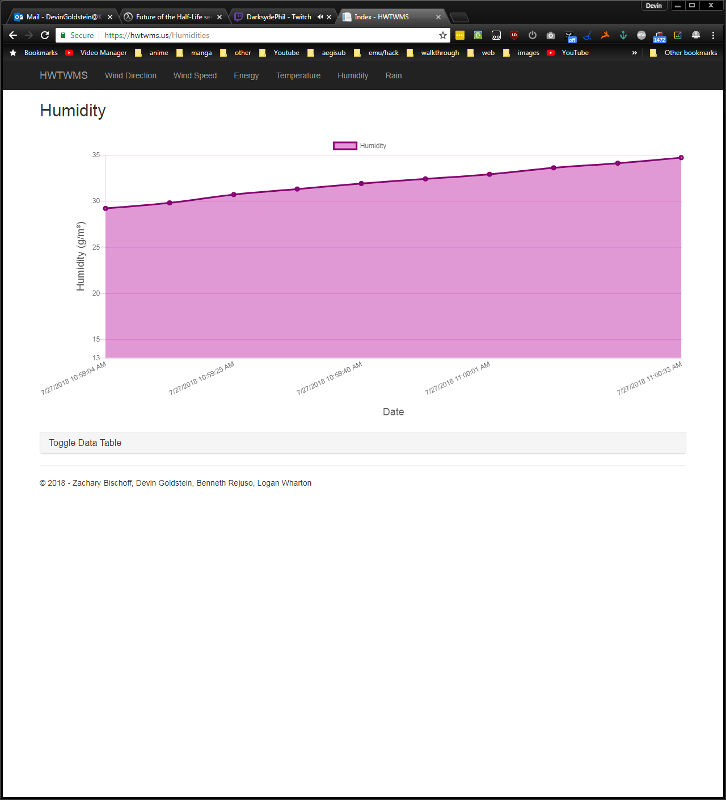
Figure 6.4.2.2 Final Webpage of more detailed information

Engineering Codes and Standards
This section will cover the standards related to the wind turbine and associated components. The standards will be listed out one by one first. After the standards will be discussed in the same order as listed to determine its impact on our wind turbine design.

Wind turbine Codes and Standards
Standards and codes are from several sources including but not limited to IEC, ISO, CSA, etc. There is some overlap between standards and this will be mentioned in section 7.2. There might be more standards that might apply to project but these were the major ones that we could locate for free with a description. Not all standards and codes listed here will be directly applicable and that will be explained also in section 7.2.

IEC 60050-415 Ed. 1.0 b:1999
International Electrotechnical Vocabulary - Part 415: Wind turbine generator systems

ISO 12494:2017
Atmospheric icing of structures
ISO 12494:2017 describes the general principles of determining ice load on structures of the types listed in this clause. In cases where a certain structure is not directly covered by this or another standard or recommendation, designers can use the intentions of this document. However, it is the user's responsibility to carefully consider the applicability of this document to the structure in question. The practical use of all data in this document is based upon certain knowledge of the site of the structure. Information about the degree of normal icing amounts (= ice classes) for the site in question is used. For many areas, however, no information is available. Even in such cases, this document can be useful because local meteorologists or other experienced persons should be able to, on the safe side, estimate a proper ice class. Using such an estimate in the structural design will result in a much safer structure than designing without any considerations for problems due to ice. CAUTION it is extremely important to design for some ice instead of no ice, and then the question of whether the amount of ice was correct is of less importance. In particular, the action of wind can be increased considerably due to both increased exposed area and increased drag coefficient. ISO 12494:2017 is intended for use in determining ice mass and wind load on the iced structure for the following types of structure: - masts; - towers; - antennas and antenna structures; - cables, stays, guy ropes, etc.; - rope ways (cable railways); - structures for ski-lifts; - buildings or parts of them exposed to potential icing; - towers for special types of construction such as transmission lines, wind turbines, etc. Atmospheric icing on electrical overhead lines is covered by IEC (International Electrotechnical Commission) standards. This document is intended to be used in conjunction with ISO 2394. NOTE some typical types of structure are mentioned, but other types can also be considered by designers by thinking in terms of which type of structure is sensitive to unforeseen ice, and act thereafter. Also, in many cases, only parts of structures are to be designed for ice loads because they are more vulnerable to unforeseen ice than is the whole structure. Even if electrical overhead lines are covered by IEC standards, designers can use this document for the mast structures to overhead lines (which are not covered by IEC standards) if they so wish.

ANSI/AGMA/AWEA 6006-A03 (R2016)
Design and Specification of Gearboxes for Wind Turbines

IEC 60076-16 Ed. 1.0 b:2011
Power transformers - Part 16: Transformers for wind turbine applications
"IEC 60076-16:2011 applies to dry-type and liquid-immersed transformers for rated power 100 kVA up to 10 000 kVA for wind turbine applications having a winding with highest voltage for equipment up to and including 36 kV and at least one winding operating at a voltage greater than 1,1 kV."

ISO 12925-1:2018
Lubricants, industrial oils and related products (class L) - Family C (gears) - Part 1: Specifications for lubricants for enclosed gear systems
ISO 12925-1:2018 establishes the specifications relative to family C (gears) for lubricants, industrial oils and related products of Class L (see ISO 6743 6). This document deals only with lubricants for enclosed gear systems. Lubricants for open gears and greases for gears (enclosed or open) are not covered. ISO 12925-1:2018 can be read in conjunction with ISO 6743 6. The following categories specified in ISO 6743 6 are covered by this document: CKB, CKC, CKD, CKE, CKSMP, CKTG, CKES, CKPG, CKPR.

AS 4959-2010
Acoustics - Measurement, prediction and assessment of noise from wind turbine generators (FOREIGN STANDARD)
Sets out a method for the measurement, prediction and assessment of noise from wind turbine generators.

BS EN 50308:2004
Wind turbines. Protective measures. Requirements for design, operation and maintenance (British Standard)
This European Standard specifies requirements for protective measures relating to the health and safety of personnel, relevant to commissioning, operation and maintenance of wind turbines. It does not describe instructions and provisions for safe working during manufacture, transport, assembly and installation of the wind turbine. Requirements are specified regarding-- hardware provisions being a part of the turbine such as platforms, ladders, lighting,-- manuals and warning signs to accommodate safe and quick operation, inspection and maintenance. The requirements and/or measures specified account for the hazards-- of mechanical origin such as falling, slipping, locking in, -- of thermal origin (fire) such as burns by flames or explosions, -- of electricity such as contact with live parts, -- generated by noise such as stress and loss of hearing, -- generated by neglecting ergonomic principles in machine design such as unhealthy postures or human errors. This standard is prepared for horizontal axis, grid connected wind turbines. For other concepts (e.g. vertical axis turbines) the principles are still valid, but the specific rules or requirements have to be adjusted to the actual concept. Additional provisions and procedures are necessary for turbines installed in water or offshore. The present document only draws attention to these. Provisions and procedures for lifts and Suspended Access Equipment (SAE) in the turbine tower are not included in this standard. This standard is not applicable to wind turbines manufactured before the date of its publication by CENELEC.

BS EN 12843:2004
This Standard specifies requirements for precast concrete poles (also commonly called masts) (either all of a piece or composed of elements), reinforced and/or pre-stressed as structural elements; they may be hollow or solid and may receive or include additional components (e.g. cross-arms, platforms etc.), inserts and connectors. Additional elements may be connected to pole elements. Structures made from such elements in mono- or multi-legged form may be used for: - overhead electrical lines; - telecommunication lines; - overhead electrical lines for railways, trams and similar; - supports for lighting; - supports for loudspeaker installation; - antenna and telecommunication poles; - supports for wind turbines; - and similar installations. This Standard does not cover lighting columns for use in traffic circulation areas.

IEC 61400-1 Ed. 3.0 b:2005
Wind turbines - Part 1: Design requirements
"Specifies essential design requirements to ensure the engineering integrity of wind turbines. Provides an appropriate level of protection against damage from all hazards during the planned lifetime. Is concerned with all subsystems of wind turbines such as control and protection mechanisms, internal electrical systems, mechanical systems and support structures. Applies to wind turbines of all sizes. See IEC 61400-2 for small wind turbines."

IEC 61400-2 Ed. 3.0 b:2013
Wind turbines Part 2 Small wind turbines
IEC 61400 2 2013 deals with safety philosophy quality assurance and engineering integrity and specifies requirements for the safety of small wind turbines SWTs including design installation maintenance and operation under specified external conditions It provides the appropriate level of protection against damage from hazards from these systems during their planned lifetime This standard is concerned with all subsystems of SWTs such as protection mechanisms internal electrical systems mechanical systems support structures foundations and the electrical interconnection with the load While this standard is similar to IEC 61400 1 it does simplify and make significant changes in order to be applicable to small wind turbines The main changes with respect to the previous edition are as follows: the title has been modified to better reflect the scope and restructured into a part Design evaluation and a part Type testing to harmonize use with IEC 61400 22 conformity testing and certification. Caution provided regarding the use of simplified equations and added various annexes wind conditions tropical storms extreme environmental conditions EMC testing dynamic behavior etc.

IEC 61400-3 Ed. 1.0 b:2009
Wind turbines - Part 3: Design requirements for offshore wind turbines
"IEC 61400-3:2009 specifies additional requirements for assessment of the external conditions at an offshore wind turbine site and specifies essential design requirements to ensure the engineering integrity of offshore wind turbines. Its purpose is to provide an appropriate level of protection against damage from all hazards during the planned lifetime. Focuses on the engineering integrity of the structural components of an offshore wind turbine but is also concerned with subsystems such as control and protection mechanisms, internal electrical systems and mechanical systems. It should be used together with the appropriate IEC and ISO standards, in particular with IEC 61400-1."

IEC 61400-4 Ed. 1.0 en:2012
Wind turbines - Part 4: Design requirements for wind turbine gearboxes
IEC 61400-4:2012(E) is applicable to enclosed speed increasing gearboxes for horizontal axis wind turbine drivetrains with a power rating in excess of 500 kW. This standard applies to wind turbines installed onshore or offshore. It provides guidance on the analysis of the wind turbine loads in relation to the design of the gear and gearbox elements. The gearing elements covered by this standard include such gears as spur, helical or double helical and their combinations in parallel and epicyclic arrangements in the main power path. The standard is based on gearbox designs using rolling element bearings. Also included is guidance on the engineering of shafts, shaft hub interfaces, bearings and the gear case structure in the development of a fully integrated design that meets the rigors of the operating conditions. Lubrication of the transmission is covered along with prototype and production testing. Finally, guidance is provided on the operation and maintenance of the gearbox.

IEC 61400-11 Ed. 3.0 en:2012
Wind turbines - Part 11: Acoustic noise measurement techniques
IEC 61400-11:2012(E) presents measurement procedures that enable noise emissions of a wind turbine to be characterized. This involves using measurement methods appropriate to noise emission assessment at locations close to the machine, in order to avoid errors due to sound propagation, but far away enough to allow for the finite source size. The procedures described are different in some respects from those that would be adopted for noise assessment in community noise studies. They are intended to facilitate characterization of wind turbine noise with respect to a range of wind speeds and directions. Standardization of measurement procedures will also facilitate comparisons between different wind turbines. This new edition constitutes a technical revision, introducing new principles for data reduction procedures.

IEC 61400-12-1 Ed. 2.0 b:2017
Wind energy generation systems - Part 12-1: Power performance measurements of electricity producing wind turbines
IEC 61400-12-1:2017 specifies a procedure for measuring the power performance characteristics of a single wind turbine and applies to the testing of wind turbines of all types and sizes connected to the electrical power network. In addition, this standard describes a procedure to be used to determine the power performance characteristics of small wind turbines (as defined in IEC 61400-2) when connected to either the electric power network or a battery bank. The procedure can be used for performance evaluation of specific wind turbines at specific locations, but equally the methodology can be used to make generic comparisons between different wind turbine models or different wind turbine settings when site-specific conditions and data filtering influences are taken into account. This new edition includes the following significant technical changes with respect to the previous edition: new definition of wind speed, inclusion of wind shear and wind veer, revision of air density correction, revision of site calibration, revision to definition of power curve, interpolation to bin center method, revision of obstacle model, etc. Key words: Wind turbines, Wind energy, renewable energy, performance, efficiency

EC 61400-13 Ed. 1.0 b:2015
IEC 61400-13:2015(B) describes the measurement of fundamental structural loads on wind turbines for the purpose of the load simulation model validation. The standard prescribes the requirements and recommendations for site selection, signal selection, data acquisition, calibration, data verification, measurement load cases, capture matrix, post-processing, uncertainty determination and reporting. Informative annexes are also provided to improve understanding of testing methods. This standard replaces IEC TS 61400-13 published in 2001; it constitutes a technical revision and transition from technical specification to International Standard.

IEC/TS 61400-14 Ed. 1.0 en:2005
Wind turbines - Part 14: Declaration of apparent sound power level and tonality values
Gives guidelines for declaring the apparent sound power level and tonality of a batch of wind turbines. Is to be used in conjunction with IEC 61400-11 which gives measurement procedures for apparent sound power level and tonality.

IEC 61400-21 Ed. 2.0 b:2008
In turbines - Part 21: Measurement and assessment of power quality characteristics of grid connected wind turbines
"IEC 61400-21:2008 covers the definition and specification of the quantities to be determined for characterizing the power quality of a grid connected wind turbine; measurement procedures for quantifying the characteristics; and procedures for assessing compliance with power quality requirements, including estimation of the power quality expected from the wind turbine type. The main changes with respect to the previous edition deal with interharmonics and current distortions (<9 kHz); response to voltage dips; active power ramp rate limitation and set-point control; reactive power capabilities and set-point control; grid protection and reconnection time after grid faults."

IEC 61400-22 Ed. 1.0 b:2010
Wind turbines - Part 22: Conformity testing and certification
"IEC 61400-22:2010 defines rules and procedures for a certification system for wind turbines (WT) that comprises both type certification and certification of wind turbine projects installed on land or off-shore. This system specifies rules for procedures and management for carrying out conformity evaluation of WT and wind farms, with respect to specific standards and other technical requirements, relating to safety, reliability, performance, testing and interaction with electrical power networks. "

IEC 61400-23 Ed. 1.0 en:2014
Wind turbines - Part 23: Full-scale structural testing of rotor blades
IEC 61400-23:2014(EN) defines the requirements for full-scale structural testing of wind turbine blades and for the interpretation and evaluation of achieved test results. The standard focuses on aspects of testing related to an evaluation of the integrity of the blade, for use by manufacturers and third party investigators. The following tests are considered in this standard: - static load tests; - fatigue tests; - static load tests after fatigue tests; - tests determining other blade properties. The purpose of the tests is to confirm to an acceptable level of probability that the whole population of a blade type fulfils the design assumptions.

IEC 61400-24 Ed. 1.0 en:2010
Wind turbines - Part 24: Lightning protection
"IEC 61400-24:2010(E) applies to lightning protection of wind turbine generators and wind power systems. Defines the lightning environment for wind turbines and application of the environment for risk assessment for the wind turbine. Defines requirements for protection of blades, other structural components and electrical and control systems against both direct and indirect effects of lightning. Recommends test methods to validate compliance. Provides guidance on the use of applicable lightning protection, industrial electrical and EMC standards including earthing. Provides guidance regarding personal safety. Makes normative references to generic standards for lightning protection, low-voltage systems and high-voltage systems for machinery and installations and EMC. "

IEC 61400-25-1 Ed. 2.0 b:2017
Wind energy generation systems - Part 25-1: Communications for monitoring and control of wind power plants - Overall description of principles and models
IECá61400-25-1:2017 gives an overall description of the principles and models used in the IECá61400¡25 series, which is designed for a communication environment supported by a client-server model. Three areas are defined, that are modelled separately to ensure the scalability of implementations: wind power plant information models, information exchange model, and mapping of these two models to a standard communication profile. This new edition includes the following significant technical changes with respect to the previous edition: general harmonization of text and overview models with the other parts of the IECá61400¡25 series, harmonization of definitions in other related standards.

IEC 61400-25-2 Ed. 2.0 b:2015
Wind turbines - Part 25-2: Communications for monitoring and control of wind power plants - Information models
IEC 61400-25-2:2015 specifies the information model of devices and functions related to wind power plant applications. In particular, it specifies the compatible logical node names, and data names for communication between wind power plant components. This includes the relationship between logical devices, logical nodes and data. The names defined in the IEC 61400-25 series are used to build the hierarchical object references applied for communicating with components in wind power plants. Main changes with respect to the previous edition consist of: - harmonization with newer editions of IEC 61850 standards; - reduction of overlap between standards and simplification by increased referencing, - extension of data objects for operation of smart grids, - extended and enhanced semantics for existing data objects, etc.

IEC 61400-25-3 Ed. 2.0 b:2015
Wind turbines - Part 25-3: Communications for monitoring and control of wind power plants - Information exchange models
IEC 61400-25-3:2015 specifies an abstract communication service interface describing the information exchange between a client and a server for: - data access and retrieval, - device control, - event reporting and logging, - self-description of devices (device data dictionary), - data typing and discovery of data types. Main changes with respect to the previous edition consist of: - harmonization with newer editions of IEC 61850 standards; - reduction of overlap between standards and simplification by increased referencing, etc.

IEC 61400-25-4 Ed. 2.0 b:2016
IEC 61400-25-4:2016 specifies the specific mappings to protocol stacks encoding the messages required for the information exchange between a client and a remote server for: data access and retrieval, device control, event reporting and logging, publisher/subscriber, self-description of devices (device data dictionary), data typing and discovery of data types. The mappings specified in this part of IEC 61400-25 comprise: - a mapping to SOAP-based web services, - a mapping to OPC/XML-DA, - a mapping to IEC 61850-8-1 MMS, - a mapping to IEC 60870-5-104, - a mapping to DNP3. The main technical changes with regard to the previous edition are as follows: - general harmonization with information models in IEC 61400-25-2 and information exchange services in IEC 61400-25-3; - reduction of overlap between standards and simplification by increased referencing.

IEC 61400-25-5 Ed. 2.0 en:2017
Wind energy generation systems - Part 25-5: Communications for monitoring and control of wind power plants - Compliance testing
IECá61400-25-5:2017 specifies standard techniques for testing of compliance of implementations, as well as specific measurement techniques to be applied when declaring performance parameters. The use of these techniques will enhance the ability of users to purchase systems that integrate easily, operate correctly, and support the applications as intended. This part of IECá61400-25 defines: the methods and abstract test cases for compliance testing of server and client devices used in wind power plants; the metrics to be measured in said devices according to the communication requirements specified in IECá61400-25 (all parts). This new edition includes the following significant technical changes with respect to the previous edition: - harmonization with structure and test cases in IECá61850-10:2012; - reduction of overlap between standards and simplification by increased referencing to the IECá61850 standard series.

Codes and Standards Design Impact
As mentioned before this section will list go through each standard individually and discuss that standard or codes possible impact on our design.

IEC 600050-415 Ed. 1.0 b:1999
This standard is about using common, international electro technical terminology in the documentation for a wind turbine system. While this standard does not have a direct impact to our design, it is relevant to our project documentation and therefore we will abide using common electro technical terms throughout this document whenever possible.

ISO 12494:2017
This standard is for accounting for the possibility of ice load on a wind turbine. An ice load can decrease the efficiency and power output of a wind turbine. In the case of our design, we do not think that the potential of an ice load on a small wind turbine is great enough to consider ice load calculations. Ice load is more of concern for large wind turbines whose goal is the produce as much energy and efficiency in the megawatt as possible. We are only concerned about producing 500 watts, a minuscule amount in comparison. Even though we would ideally design our wind turbine system for far northern areas, where ice load for small wind turbines might be a concern, our goal of just producing supplementary power will lower the concern of ice load.

ANSI/AGMA/AWEA 6006-A03 (R2016)
This standard has to with the design and specification of the gearboxes inside of the wind turbine. This is not a design concern for us because the wind turbine we are purchasing comes with its own gearbox and therefore will meet these standards already. This assuming that seller of wind turbine did in fact adhere to this standard which is most likely the case. Nevertheless, upon procurement we will check gearbox for this standard if there is a possibility to have access to the inside of wind turbine we are buying.

IEC 60076-16 Ed. 1.0 b:2011
This standard is about power transformers and there application in wind turbines. Since our wind turbine is produces DC current there is no need for us to use a transformer so this standard is not applicable.

ISO 12925-1:2018
This standard covers lubricants for enclosed gear systems. This will not have a direct impact on our design but might need to be included for maintenance purposes.

AS 4959-2010
This standard is related to the acoustics measurement and assessment of a wind turbine. This is a consideration for us because our small wind turbine will not produce enough noise to be of concern.

BS EN 50308:2004
This standard regarding hardware provisions to facilitate inspection and maintenance. This is a British standard so it is not directly applicable to our project and even so our project is too small in scale for such hardware parts such as a ladder or manuals.

BS EN 12843:2004
British Standard regarding masts and poles. Since it is British we do not have adhere to it for our project but also this standard more so for large wind turbines not small wind turbines. Not applicable.

IEC 61400-1 Ed. 3.0 b:2005
Standard regarding the design requirements of a wind turbine. This standard will not affect our design. Since we are purchasing the wind turbine than we will not have to worry about the implementing the standards ourselves but we have double check that our wind turbine meets these standards after procurement.

IEC 61400-2 Ed. 3.0 b:2013
This standard is a rehash of the standard above, albeit more word specific for small wind turbines. As with the standard above, there will be no design impact from this standard. Just the need to double check to see that wind turbine meets these standards.

IEC 61400-3 Ed. 1.0 b:2009
This standard has to with farther design requirements for offshore wind turbines. This is not applicable to our project because our wind turbine will be onshore.

IEC 61400-4 Ed. 1.0 en:2012
This seems to overlap other standards mentioned before about gearbox design and lubrications. This will not be applicable to our design because the wind turbine should meet these standards

IEC 61400-11 Ed. 3.0 en:2012
This standard is an overlap of a previously listed standard about acoustic measurement for a wind turbine. Also not applicable for our small wind turbine project.

IEC 61400-12-1 Ed. 2.0 b:2017
This standard is for measurement of power performance of wind turbines. This standard could potentially affect our design because it applicable to wind turbines connected to battery banks. We will potentially have to add more sensors to account for the multitude of testing required and will have to incorporate this standard in hardware testing.

IEC 61400-13 Ed. 1.0 b:2015
Standard regarding measurement of mechanical loads. Should not be applicable to our small wind turbine and should be already accounted for by the seller. The only mechanical load we could encounter is icing and that is not relevant to our project.

IEC/TS 61400-14 Ed. 1.0 en:2005
Standard for declaring apparent sound power level. Not applicable to us because we are not concerned with the sound level of our small wind turbine. We believe sound level will not be concern due to the scale of our project.

IEC 61400-21 Ed. 2.0 b:2008
Standard having to deal with the measurement and assessment of grid-connect wind turbines. Is not applicable to us because our small wind turbine will not be connected at all. Connection to battery bank or off-grid connection.

IEC 61400-22 Ed. 1.0 b:2010
Standard concerning conformity testing and certification. Of wind turbines. This standard could have impact on design in terms testing and safety. Will account for it in hardware testing.

IEC 61400-23 Ed. 1.0 en:2014
Standard relating to the testing of the rotor blades. This standard is not applicable to us because this type of testing should have been performed by the manufacturer of our wind turbine.

IEC 61400-24 Ed. 1.0 en:2010
Standard regarding lightning protection. The wind turbine we will purchase should have already been designed with this standard in mind, show it should affect our design.

IEC 61400-25-1 Ed. 2.0 b:2017
Standard relating to Communications for monitoring and control wind power plant.

IEC 61400-25-2 Ed. 2.0 b:2015
Standard relating to Communications for monitoring and control wind power plant.

IEC 61400-25-3 Ed. 2.0 b:2015
Standard relating to Communications for monitoring and control wind power plant.

IEC 61400-25-4 Ed. 2.0 b:2016
Standard relating to Communications for monitoring and control wind power plant.

IEC 61400-25-4 Ed. 2.0 b:2016
Standard relating to Communications for monitoring and control wind power

Block Diagrams
These block diagrams will serve as a base to the project at hand. This will be a simplified version of the actual design behind the project and how all of the components are interconnected.

Hardware
This diagram shows how we intend to connect all the hardware components together. This is a very high-level diagram, and more specifics regarding each component are described in detail in other sections.

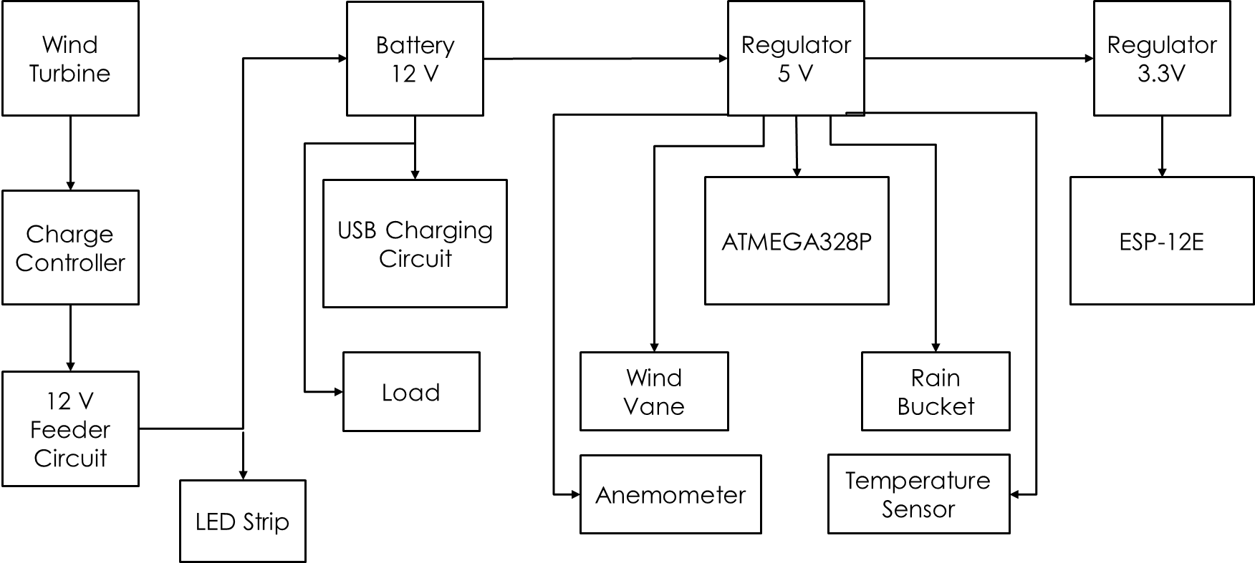
Figure 7.2.25.1

Software
The diagram below shows a high level over view of how we intend the software to interact with the various sensors and peripherals for our project. The software is described in more detail in section 6.2.
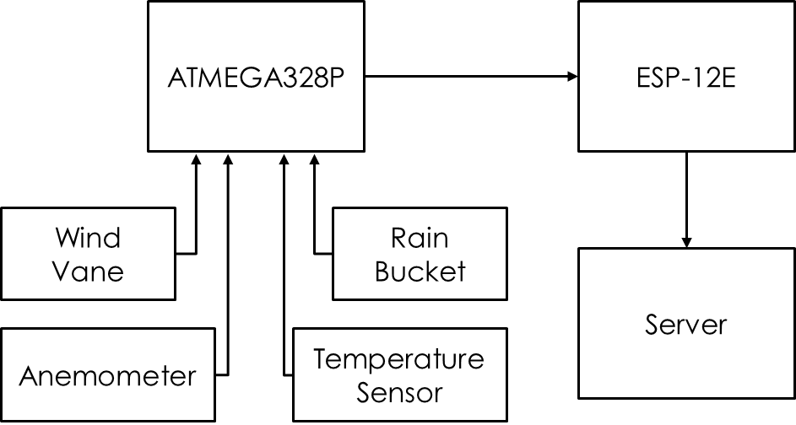
Figure 7.2.25.1

Project Prototype Construction and Coding
Most of the construction will be simple for some of the major components of this project. The wind turbine will be connected to the generator. A PVC pipe or similar object will act as a tower and a cable conduit connected to a base where most of the internals will be housed. The base material will need to be durable but not too expensive at the same time. It must also be somewhat weather-proof as there are electronics housed within it. However, we also need to make sure there is enough airflow so that our electronic do not get too hot, so ventilation must be added. Heatsinking may also be required if the electronics still get too hot even with increased passive cooling. Software will rely on the sensors and getting the correct data. We must connect our sensor to the correct GPIO and figure out whether the sensors are analog or not along with seeing whether that the GPIO on our microcontroller is analog or not. This can be simulated by strobing the GPIO pin by rapidly changing it from input to output.

Parts Acquisition and BOM
Most of the basic parts will be acquired from online retailers such as Amazon. Things such as the display, the microSD cards for the microcontroller, and cabling can be acquired from this retail giant. Prices are generally on-par or significantly cheaper on Amazon compared to other vendors and their large stock allowed us to compare different products and select what would be considered optimal for this project. The microcontroller on the other hand will need to be purchased from the manufacturer directly as no other retailer carries this specific one. Most of the sensors can be acquired from either sparkfun or adafruit. The sensors are relatively inexpensive and usually come on a breakout board that will be helpful when using the development board and prototyping/testing the system. Other major components such as the wind turbine itself and the battery that will be using will come from eBay. eBay usually has a large stock of used and or relatively uncommon items due to how many users sell on the platform. While batteries are quite common, this specific battery is not common enough to be sold on Amazon and the wind turbine is quite niece and will either must be ordered from eBay from someone who is selling it or buying it straight from the manufacturer, but that may not be possible due to the unbranded nature of the item in question.

PCB Vendor and Assembly
Once the PCB board design is confirmed to be completed, the board file will be sent to 4pcb.com to be printed. At least three boards will be ordered due to a special the manufacturer provides. If needed, a second rev of the PCB will be ordered with any changes. Assembly will be performed by the electrical engineering students that are a part of this group.

Final Coding Plan
As we will go with the A10-OLinuXino-LIME for our microcontroller, we will be using a Linux distro for the board meaning that we can write in higher-level languages such as C++ with templates (because we can freely dynamically allocate memory), Java, C#, Python, JavaScript, and so forth. Within Olimex’s GitHub repository lays the libraries necessary for manipulation of GPIO, I2C, and SPI. The libraries exist in two flavors: C and Python. The C library is a bit un-kept and we would have to write a bit of code to initialize the pins, set them to high low, and to pull data off them.

The Python library is the most complete and will be used instead as there would be no need to redundantly rewrite code for something that has been written. Python would also allow us to asynchronously pull data off the pins as we don’t need to get any of the data in any specific order. This would allow us to poll the data from the pins in any order and write to files whenever they are finished polling.
Figure 7.2.25.1 - Example of Python code to blink an LED on GPIO port PH2
This data would later be sent to a web server running on the device. This server could code written in any of the languages written above, minus C++ usually. Most server code has shifted away from using Apache or Nginx (Engine-X) and serving PHP and instead has shifted towards using Node.js as their primary server platform. Node.js allows the user to write JavaScript for server code and use that for their web server. JavaScript is a very common language used on the internet and browsers to allow for interactivity of web pages. For example, JavaScript was used to control playback on a video player and tells the video to seek to a certain part or even play and pause which would be styled with HTML and CSS on the frontend. However, JavaScript was only client-side where PHP or JSP would take of the server interactivity. With Node.js, the server can also be written in a familiar web language and expand the interactivity on the web page as JavaScript is inherently object-oriented allowing for the creation of classes, which allow for polymorphism and the like.
Figure 7.2.25.2 - Node.js JavaScript code to start a basic server with a webpage
All data from the sensors would be pushed to a Node.js server. The webpage that it is running would be divided into multiple sections depicting the temperature from the temperature sensors, the weather pulled from the internet, the wind speed and wind direction, and finally how much energy has been pulled in from the turbine. This page would be dynamic. When you tap or click on a section, for example, energy, a chart with energy vs time would appear displaying how much energy you have accused over time. This could also change into how much energy was generated per unit of time, say watts per hour.

Since our server will be available over the network and connected to a router, using Ethernet, we will set a static IP to the microcontroller. Any device in the house or wherever the system is can natively access the web page and get the information. An Apache or Nginx reverse proxy can be used along with a port forward of port 80 and port 443 for SSL and a free domain with a free SSL certificate from Let’s Encrypt to securely access the page over the internet.

We would also use the display and mount it somewhere convenient for the user such as a wall. Therefore, the user has two options for getting the system’s information: the user can access the web page using any device on the network or by walking to the display and interacting with it using the touch screen. Behind the scenes, SSH could be used for quickly resetting the server and microcontroller and installing updates without being intrusive to the other users of the system.
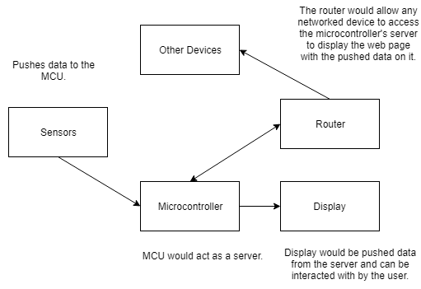
Figure 7.2.25.3 - Block diagram of network setup

Changes in Senior Design II
Since we did not go with the A10-LIME or even the A20-LIME, the software and coding plan changed quite a bit. Since we had switched to the Atmega 328P as our primary controller, the Arduino UNO became our development board. The Arduino line primarily uses the Arduino IDE as their primary IDE, so we followed suit. Instead of using Python, our primary language instead became C++ as that is the primary language of the IDE itself. The Arduino IDE simplifies the programming process and automatically adds the most used headers that the Arduino products use. Unlike Code Composer Studio, the Arduino IDE creates convenient wrapper functions for protocols most used on the platform such as Serial or I2C (or by their nomenclature, Wire). The serial connection can easily be activated with a specific baud rate by declaring Serial.begin(<baud>). Since our device also has more RAM than the MSP430, we can use the String library much more liberally because we have more memory and do not have to worry about memory fragmentation as much. While this can usually be done with sprintf from the standard stdlib.h header, the Arduino does not support the %f format specifier. Using sprintf over the String library would reduce our memory consumption, but as it stands, our program compiles and has plenty of memory free.
Conveniently, the ESP8266 also uses the Arduino IDE for its primary IDE. It can use most of the same functions that the Atmega uses as well as its own new set of functions. As stated before, this chip can connect to most Wi-Fi networks with speeds up to 802.11n with the only restriction on WPA2 Enterprise networks. The ESP8266 does not have any ability to connect to such networks without workarounds that may or may not work, however, most users will not have a problem with this. Whenever the sensor data is sent from the Atmega, it will be sent in a query string format where the ESP8266 will connect to the network and send data by accessing a web page and supplying it data via a GET request. Afterwards, it will go to sleep. If the ESP8266 is not connected to the internet, our fallback is that nothing happens, it goes to sleep until it is polled by the Atmega once again.
The web application is written in C# with the ASP.NET Core framework. For our database, we are using SQL Server 2016. Microsoft also provides a way to access a database without using raw SQL commands. This is known as Entity Framework Core (EF Core). EF Core allows for a migration model for a web application. This allows you to create a model representing a table within the database. This model is in a form of a class with standard properties such as an integer field for ID or a string field for name. Inside of a database model (DbContext), these tables/models can be added to the DbContext class as DbSets. Adding the migration will automatically create methods to add to the database and add and drop tables appropriately. The database is then updated and the programmer, for the most part, will not have to write any raw SQL commands and just perform database queries using a combination of the database context and LINQ statements. This allows for a protection layer against the database and attempts to mitigate SQL injection attacks to rip data from a database.
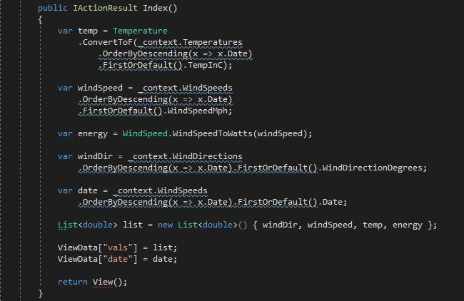
Figure 9.3.1.1 - Using LINQ and DbContext to gather data from the database without using raw SQL commands.
The Views or Pages themselves are written in a combination of C#, HTML, CSS, and JavaScript. The Controller sends data to the View based on what page a user requests and then the runtime compiler compiles the page with the data and renders everything as standard HTML, CSS, and JavaScript. For our purposes, each View will contain both a graph and table that displays the data when applicable. The graph is created by chart.js. When the View is requested, the database information is passed to the View and the View reencodes the data to JSON so chart.js can read that information and create the graph.
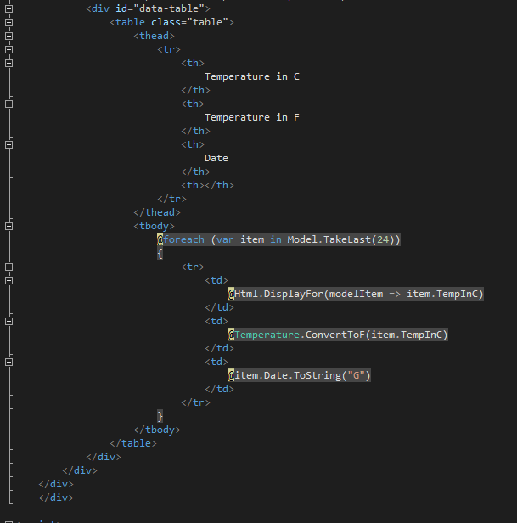
Figure 9.3.1.2 - Creating a table within a View using a combination of C# and HTML

Project Prototype Testing
Prototyping will be one of the most important parts of this project. Most of the sensors do not come with full specifications, so we will have to learn how each of them works via experimentation. Circuit design and components may change due to prototyping and experimentation if we find out, for example, we need to add a low-pass filter somewhere or we need to add resistance to a sensor to get the correct voltage for it to work. All the software requires that everything that comes into the microcontroller to be within a certain voltage range to not damage both the sensor and microcontroller, so it is important that we can get our power regulation correct. Most of the important hardware will be more robust, but we still want to get the correct data from it and supply it with the correct power requirements.

Hardware Test Environment
The first step to testing the hardware is to place each component on a breadboard. Every component should be connected the way that they need to be, and the voltage being supplied to each will be checked. Most of the IC’s on the board will be operating at either 3.3V or 5V, so it is very important to make sure that the 12V being supplied by the turbine will be stepped down to these voltages levels. This testing environment will provide some crucial information on components that are very important to the system’s operation. A working system on the breadboard will also translate to the PCB design to ensure that all electrical connections are correct.

To test the power being generated from the turbine, we will require that the turbine spins at different speeds. Since we cannot rely on Mother Nature to provide the correct wind speeds for us, we will be using an electric drill instead. This will allow us to simulate wind speeds at a couple of different levels. As mentioned previously in Section 5.8.1, we can use the turbine’s power curve to determine wind speed. For testing, we can generate our own power curve to compare with that provided by the manufacturer. This will ensure that out wind speed readings are as accurate as possible.

Circuitry Operation
The system will need to be powered by two sources, the turbine and battery. We will have the system set up to always be self-powered. In normal conditions, where winds are fast enough to rotate the turbine blades, the power generated should be supplying the sensors and microcontroller. This would be ideal because we are generating clean energy and it makes sense to use some of this to power the system. In the chance that wind speeds are not strong enough to spin the turbine, the system should be powered by the battery. This battery will be storing power while the generator is running, so it should always have enough juice to run any processes the microcontroller needs.

Software Test Environment
Most of the software code can be tested without the main assembly as most of the sensors do not rely on the completed product. Using a standard breadboard and breadboard wiring, we can connect most of the sensors to the microcontroller’s GPIO. To make this aspect more convenient and to make sure a display, keyboard, and mouse is not necessary, we will connect the microcontroller with Ethernet and use another computer to SSH into the microcontroller. This will allow us to access a full Linux terminal environment on the microcontroller over the network. We will then write Python scripts to access GPIO and pull data off the pins. Data will be written to stdout (standard output) and verify if our data is correct or if they need to be run through a formula for correctness. The Node.js server will run in the background and will be checked over the network if our Python script is also outputting the data into the JSON (JavaScript Object Notation) format within the time we have specified.

Software Test Environment Changes in Senior Design II
As it stands, almost everything has changed in terms of the software testing environment. All our sensors are connected to our main microcontroller, the Atmega 328P. In turn, the Atmega is connected to the ESP8266 through the serial UART connection to send and receive data. Instead of using SSH, we will use the built-in serial monitor that is built into the Arduino IDE, and with that, no mouse, display, or keyboard are directly required for the task at hand.
Another result from this shift is that we will no longer be required to limit ourselves to Linux only. The Arduino IDE is cross-compatible, so programming can be done on any Operating System. Our web application is running on the .NET Core Framework, which is also Operating System agnostic. Specifically, we are using ASP.NET Core 2.0 which allows one to use the Kestrel web server engine built into the framework. This works similarly to Node.js or the Python Django framework which start an HTTP server on port 8080. While all these ports can be configured, Kestrel starts on port 5000 on localhost. To correctly connect to the web server, a reverse proxy must be configured as by default, only the local machine can connect to the server. Kestrel allows for the UseUrls() method to specify binding on all IP addresses on the machine so that remote machines on the local network can connect to it.
While watching the serial monitor for the ESP8266, we can see whether the data has been sent to the server correctly. The web server is setup in such a way where it will display how many rows have been affected. If we see that all rows have been affected, the data has been saved to the database. At 0, it failed, and no information has been saved.

Standard Operations
As far as operations go, this system can be split into two sections: the energy generation from the wind turbine and the weather monitoring system. The energy generation system can mostly run on its own and does not need a lot of attention. The wind turbine will obviously spin on its own when there is a strong enough breeze and will also orientate itself towards the wind due to its tail. The energy produced will be sent through the charge controller before charging the battery. The charge controller contains some LED indicators that detect a battery connection, battery charging, and overcharging from the turbine. In case of overcharging, the charge controller will dump the extra energy to prevent the battery from getting damaged. From here, the energy stored in the battery is free to be used by the weather monitoring system and other loads that may be connected, i.e. the USB charging circuit that was built for this project.
The weather monitoring system is simply activated by an ON/OFF switch that is located near the battery. When switched ON, the battery feeds the PCB power. From here, the voltage level is regulated from 12 V to 5 V. Pin headers located at the top and bottom of the PCB also provide a 12 V connection. One of these headers is connected to the USB charging circuit, which has its own 5 V regulator and external circuit that limits the charging current to 500 mA. The other pin header is connected to a bypass regulation circuit. This circuit contains a 3.3 V regulator that provides this necessary voltage to the ESP-12E Wi-Fi module. This is bypassing the 3.3 V regulator on the PCB because it is current not operational. The 5 V and 3.3 V should power the ATMega328P and ESP-12E, respectively. When these two components are ON, the system is ready to start transmitting data to the web application.
If the ESP12-E fails to connect to the network, it will keep retrying every 5 seconds until it reestablishes a connection. From there, the ESP will not do anything until it receives data from its serial connection from the Atmega and the ESP will go into rest mode until then. Once then, it will attempt to connect the web server over the internet. If it succeeds, new data will be written to the database and will be immediately available for viewing on the web site. If it can’t find a connection, the data will not be sent to the server and the current data will be dumped until a connection to the internet can be established once again.

Budget
As our design became more complete, we started collecting pricing for various components that our project would need. In the beginning, we estimated that the cost of the project would be somewhere in the ballpark of $1000. However, after analyzing the costs of the components we will need, it was determined that the total cost would about half of our estimate at $569.85. But since unexpected issues arise, we will keep with our estimation of $1000 just in case we need to order more components, or if something breaks and we must spend money to fix it. Generally, it is a good rule of thumb to double what your estimated cost will be to have a cushion for those accidents.

Cost Table
Below is our cost table as described above. The most expensive component for our design is the wind turbine itself. The second most expensive component is the PCB and the revisions that we made to that. The microcontrollers themselves were cheap, but some of the material needed for soldering and components for building the tower were relatively expensive. We have gone with an estimate for $1,000 for the budget of the project, but after switching microcontrollers and ordering multiple PCBs, our final budget was around $1,200.

Item | Manufacturer P/N | Vendor | Price | Qty | Total Price
Wind Turbine | Nokita | Amazon | $212.00 | 1 | $212.00
Battery | ML35-124237139 | Ebay | $64.00 | 1 | $64.00
Tower | - | Home Depot | $30.00 | 1 | $30.00
PCB | - | 4PCB | $205.00 | 1 | $205.00
Power Cables | - | Home Depot | $20.00 | 1 | $20.00
Temperature Sensor | AM2315 | Amazon | $25.00 | 1 | $25.00
Fans | CO-9050012-WW | Amazon | $29.99 | 1 | $29.99
5V Regulator | LM1084IS-5.0/NOPB | Mouser | $0.50 | 2 | $1.00
3.3V Regulator | TPS780330200DDCR | Mouser | $1.00 | 2 | $2.00
ESP8266 | ESP-12E | Various | $3.00 | 4 | $12.00
ATMega | ATMega328P | DigiKey | $2.00 | 4 | $8.00
Circuit Components | - | Various | $100.00 | 1 | $100.00
Weather Sensors | Switchdoc Labs | Amazon | $100.00 | 1 | $100.00
Misc | Various | Various | $150.00 | 1 | $150.00
A10-LIME | A10-OLinuXino-LIME | Olimex | $40.00 | 2 | $80.00
A20-LIME | A20-OLinuXino-LIME | Olimex | $55.00 | 1 | $55.00
microSD cards | - | SanDisk | $16.00 | 2 | $32.00
Arduino UNO | - | Arduino | $30.00 | 1 | $30.00
NodeMCU ESP-12E | - | NodeMCU | $12.99 | 2 | $25.98
Total |  |  |  |  | $1181.97

Table 10.2.1.1

House of Quality
This is our preliminary house of quality. The goals are listed on the right-hand side and the specifications and their respective values are listed on the top and value. The values and relations are pending and are subject to change as we progress. The goals and the specifications with their values shall be listed out below for clarity.

Goals:
- Affordable
- Reliable/Useful
- Safe
- Easy to install/Operation
- Compact
- Smart Technology

Specifications:
- Power Output = 500 W
- Total Cost = $800
- Weight = 6.8 Kg
- Height = 4m
- Start-up wind speed = 2 m/s
- Survival wind speed = 50 m/s
- Rated wind speed = 13 m/s

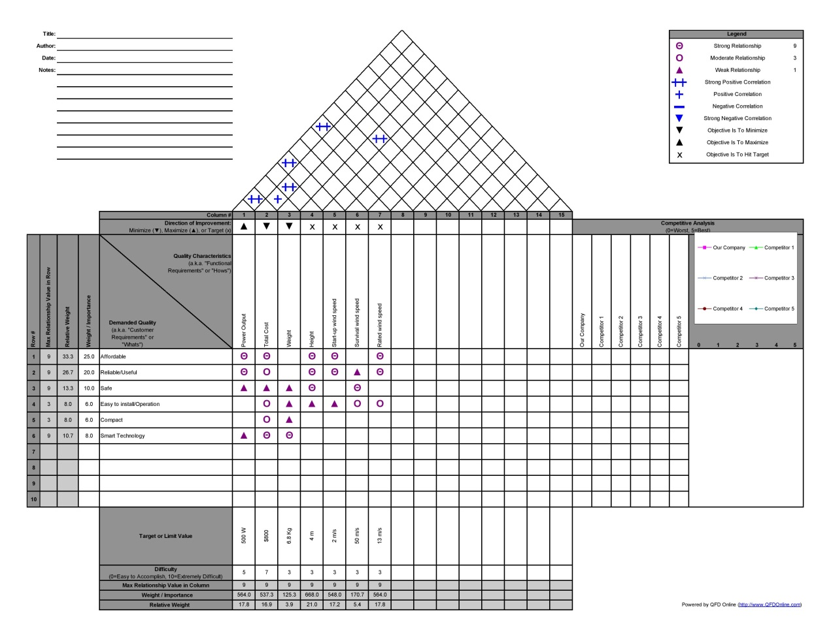
Figure 12.2.1 - House of Quality

Milestone Schedule
To successfully complete this project on time and within the given constraints and design goals, it is adamant that we adhere to a schedule to keep ourselves on track. Below is a tentative milestone list for our project. We have broken our milestones down into weeks, so that gives us a little bit of leeway when it comes to meeting deadlines. In addition, we have allotted some milestones to take more time than we expect them to, which we can then use should we run into issues elsewhere in the project.

Senior Design I - Spring 2018
Our Milestones for Senior Design I revolve around completing this research document. Since we changed projects around week 8, we actually had half the amount of time to complete these milestones but because of the extra weeks we gave ourselves, we were able to complete it within the allotted time.
Weeks | Milestones
Week 3 | Divide and Conquer: Initial documentation completed
Week 4 | First interdisciplinary meeting & first design interaction completed
Week 5 | Begin researching and adding to documentation
Week 6 | Decide on needed hardware and software
Week 6, 7 | Completed at least half of documentation completed
Week 8 | Begin layout of PCB
Week 9 | Restart with new project/Begin ordering parts
Week 10, 11 | Experiment with parts and start writing code
Week 12 | Have at least 75% of documentation completed
Week 13, 14 | Finish document and start proofreading entire document
Week 15 | Begin to finalize document
Week 16 | Documentation is completed
Table 10.2.1.1

Senior Design II - Summer 2018
Our milestones for Senior Design II revolve around building a prototype for our design. We have given ourselves extra weeks to complete certain milestones if we have a catastrophic failure or incident. Also, since we are doing this class during the summer, we have even less time to complete our milestones than we did for Senior Design I.

Weeks | Milestones
Week 1 | Begin constructing first prototype
Week 2 | Begin to Finalize Code, determine if parts for a mock 2 need to be ordered
Week 3 | Finish/Finalize Prototype 1
Week 4 | Finish/Finalize Prototype 1, Test Porotype 1
Week 5 | Test Prototype 1, analyze Test Results, note any changes that need to be made
Week 6 | Begin Building prototype 2
Week 7 | Finish/finalize prototype 2
Week 8 | Finish/finalize prototype 2, Test prototype 2
Week 9 | Test prototype 2, analyze test results, note any changes that need to be made
Week 10 | Implement any changes, make sure documentation is up to date
Week 11 | Final design product is working and ready to be finalized, finalize documentation
Week 12 | Final design product will be presented to board committee
Table 10.2.1.1

Bibliography
- BU-201: How does the Lead Acid Battery Work? (n.d.). Retrieved March 21, 2018, from http://batteryuniversity.com/learn/article/lead_based_batteries
- Lithium-based Batteries Information. (n.d.). Retrieved March 21, 2018, from http://batteryuniversity.com/learn/article/lithium_based_batteries
- BU-205: Types of Lithium-ion. (n.d.). Retrieved March 21, 2018, from http://batteryuniversity.com/learn/article/types_of_lithium_ion
- Battery and Energy Technologies. (n.d.). Retrieved March 23, 2018, from http://www.mpoweruk.com/nickel_hydrogen.htm
- Table 3.5.1. Characteristics of commonly used rechargeable batteries. Adapted from "BU-107: Comparison Table of Secondary Batteries," by Battery University. BU-107: Comparison Table of Secondary Batteries. Retrieved March 21, 2018, from http://batteryuniversity.com/learn/article/secondary_batteries. 2018 by Isidor Buchmann.
- Figure 3.5.1. Construction of SLAB. Adapted from "Sealed Lead Acid Batteries – The Basics," by Sandra Hoffman. Sealed Lead Acid Batteries – The Basics. Retrieved March 21, 2018, from https://www.upsbatterycenter.com/blog/wp-content/uploads/2014/04/Deep-Cycle.jpg
- Figure 3.8.1. An Anemometer(Wind speed sensor). Retrieved April 8th, 2018, from Raspberry Pi Learning Resources, https://www.raspberrypi.org/
- Figure 3.8.2 Reed Switch Retrieved April 8th, 2018, from Raspberry Pi Learning Resources, https://www.raspberrypi.org/
- Figure 3.5.3. Golf cart batteries in compartment. Adapted from "Electric Golf Cart Batteries – How to Make It Last Longer," by Wilsie Chimp. Electric Golf Cart Batteries – How to Make It Last Longer. Retrieved March 21, 2018, from https://www.upsbatterycenter.com/blog/wp-content/uploads/2014/04/Deep-Cycle.jpg
- Figure 3.5.5. Visualization of flooded lead acid battery. Adapted from "What is a Lead-Acid battery?" by Wilsie Chimp. What is a Lead-Acid battery? Retrieved March 21, 2018, from https://www.upsbatterycenter.com/blog/wp-content/uploads/2014/04/Deep-Cycle.jpg
- Figure 3.9.1 - A MSP430 Launchpad board with an MSP430G2553 processor. Retrieved April 7th, 2018, from TDEgypt https://www.tdegypt.com/product/msp430-launchpad-value-line-development-kit/
- Figure 3.9.2 - MSP430G2553 pinout diagram. Retrieved April 7th, 2018, from Argenox http://www.argenox.com/library/msp430/general-purpose-input-output-gpio-chapter-5/
- Figure 3.9.3 - MSP430 bit mapping and port grouping. Retrieved on April 7th, 2018 from OCFreaks! http://www.ocfreaks.com/msp430-gpio-programming-tutorial/
- Figure 3.9.4 - MSP430 JTAG diagram. Retrieved on April 8th, 2018 from Texas Instruments Wiki http://processors.wiki.ti.com/index.php/JTAG_(MSP430)
- Figure 3.9.5 - Code Composer Studio. Retrieved on April 8th, 2018 from nlvocables http://www.nlvocables.com/blog/?p=215
- Figure 3.9.6 - Raspberry Pi Model 3. Retrieved on April 8th, 2018 from Raspberry Pi https://www.raspberrypi.org/products/raspberry-pi-3-model-b/
- Figure 3.9.7 - Raspbian OS. Retrieved on April 8th, 2018 from Raspberry Pi Spy https://www.raspberrypi-spy.co.uk/2016/09/introducing-pixel-the-new-raspbian-desktop/
- Figure 3.9.8 - Raspberry Pi GPIO pinout. Retrieved on April 8th, 2018 from Raspberry Pi https://www.raspberrypi.org/documentation/usage/gpio-plus-and-raspi2/
- Figure 3.9.9 - Raspberry Pi GPIO Breakout Board. Retrieved on April 9th, 2018 from Pi My Life Up https://pimylifeup.com/raspberry-pi-gpio/
- Figure 3.9.10 - JTAG on Raspberry Pi. Retrieved on April 8th, 2018 from sysprogs https://sysprogs.com/VisualKernel/tutorials/raspberry/jtagsetup/
- Figure 3.9.11 - WiringPi library within an IDE - Retrieved April 9th, 2018 from sparkfun https://learn.sparkfun.com/tutorials/raspberry-gpio
- Figure 5.2.1 - Mini Wind Turbine. Retrieved on April 9th, 2018 from Voltec Energy http://voltecenergy.co.uk/wind-turbines/39-mini-wind-turbine-ew600-12v24v-with-generator-blades-and-charge-controller.html
- Figure 6.7.1 - Example figure of what functions the display could show. Retrieved on April 8th from OMG! Chrome! http://www.omgchrome.com/weather-apps-for-desktop-chrome/
- Figure 6.7.2 - Display for a Raspberry Pi. Retrieved on April 9th, 2018 from Raspberry Pi https://www.raspberrypi.org/products/raspberry-pi-touch-display/
- Figure 6.7.3 - Visual Studio with WiringPi.NET code. Retrieved on April 9th, 2018 from gitlearning https://gitlearning.wordpress.com/2016/06/01/single-led-circuit-with-the-pi/
- Figure 8.1.1 - Digital multimeter testing a circuit. Retrieved on April 9th, 2018 from adafruit https://learn.adafruit.com/multimeters/continuity
- Figure 8.3.1 - Raspberry Pi with a DHT11 temperature and humidity sensor. Retrieved on April 9th, 2018 from UUGear http://www.uugear.com/portfolio/dht11-humidity-temperature-sensor-module/
- Figure 3.8.4 WeatherRack - Anemometer / Wind Vane / Rain Bucket - Retrieved April 9th, 2018 from Amazon https://www.amazon.com/
- Figure 3.8.5: Temperature and Humidity Sensor - Retrieved on April 9th, 2018 from Adafruit https://www.adafruit.com/
- Figure 3.8.6 Raspberry Pi Sense Hat - Retrieved April 8th, 2018 from Amazon https://www.amazon.com
- Figure 3.8.7 Zebra Black Ice Case ~ for Raspberry Pi 3, Pi 2 By C4labs retrieved April 8th, 2018 from Amazon https://www.amazon.com/Zebra-Black-Case-Raspberry-C4labs/dp/B00M6G9YBM
- Figure 3.8.8 Example of a water shield for the Pi with Sense Hat Retrieved April 8th, 2018 from makezine.com https://makezine.com/projects/raspberry-pi-weather-station-mount/
- Figure 3.8.10 INA219 Current and Voltage Sensor Retrieved April 8th, 2018 from Rototron.com https://www.rototron.info/
- Figure 3.8.11 Solar Charge Controller retrieved April 8th, 2018 from Rototron.com https://www.rototron.info/
- Table 3.8.12 Solar Controller Data Retrieved April 8th, 2018 as a snippet from a YouTube video by rdagger68: https://www.youtube.com/watch?v=1VxP38XlVEQ
- Figure 3.1.1 How a wind turbine works - Retrieved April 7th, 2018 from http://www.poweryourknowledge.com/wind.html
- Figure 3.1.2 How wind turbines work - Retrieved April 7th, 2018 from https://www.energy.gov/eere/wind/how-do-wind-turbines-work
- Figure 3.2.1-3.2.4 Daylight and Twilight & Average wind speed - Retrieved April 8th, 2018 from https://weatherspark.com
- Figure 3.3.1 -3.3.10 Xzeres Turbines and Power Curves - Retrieved April 7th, 2018 from http://www.xzeres.com
- Figure 3.8.9 Example of a thermistor Retrieved April 20, 2018 from http://bitlev.com
- Figure 3.5.2.1 La Crosse Technology TX-23U Wind Sensor Retrieved April 20th 2018 from amazon.com
- Figure 3.5.2.2: FLORA 9-DOF Accelerometer/Gyroscope/Magnetometer Retrieved April 20th, 2018 from amazon.com
- Wind Turbine Standards Retrieved April 25th, 2018 from https://webstore.ansi.org/energy/wind-turbine/default.aspx
- Figure 10.2.1.1 Adafruit Electret Microphone Amplifier with Adjustable Gain Retrieved April 2th, 2018 from amazon.com

Copyright Permissions
TI:

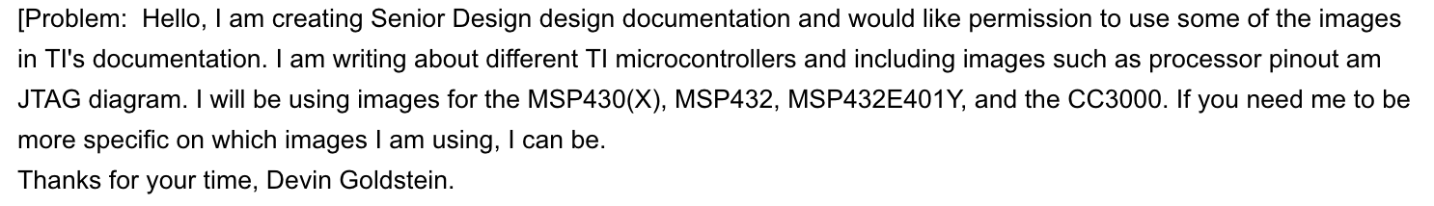


Ocfreaks:



Xzeres Wind



AeroVironment



Bergey Excel


Rototron
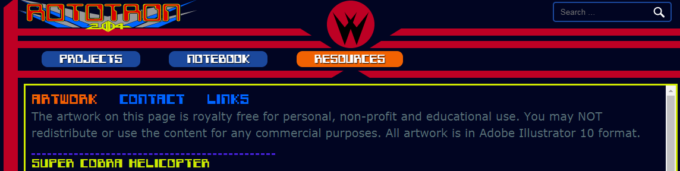
Raspbery Pi Foundation

Makezine.com

Amazon and YouTube images are used under the Fair Use Doctrine

WeatherSpark
